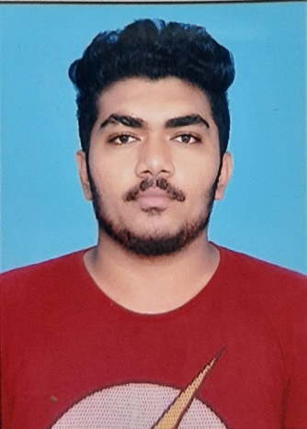

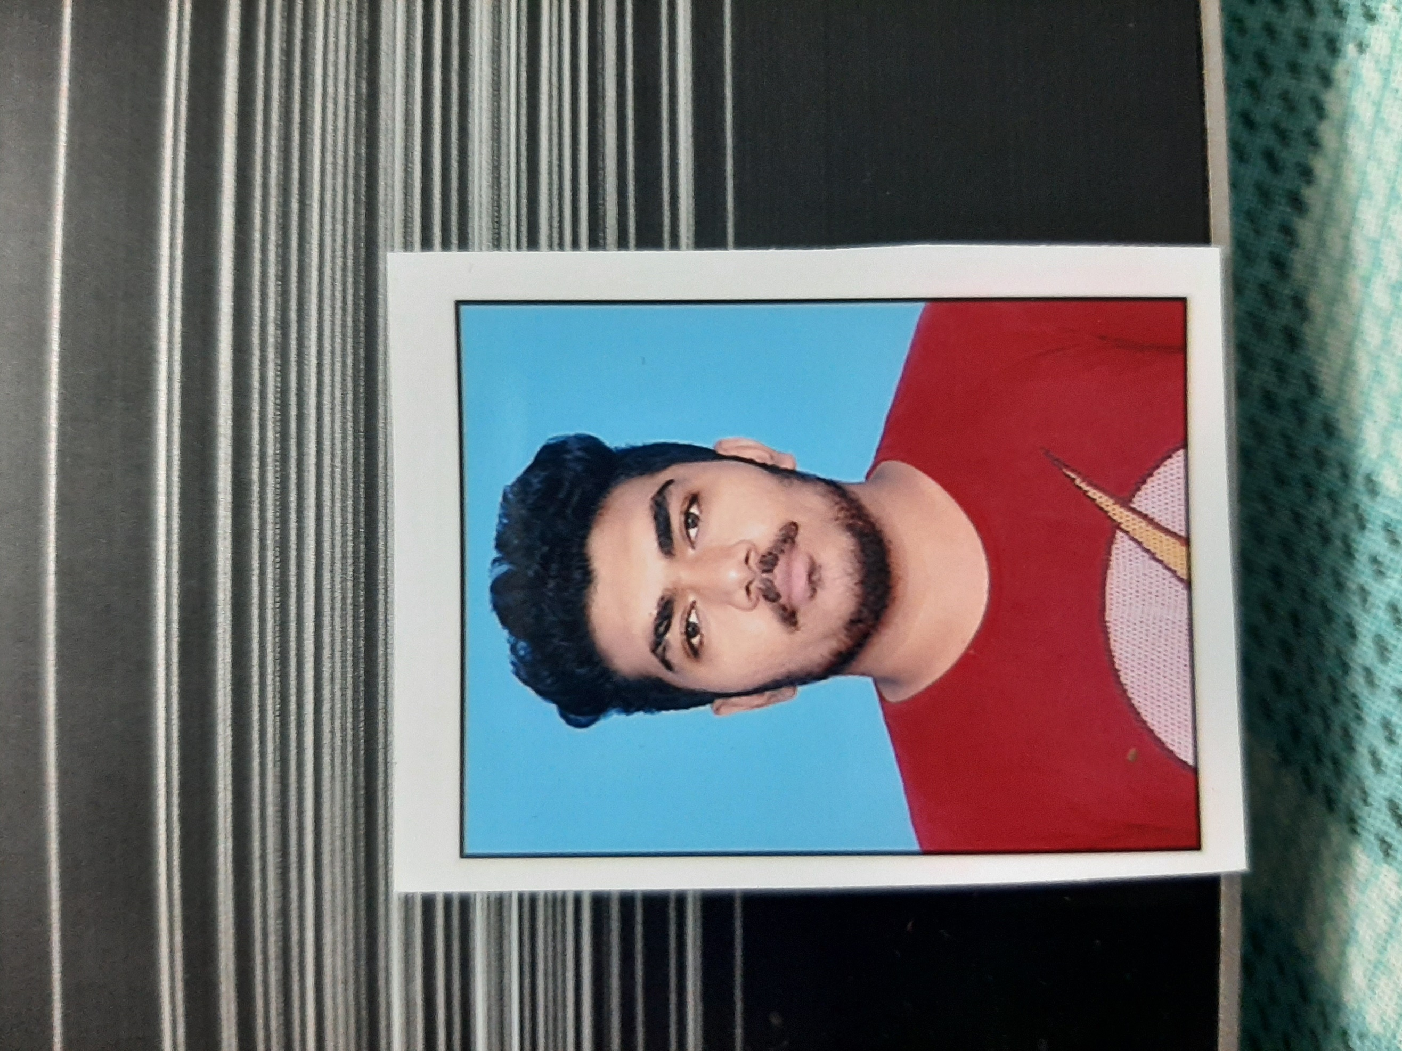

KEYUR

CHAWLA

**CIVIL ENGINEER.**

**CONTACT**

***PHONE:***



+91 9913224344

***LinkedIn:***

<https://www.linkedin.com/in/keyur-chawla-09606b183>

***EMAIL:***

*Key.chawla@gmail.com*

# PROFILE



Performance-driven and professional with over 1+ years of **site** experience assisting with and fulfilling organization staffing needs and requirements. With excellent communication skills, skilled in time management & 2D Drafting with excellent accuracy. Strong **Working plan** skills and able to work independently. And I want to work towards a designation as BIM manager of the Company.

# SKILLS

Quick Learner 85%

Management Activities 75%

Communication Skill 85%

2D Drafting 90%

Daily Task Reporting 95%

Working plan 90%

3D modelling 85%

Rendering 80%

Revit Family Creation 60%

EDUCATION



**Gujarat Technological University (**Aug 15 – Jul 19**)**

* Bachelor's in Civil Engineering with 6.83 CGPA.

|  |  |
| --- | --- |
| TECHNICAL SKILLS  •  Expert  MS Office  •  Expert  AutoCAD  •  Expert  Revit  •  Expert  Outlook  •  Beginner  FormIt |  |

**Class Xll (**Jun 13 – Aug 15**)**

* GHSEB Board with 60.93 Percentile.

# WORK EXPERIENCE



Shree Siddhivinayak Developers.

Ahmedabad – India [*May 19 – Present*]

* Started as a Junior Site Engineer.
* The Project name is Ashtha Tapovan. Its G+12 Floors Apartment.
* Supervise Project Workers, External Contractor and Sub-contractor.
* Write Daily Detailed Reports of logging work progress for quality assurance.
* Material and Equipment management.

Work on engineering designs preparing reports, construction drawings, specifications, calculations, equipment, selection for various projects.

* Monitor the progress of civil contractors as per the schedule agreed.

# PROJECT

* T6th Sem:- CRMB (Crumb Rubber Modified Bitumen)
* It gives more flexibility and stability in the road.
* 7th Sem:- Smog Eating Concrete.
* Its function adsorbs pollution like NOx and oxidizes in non-toxic gases.
* Our Smog Eating Concrete project is selected and funded by SSIP(Student Startup and Innovation Policy).
* 8th Sem:- We made a prototype of Smog Eating Concrete.

# Declaration:-

* I hereby declare that the above-mentioned details are true to the best of my knowledge.

Place:- Ahmedabad

Date:-

KEYUR CHAWLA