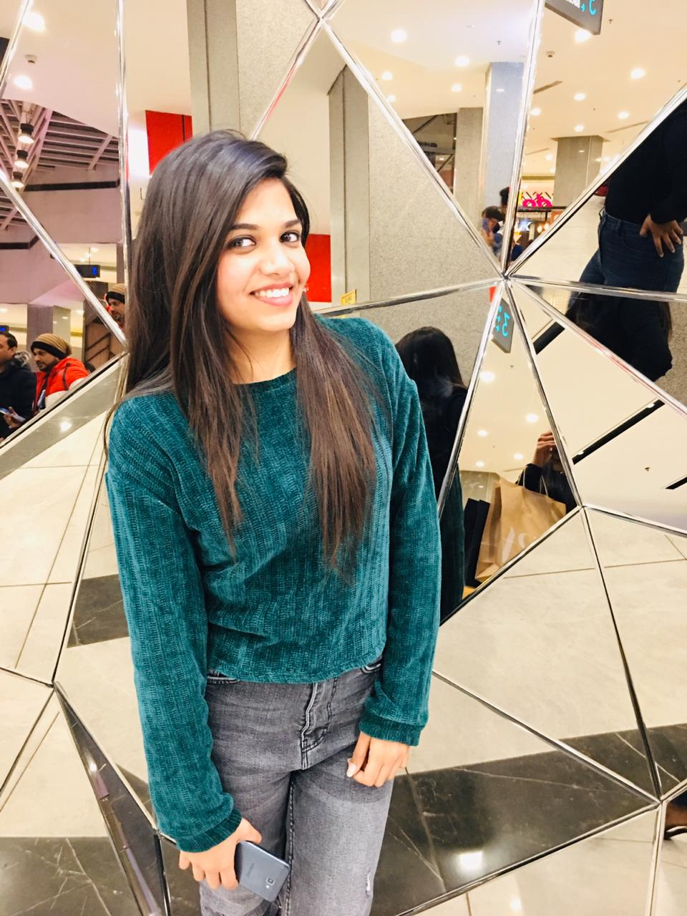MUSKAN GUPTA

Contact no: +91 9915342516

Email: mg142516@gmail.com

Address: Ward no.1, House no.23

R.S.PORA, JAMMU-181102

**Career objectives**

I wish to learn something new and enhance my skills in a dynamic and stable workplace**,** with an opportunity of working with diverse group of people.

**Key competencies**

* Communication: I can use appropriate language, style and methods depending on audience and the purpose of communication.
* Flexibility: I have responded positively to change and adapted to new situations quickly.

**Academic qualifications**

|  |  |  |  |  |
| --- | --- | --- | --- | --- |
| Year | Degree | School/Institute | Board | CGPA/Percentage |
| 2021 | Bachelor of Engineering | Chandigarh University | Chandigarh university | 6.28 (till 5th Sem) |
| 2017 | 10+2 | Green wood hr. sec. school. | J&K Board | 63 |
| 2014 | 10 | Prince doll hr.sec. school. | J&K Board | 86 |

**Projects and Training**

* Industrial training on networking (CCNA) from A2IT (Mohali, Chandigarh) for a duration of 6 weeks.
* Project based on unmanned ground vehicle using smartphones during 4th Semester.
* Project based on RFID attendance marking system using smart cards during 5th Semester.
* Recently, we work on Cisco picketer.

**Technical Provinces**

• Languages: C, C++, SQL,

• Software’s: MultiSim, Oracle, Cisco Packeter, Arduino.

**Extra-Curricular achievements**

* Participated and got certificate of appreciation in poster making competition on engineer’s day.
* Participated, Organized and Coordinated EVENTS.

**HOBBIES**

* Travelling and exploring new places.
* Liked to play sports like Badminton, etc.
* Interested in Modelling.

**PERSONAL INFORMATION**

Father’s name: VIJAY KUMAR

Mother’s name: NIDHI GUPTA

Date of birth: 03/07/1999

Languages known: English, Hindi, Punjabi

**CAMPUS CONTACT**

Chandigarh University

NH-95 Chandigarh-Ludhiana Highway,

Mohali, Punjab, 140413 (INDIA)

General Helpline No: +91-160-3051003

Toll Free: 1800 200 0025