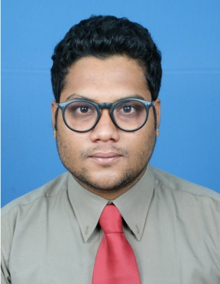

**GANAPATHY RAMAN. R**

**Date of Birth** : **16- 07 -1993**

**Mobile: +91 7736617443**   
[**gannsraman@gmail.com**](mailto:gannsraman@gmail.com)

**VI/1251, VADAKKE MADOM, GUJARATHI ROAD,**

**MATTANCHERRY, KOCHI-682002**

**Career Objective**

To be an expert in the practical field through commitment, perseverance and continuous improvement.

**Key Skills**

* Excellent communication skill.
* Planning and Organizing events.
* Quick decision making.
* Good analytical skills.
* Adaptability.
* Ability to build rapport with customers..
* Innovative.
* Good Knowledge in MS OFFICE.

**Personality Traits**

* Honest,Sincere,High level of Integrity and Dedication.,
* Hard & Smart working.
* Efficient Team player and achiever.
* Self motivated and self confident.
* Pursue continuously to improve knowledge and skills.

**Academic Qualification**

2014-2016 - **MBA (Finance & Marketing), ASIET, Kalady.**

2011-2014 - **BCOM, SANATHANA DHARMA COLLEGE, ALAPPUZHA.**

2009-2011 - **PLUSTWO**, **SRI COCHIN GUJARATHI VIDYALAYA HSS,KOCHI.**

2008-2009 - **SSLC, T.D. HIGH SCHOOL, KOCHI.**

**Experience**

* **One year experience as Sales Executive in Freightlinks International (I) Pvt Ltd, Willington Island, Kochi.**
* **One and half year experience as Transaction Analyst in Conduent Business Services LLC. Infopark, Kochi.**
* **One year experience as Benefits Administration Associate at Conduent Business Services, Infopark, Kochi.**

**Academic Projects Undertaken**

***UG Project*** :“COMPARATIVE ANALYSIS OF EDUCATION LOAN” – with specific reference to **STATE BANK OF TRAVANCORE** AND **FEDERAL BANK**.

**Internships and Workshops**

* **Internship -** A study on **Working Capital Management** at **L&T INFRASTRUCTURE ENGINEERING LTD, Chennai.**
* Certification of **International Financial Reporting Standards(IFRS)** issued by **INTERNATIONAL ASSOCIATION OF ACCOUNTING PROFESSIONALS(IAAP)**
* Certification of **CERTIFIED LOGISTICS PROFESSIONAL** issued by **World Human Resources Development Education(WHRDE) .**

**Achievements**

* Won first prize in football competition conducted by Brahmins Welfare Association.
* Certificate of merit issued by Kerala Brahmana Saabha in Cricket.
* Won second prize for Open Doubles Table Tennis conducted by Conduent Inc., Vismaya Infopark.

**Languages Known**

To speak : English, Malayalam,Tamil

To write : English, Malayalam, Hindi.

**Hobbies:**

* Travelling
* Swimming

**Extra-Curricular Activities**

* Football
* Cricket
* Photography

**Declaration**

I hereby declare that the above furnished data is true to best of my knowledge and belief.

Place: Kochi

Date : GANAPATHY RAMAN. R