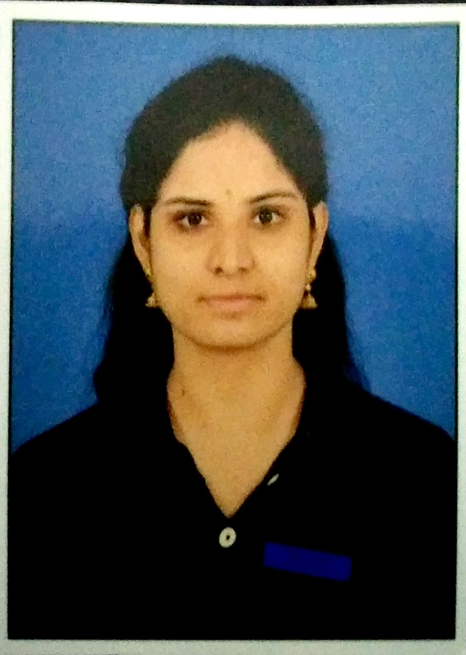

**N. RASAGNYA**

H.No: E-21, IICT colony.

Hubsiguda, Nacharam road

Pin: 500030

**Mail ID**: rasagnya1990@gmail.com

Mobile: 9553860580

**Career Objective:**

Focusing on a challenging and growing long term career in pharmaceutical sector or an organization where my knowledge can be shared and enriched. Strive for a growth where I can explore my experience with the strong analytical and to grow within the organization.



**Educational Qualifications:**

* PG (**M. PHARMACY**)           :      From Vision College of Pharmacy (2013-2015)
* Degree (**B. PHARMACY**) : From Raghu College of Pharmacy (2009-2013)
* Intermediate : From Sri Chaitanya Junior College (2006-2008)
* S.S.C : From  N.M. High School (2005-2006)
* Long term for EAMCET: 2008-09



**Technical Skills:**

* MS- Office

- Excel

- Word



**Experience:**

* Participated in Poster presentation “**YUVATARANG 2010**”, organized by Vignan college of Pharmacy, Duvvada.
* Participated in poster presentation entitled “**NEURODEGENERATIVE DISORDERS**”,national conference on recent machineries in Pharmaceutical Industries, organized by Raghu College of Pharmacy
* Attended **National conference** on **“Application of Nano Technology in Pharmacy”** held on 14th July 2012, organized by Raghu College of Pharmacy
* Trained in **ARAVINDO PHARMACEUTICALS**, Vishakhapatnam for Industrial training for the duration of 3months.
* Experienced as a faculty for “**Cosmetic Science**” in **Omega College of Pharmacy**, Edulabad, Hyderabad, for one year (for 4th/8th semester students) : (**2015-16)**
* Experienced as biology teacher for 2 years in Krishnaveni Talent School. ( 2016-18)
* Experienced as an academic principal, along with it, as a coordinator for LEAD curriculum, in Saraswati C. B. S. E. Schools, for the academic years, 2018-20
* Worked for an educational app, named "Lucid Study" in 2020-21.



**Personal Strength:**

1. Smart working and discipline.
2. Hard working nature.
3. Positive thinking
4. Good communication skills



**Personal Profile:**

Name :      **N. RASAGNYA**

Father’s Name               : N. SATYANARAYANA

Date of Birth : 03-09-1990

Gender        : Female

Marital Status : Married

Mother Tongue : Telugu

Language Known : Telugu, Bengali, English & Hindi

Nationality : Indian

Hobbies : Listening Music, Professional classical dancer (Bharatanatyam),

Travelling



**Declaration**

I hereby declare that the above furnished information is true to the best of my knowledge.

Place: Hyderabad

Date: 23-04-2021   **(N.RASAGNYA)**