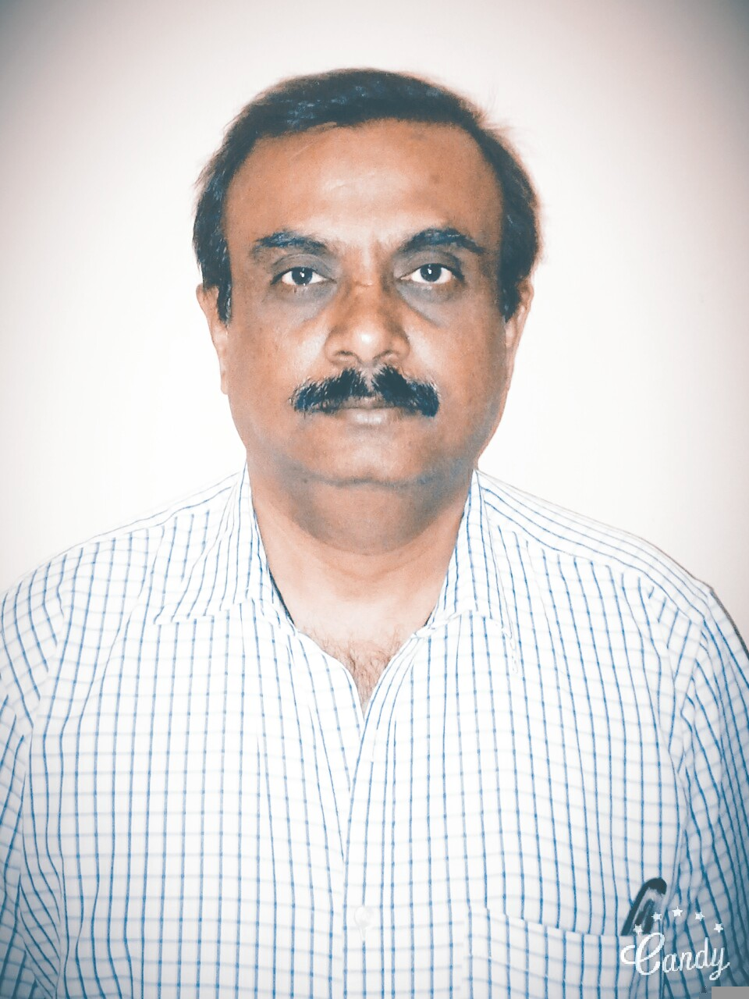 Rajendra K.Purohit
Gaana Regency, #104, Block4, Yelachenahalli, Bangalore.
Mobile No. 9845279329 rpurohit@mail.com

Summary

Over 20+ years of experience in all phases of design, implementation, and support of operation, service delivery using the best practices of ITIL and using PMI project Management methodology managed small to medium sized projects. Good Knowledge in the domain of Networking (Cisco data and voice networking)
Core strengths:
- 10 plus years of Project Management as per PMI Process
- Providing the design solutions for the network data &voice setup.
- Strategic &Technical planning and execution of data and voice network integration,
- People Management and leadership skills
- Network performance analysis, capacity planning.
- Business Impact Assessment and Business Resumption/Disaster Recovery
- Develop new business initiatives within clients and lead the sales coordinating pre-sales and bid teams. Working knowledge of ITIL process
Expertise
- Implement performance standards and measurements for the IT operation team to manage ongoing service delivery and attain delivery efficiency
- Own Service Management processes, tools and disciplines and ensure they are applied in all aspects of contract delivery
- Responsible for running an ITIL compliant operation and enforcing security and compliance requirements
- Designed & implemented the LAN(VLAN)/WLAN using Cisco Solution
- Designed Cisco Voice solutions IP Telephony as an enterprise voice solution.
- Providing the Structure Cabling solution for the IT Infrastructure setup

Skills Summary
Project Management:
- Network ( Data & Voice) Integration
- Datacenter Migration
- Enterprise wide Implementations
IT Service Lifecycle:
- Service Strategy:-Financial Mgt for IT services, Demand Mgt, Business Relationship Mgt. Service Portfolio mgt
- Service Design:-Design coordination Mgt,SLA Mgt, Capability & availability Mgt, IT service continuity (BCP)Mgt, Supplier Mgt,
- Service Transition:-Asset & Configuration Mgt, Change Mgt, Knowledge Mgt, Transition planning Support Mgt.
- Service Operation:-Incident Mgt, Problem Mgt, Access Mgt.
Continuous Improvements:- Improvement actions & plans-7 step process

IT Project Lifecycle:
- Requirements Analysis
- Project Planning & Scheduling the activities
- Risk Identification ,Assessment & Mitigation Plan
- Execution, Monitoring & Control
- Testing/QA/Training/Closer
Value-Added Leadership:
- Cross-Functional Supervision
- Team Building & Mentoring
- Client Relations & Presentations
- Business & IT Planning
- Vendor Management
Major Achievement:
- Led teams across broad technical, financial and business disciplines. Focused teams on business objectives and tracked progress to ensure project milestones were completed on time, on budget and with the desired results.
- Mitigated risk factors through careful analysis of financial and statistical data. Anticipated and managed change effectively in rapidly evolving global business environments.
- As a technical Manager resolved the technical issues related to the switching in the Ring topology
- Resolved the prolonged technical issues related to the patch management server connectivity issue with client & patch updating by coordination with OEM
Career Progression & Experiences:
Freelancer –IT Infrastructure Project Management & IMS Consultant-Dec.2016 to till date.
For the Client MRPL following services provided on call basis;
Provide Technical Support on LAN/VLAN/WLAN Industrial (Moxa L3) switches configured on Ring Topology.
Provide Technical Support on Clear Pass (NAC) implemented to control & Secure Network devices & Endpoint devices to access resources by configuring endpoint profile access policy with coordination with OEM
Manage Bluecoat Proxy SG perimeter defence for securing and controlling Web-based content and applications.
Automated device management, application deployment, using Dell KACE K1000 SME in collaboration with OEM
Patch Management Reporting & Service Desk Ticketing system by using Dell KACE K1000 SME.
For the client ABC Java Technologies, following services provided on requirement basis;
Resolved the LAN/WLAN( Linksys AP1200C) latency issues, resolved Data backup issues by implementing automated backup Solution.
Configured Tacitine UTM for Client to Site VPN for remote work users.

OPTIT Technologies Pvt.Ltd.(Bangalore),Project Manager,Nov.2012 to Nov.2016
PM (Technical)-Hospitality Project-Shangri-La(SLIM)

- Planning IT infrastructure as per SLIM design standard, by working closely with SLIM IT.
- Coordinating with cross-functional team for the preparation of co-ordination drawing, shop drawing.
- Driving the project by coordinating with vendor for structured cabling for Data, voice, CCTV, Digital signage services.
- Designing the server room, hub room, CCTV control room as per SLIM guideline, coordinating with vendor for setting up the server room/hub rooms.
- Procurement planning, validating BOM, validating pricing as a value added services.
- Planning the implementation of wired & wireless local Area Network & wide area network.
- Coordinating with ISP for commissioning of Leased Lines & PRI Lines & coordinating with EPABX vendor for configuring voice network.
- Coordinating with SLIM IT(Global IT Team) for the implementation of Site-to-site VPN using Cisco ASA 5525 with High Availability failover configuration
- Coordination with IT vendor for the implementation Palo Alto 220 FW
- Arranging training for the IT support team as a handover part to the SLIM operation team
- Conducting UAT, Closing the project by handovering projects handover documents with completion certificate.

Following Major clients handled for the Managed services as SDM;

eXotel, LivSpace, Langoor, EEC , Vasavi Group of Education & Hospital

Intarvo Technologies Pvt. (Bangalore)AGM-IMS Delivery,Sep-2011-to-March-2012
As a AGM, lead the sales, presale & operation team, working together in the bidding the tender on RIM projects by responding to the RFPs.
Worked closely with presale team & client (TCS) with successfully bidding the simulation-based education to the schools & winning the project.
Leading the Project team on setting up of the IT infrastructure for RIM support for the end user systems mainly for the HP & Acer under warranty Laptops & Desktops.
Geodesic Techniques Pvt.Ltd (Bangalore), Advisor-IT Infrastructure
Lead the support team on IT operation service support and projects manage the opening of Branch locations. Provide end user support for 450+ corporate users. Install, configure, and troubleshoot secure LAN’s, WAN’s. Consistently manage numerous simultaneous technical projects, lead engineer for installations & upgrades. Provide networking solutions that both accommodate special needs on time and within budget.

e4e Business Solutions Ltd(Bangalore) Manager-Protects Transition ,Jan 2009-May 2009
Project Management & Respond to RFP on RIM projects for the following clients;

FileMaker:
Responded to client RFP on Datacenter setup & Remote Monitoring (RIM) Solutions
Avaya:
Responded to client RFP on Monitor & Managed services for Avaya & for Avaya Clients
Cowen:
Responded to clients RFP on Monitor & Managed services for the Servers/ applications servers
ISO 27001 Implementation & Certification
Actively involved in ISO 27001 implementation & certification process
Performance evaluation - evaluate/audit/review the information security controls, processes and management system in order to make systematic improvements where appropriate.
Improvement - address the findings of audits and reviews (e.g. nonconformities and corrective actions), make continual refinements to the ISMS

Wipro Technologies.Ltd (Bangalore) Implementation Manager, Nov204-Nov2008

Onsite Projects:

- For Pitney Bows Harlow-UK, as an implementation manger, designed the DR Site relocation from Leeds to Watford, which includes Understand/Review the IT assets and infrastructure setup, provide a requirement analysis document. Design the solution to integrate and implement the integration.

- For Thames Water Reading UK,as a Technical consultant, provided the office movement plan designed the solution for network migration from London Millharbour to Reading

- For Thames Water, Reading UK,as project manger leading the team of engineers and consultants handled design analysis and completed the Migration of Lotus Notes to MS outlook, server Deployments, Application rollouts, migration of Thames Water Millharbour laboratory to Spencer House Laboratory as a part of Lab centralization project

Offshore Projects:
Designing the UBS off shore development center network and connectivity with the other centers across different locations as per the client requirements
Collaboration with Sr.executives,developing an accountability network applied best practice for the Business Continuity Management plan, Managed the development and maintenance of Incident Management, Recovery Support, Business Unit, Corporate Technology, and Operations Business Continuity Recovery plans.
Leading the team of implementation engineers as technical design authority
Leading the team for the shadow support managing the UBS Hub network operations & keeping track of HUB support SLA
Participate in client Network Audit, closer actionable (corrective/ preventive actions) on audit findings.

Wipro Technologies, in house projects:

PM(Technical) Involved in designing of various networking projects & managing the Networking projects under the PMO Guidelines, following are the major projects handled;
- US Datacenter remote management:
- Outsourcing International call to Infonet
- Call accounting software implementation

- WT-WCCLG network integration

- WT-WFP network integration & mail migration to wipro.com

Network Solutions Pvt.Ltd,(Bangalore) Sr.Technical support Engineer Nov.1997 to Nov 2004
I was managing around 8 customer accounts, leading technical team with a group of 5 engineers.
Project involvement: Working with design team understanding customer requirement preparing project Definition document, project plan,& taking Technical sign off with customer

Major Projects Handled:

- Transworks (BPO):
- Nirvana Business Solutions(BPO)
- GE (R&D Division)
- Sharp software
- Sasken Technologies Ltd.
- Wipro
- Hexaware
- P&O Nedllyod ,Pune
- Novell Software India Ltd
- ACS

Computek India Ltd ,(Bangalore)Customer Support Executive, April92- OCT 1997

Handling of customer sites, AMC renewal, troubleshooting computer hardware, OS related problems.

Educational Qualification:

Pre-University Course (10+2) 1986
3 years Dip.in Electronics&Ceommunication Engineering-Feb.1990
Date of Birth 29-06-1966.
Professional Certifications:
CCNA Jan 2001
CCNP May 2003
CIPT April 2004
CVOICE July 2004

Trainings:

Customer Leadership Interface Program workshop at Wipro Technologies: April 2005

Accelerate-Global Management training at Wipro Technologies: July 2006

ITIL V3 Foundation Certification, April 2012

Professional References:

Mr.Satish Narule-Tech.Director-OptiT Technologies Pvt. Ltd.
Mr.Narsimha Pai-IT Manager-Shangri-La Hotel.
Mr.Srikant Venkatesh-Sr.Network Security Consultant-Freelancer

Rajendra K Purohit
Place-Bangalore
Date 31-07-2020

