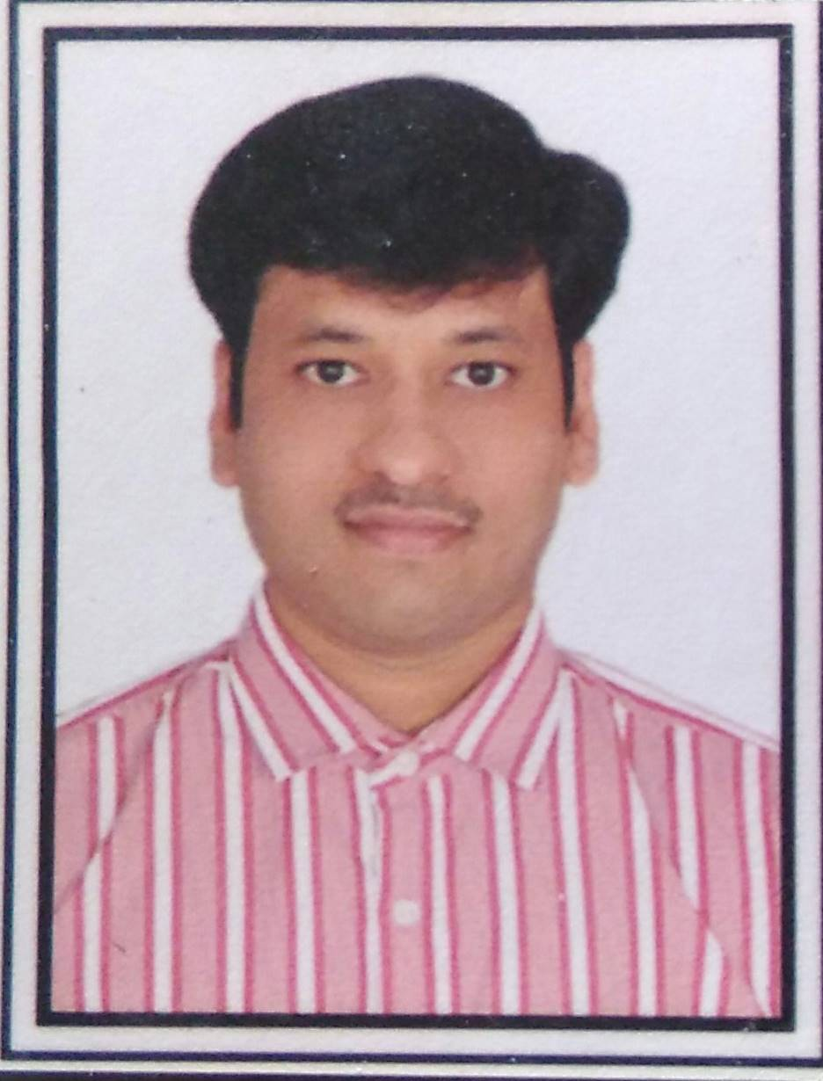
Present Address:
ABDUL HAMEED SHAIKH #601, K.K. Enclave
Email: abdul.paramantra@gmail.com Sec-19 Ulwe
Mob # 91-8169996291 Navi Mumbai: - 410206

Talented, results-oriented Sales Professional with a track record of accomplishment in rapidly expanding a sales territory and boosting the organization’s bottom line seeks a CRM Software or SAAS sales position for a progressive company.

OBJECTIVES:
- To obtain employment in IT Sales at one of the most prestigious technology companies in the state and to gain more exposure to sales and marketing to further enhance my skills.
- Expertise in solution selling and in the consultative sales process has helped lead me to success by meeting sales objectives and consistently exceeding the customer base status increase in %. Now I am looking for a new software or SAAS product to excel with. I work well in a team environment but prefer to be autonomous. I prefer newer companies and startups for their potential and will consider any company and field. Besides my sales skill set I am also technologically savvy with the ability to explain complicated ideas and systems to a diverse customers. You will find me to be a very easy going, adaptable, productive member to your team.

EDUCATION QUALIFICATION:

- MBA. [Marketing]
- BCA. (Bachelor of Computer Application)
- Diploma in Electronics and Communication Engineering from
Sandur polytechnic (Board of Technical Examination, Govt of Karnataka
- 10th: - CBSE Board (KENDRIYA VIDIYALAYA) BELLARY

Professional Qualification:
- Diploma in Digital Marketing
Marketing Skills:

- Lead Generation  - IT Sales  - Cloud Base Software Sales  - Build Sales Relationship Selling  - Technical Sales Support  - Good Knowledge of Cloud, SaaS Sales  - Sales Support Engineer  - Industrial Sales | - Cold Calling  - Pre Sales  - In-depth understanding of Internet and related infrastructure Business  - Digital Marketing  - Product Branding  - International Sales  - Inside Sales
Marketing role
- Market Initiatives & Lead Generation
- Attend Tradeshow & Events and Generate Leads for New Business Development.
- Support all Pre-Sales Activities of the company
- Provide detailed Information about Technical Specifications of Products Marketed by the Company
- Inform the Customers about the Specific SaaS, Cloud Base Application of Software Products
- Maintain social media sites / groups and professional platforms and provide regular content from internal experts on industry-related topics.
- Help Develop New Business through networking and follow-ups
- Proposing Techno Commercials Proposals to Customers.
- Support Sales Team with Inbound Lead Generation.
- Grow Inbound Leads through Increased Online Presence.
- Prepare Self Sales Tools, Planning & Marketing Materials

Software Knowledge Skills:
- Programming Language | C, C++,
Operating System | Windows 10,8.1,7, Windows Vista, Windows XP, Windows 98, MS-Dos. Mac 9.2.10.5.
- Web Tools | HTML, Dream Weaver,  Flash, Photoshop, SQL SERVER, Cloud Base Products, SaaS,

PERSONAL STRENGTHS:
- Good communication skills
- Ability to work with team
- Love to Travel and Meet new People
- Adaptability to new environment
- Capability to work individually
- Good leadership qualities

ACHIEVEMENTS:

- Stood First in NCC training camp. I was awarded with ‘A’, ‘B’, ‘C’ CERTIFICATES.
- Participated in Bharat Scout & Guides, and received RASHTRAPATI AWARD
(BY PRESIDENT OF INDIA) K.R.NARAYAN.
- Participated in All India Level Mathematics & Science Test -1998, a national level
Examination. & Secured: - B Grade.
- Participated in Golden Jubilee Celebration of India’s Independences.
- Participated in college Annual Sports Day Celebration and secured 2nd Prize.
- Participated in National Organization for Promotion of Adventure Sports & Nature Awareness Camp held at DOODH SAGAR FALLS.

Currently Worked with:

Organization: Aldius Consulting Services Pvt. Ltd (Paramantra)

Designation : Business Development Manager (BDM)
Duration : 4th January 2020 to 20th October 2020.
Handling Overall Sales Mumbai (West Region).
- CRM Sales for Manufactures, Real Estate etc.
- It’s a Custom Web Based Software.

Professional Experience:
Organization: BDS Services Private Limited
Designation: Business Development Manager (BDM)
Duration : 3rd September 2018 to 30th September 2019.
Handling Overall Sales Mumbai.
- Web Site Development,
- Google Promotion(SEO),
- IT solutions and Social media promotions.
- Custom Web Based Software Development.

Organization: Wipro Technologies
Designation: Technical Sales Support Engineer (Microsoft Cloud Services)
Duration : 18th Feb 2011 to 31st August 2018.
Experiences with Technical Support Operation.
- MS O365 (Cloud Base Services)
- MS Outlook. (2007, 2010,2013) & MAC Outlook 2011.
- MS Office (Access Database)
- MS Classroom (Microsoft Education)
- MS SQL

Responsibilities:
- Providing complete Technical Sales Support on Windows OS / MAC.
- Providing Sales Support with Microsoft Education Solution. (MS-Classroom|MS-Booking|MS Class Notebook )
- Experiences with Office 365 / Microsoft Online Support / Outlook related issues,
O365 outlook online.
- Good Experiences with MS-Access Database.
- Knowledge with SQL Server.

NOMURA
Designation: Engineer (Enterprise Infrastructure IT Service Desk,)
Organization: NOMURA (Under the payroll of E4E)
Duration: 24th September 2009 to 1st Feb 2011.

Responsibilities:
- Providing Voice support / remote support to Nomura users
- Configuration and Troubleshooting of Desktops, Laptop’s, Networked Printers,
- Troubleshooting windows OS related issues, Outlook 2007 issues ,
- Active directory user login issues, user password reset, user account unlock
- Troubleshooting users unable to login from home to Nomura connect networks.
- Raising Application installation tickets
- Internet access and Mail account setup

Project: - Attendance Management system.

This Project specialty is to manage number of employee’s login on shift base.

Gives complete details of total number of employees logged, absent, late for shift, sick leave, weekly report, monthly report.
Aditya Birla Group

Designation: Sr. Sales Tech Support Engineer (Apple - Macintosh Systems)
Organization: Minacs (Aditya Birla Group)
Duration: From 20th Nov 2006 to 11th August 2009

Responsibilities:

- Providing Complete Sales of I Pod, Mac book Pro, Air, Mac Mini.
- Providing Complete Sales Tech Support for MAC Desktops, portables,
Mac book Air, Mac Mini, I Pods,
- Sales of Apple Care Protection Plan & advises and assists users with integration of Macintosh systems.
- Provide knowledge for new Clients with Configuration Specification and basic Troubleshooting of Apple Desktops, Laptop’s and Local Printers.
- Provide knowledge with Mac OS related Issue, Mail Configuration, and Internet Wi-Fi Configuration.
- Works directly with customers and assist with technical requirements based on Apple Products.

CyberworkZ:

- Duration:-From 20th July 2005 to 25th September 2006.
- Is a Call Center which deals with both inbound & outbound Sales.
- Process for Domestic & international.

DIGI COMP SYSTEMS, B’lore (branch)
From July 2004 to July 2005.
SERVICE ENGINEER / IT Help Disk (Technical Support)

DIGI COMP SYSTEMS. (TOTAL TECH SUPPORT)
Is a Service Provider for Samsung, Philips, HCL, IBM, and Benq.
They are also into software development and Network services including Maintenance Contract. Our esteemed customers are: Wipro, Philips health care, DELL, Swiss Re Shard services,etc.www.digicompindia.com

OTHER INFORMATION:

Name : ABDUL HAMEED.
Father Name : SHAIK ABDUL KHADER
Nationality : Indian
Marital Status : Married
Languages Known : English Hindi & Kannada Telugu.
Current Address : ABDUL HAMEED.SHAIKH
#601, K.K Enclave, Sec-19 Ulwe
Navi Mumbai: - 410206

Date : 10-11-2020 Regards
Place : Mumbai Abdul Hameed Shaikh

