**Resume**

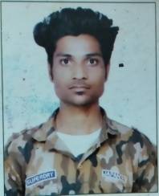

**GAURAV KUMAR**

**Mobile : 8920019965 / 9069273021**

**Email : 9810963301GAURAVKUMAR64978@GMAIL.COM**

**objective**

Secure a responsible career opportunity to fully utilize my training and skills, while making a significant contribution to the success of the company.

**PROFESSIONAL EXPERIENCE**

* TWO YEAR AMAZON INDIA AS BACKEND EXECUTIVE
* SIX MONTH HCFC CREDIT CARD AS CSE
* CURENTLY WORKING IN TELEPERFORMANCE AS CSE AND ALMOST DONE MY 12 MONTH .

**ACADEMIC / EDUCATIONAL QUALIFICATION__________________________**

* High School, From NIOS IN 2016
* Intermediate, From NIOS IN 2018
* PURSUING IN BA 1ST YEAR FROM DELHI UNIVERSITY

**PERSONAL INFORMATION**

Father’s Name : VIJAY SINGH

Date of Birth : 19/09/1998

Hobbies : Writing , Youtuber, Internet, etc.

Language Known : Hindi, English,

Address : L-281/ 9 sangam vihar new Delhi 110062 India

**BEHAVIOURAL CHARACTERISTICS**

* Commitment to quality & result..
* Self motivation, Confident, Responsibility..
* Excellent problem solving skills.
* Ability to work continuously with high energy level.

**DECLARATION**

I hereby affirm the information given in their document is correct to best of my knowledge

**[Gaurav kumar]**