Name | MD. FAISAL EJAZ
Email-id | faisalktr991@gmail.com
Mobile No | 7991156874
Address | choudhary mohalla katihar bihar , 854105

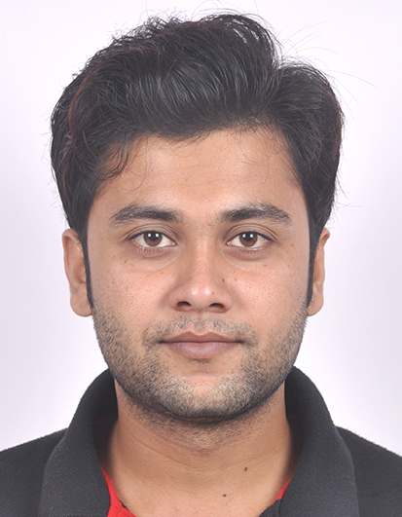

Career Objective:-

To utilize the abilities, expertise and knowledge in the organization, so as to enable the organization achieve its goals and at the same time exploit opportunities for constant learning and career development.

Education Qualification:-

EXAMINATION PASSED | SCHOOL/COLLEGE | BOARD | RESULT(%) | YEAR
SECONDARY SCHOOL | AAM CHILDRENS’S ACADEMY | CBSE | 74.1 | 2011
HIGHER SECONDARY | HASANPUR COLLEGE HASANPUR ROAD SAMASTIPUR | BSEB | 57.2 | 2013
CIVIL ENGINEERING | NETAJI SUBHASH ENGINEERING COLLEGE | MAKAUT(WBUT) | 60.01 | 2017

B-TECH IN CIVIL ENGINEERING in 2017 Form NETAJI SUBHASH ENGINEERING COLLEGE(GARIA,WEST BENGAL) Under MAULANA ABUL KALAM AZAD UNIVERSITY OF TECHNOLOGY,WEST BENGAL .(FORMELY KNOWN AS WBUT).
Year Percentage Detail
- First year | - 6.57 YGPA
- Second year | - 6.53 YGPA
- Third year. | - 6.56 YGPA
- Fourth year. | - 7.25 YGPA

Projects:-

- Title - Geometric and Pavement Design of A Highway engineering
- Duration - FINAL YEAR

Industrial Training:-

- Title : At CIVIL SURVEYING.

- Duration : 4TH JULY to 19TH JULY 2016.

- Location : BALITIKURI, HOWRAH-711113

- Brief Description : Gaining the working knowledge of CIVIL SURVEYING Technique wit Total Station.

WORK EXPERIENCE:
- 3years 2Months in APEX LOGISTIC UNDER L&T CONSTRUCTION AS A SITE ENGINEER FROM 8march2018 TO 22may2020 AT Bidkin ,paithan road, Aurangabad,Maharastra ,431105

Hobbies and Interest:
- Playing cricket, swimming,watching movies.
- Interacting with people.

Personal Information:
- Date of Birth : 14Th of dec 1995
- Father’s Name : Md. Ejazul haque
- Linguistic Proficiency : English, Hindi and URDU
- Permanent address : NEAR BADI MASJID,CHOUDHARY MOHALLA ,
KATIHAR 854105.BIHAR

Passport Detail:

- Passport no : R6524137

- Date of Issue : 10, JAN, 2018

- Date of Expire : 09, JAN, 2028

- Palace of Issue : PATNA

Strengths:-

- Honest

- Self Motivated

- Hardworking

- Positive Attitude

- Team Player

- Self Confidence

- Skills:-

- AutoCad for Architects and civil engineering

Declaration:-

I (MD FAISAL EJAZ) Declare that all the information are given by me are correct if any kind of mistakes are found in that case I will responsible for that.

Date: 1-02-19
Signature: faisal

