**AKASHDEEP MOB. NO. +918360923082**

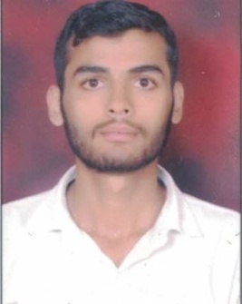**R/O:- House no 9A 88 foot road**

**Bank Avenue majitha road Amritsar**

**E-mail :- akash.deepdnn@gmail.com**

**CAREER OBJECTIVES:-**Looking forward for an opportunity to work in a challenging environment, where I can utilize my knowledge skills in contribution effectively to the success to the organization and to deliver the best of my capabilities towards the benefit of the organization.

**EDUCATIONAL QUALIFICATION:-**

|  |  |  |  |  |
| --- | --- | --- | --- | --- |
| **S. NO.** | **CLASS** | **BOARD** | **PERCENTAGE %** | **YEAR** |
| **1** | **10TH** | **P.S.E.B.** | **68%** | **2013** |
| **2** | **12TH** | **P.S.E.B.** | **62%** | **2015** |
|  |  |  | **-** |  |

**PEOFESSIONAL QUALIFICATION:-**

**SIX MONTH COURSE BASIC COMPUTER &TALLY FROM ADVANCE AMRICAN DINANAGAR**

**EXPERIENCE DETAILS:-**

|  |  |  |
| --- | --- | --- |
| **COMPANY NAME** | **EXPERIENCE** | **DEPARTMENT** |
| **VESTIGE MARKETING PVT LTD** | **2 YEARS** | **COMPTER OPERTOR** |
| **RISHMA SALES** | **1 YEARS** | **COMPTER OPERTOR** |

**PERSANAL PARTICULARS:-**

|  |  |
| --- | --- |
| **FATHER NAME:-** | **SH. RAJINDER KUMAR** |
| **DATE OF BARTH:-** | **16/09/1996** |
| **SEX:-** | **MALE** |
| **MARITAL STATUS :-** | **UNMARRIED** |
| **LANGUAGE KNOWN:-** | **HINDI, ENGLISH, PUNJABI** |
| **NATIONALITY:-** | **INDIAN** |
| **HOBBIES:-** | **LISTENING MUSIC** |

**DECLERATION:-**

**I HEREBY DECLARE THAT THE PARTICULARS OF INFORMATION AND FACTS STATED HERE IN ABOVE ARE TRUE AND COMPLETE TO THE BEST OF MY KNOWLEDGE AND BELIEF.**

**DATE……………….**

**PLACE……………… (AKASHDEEP)**