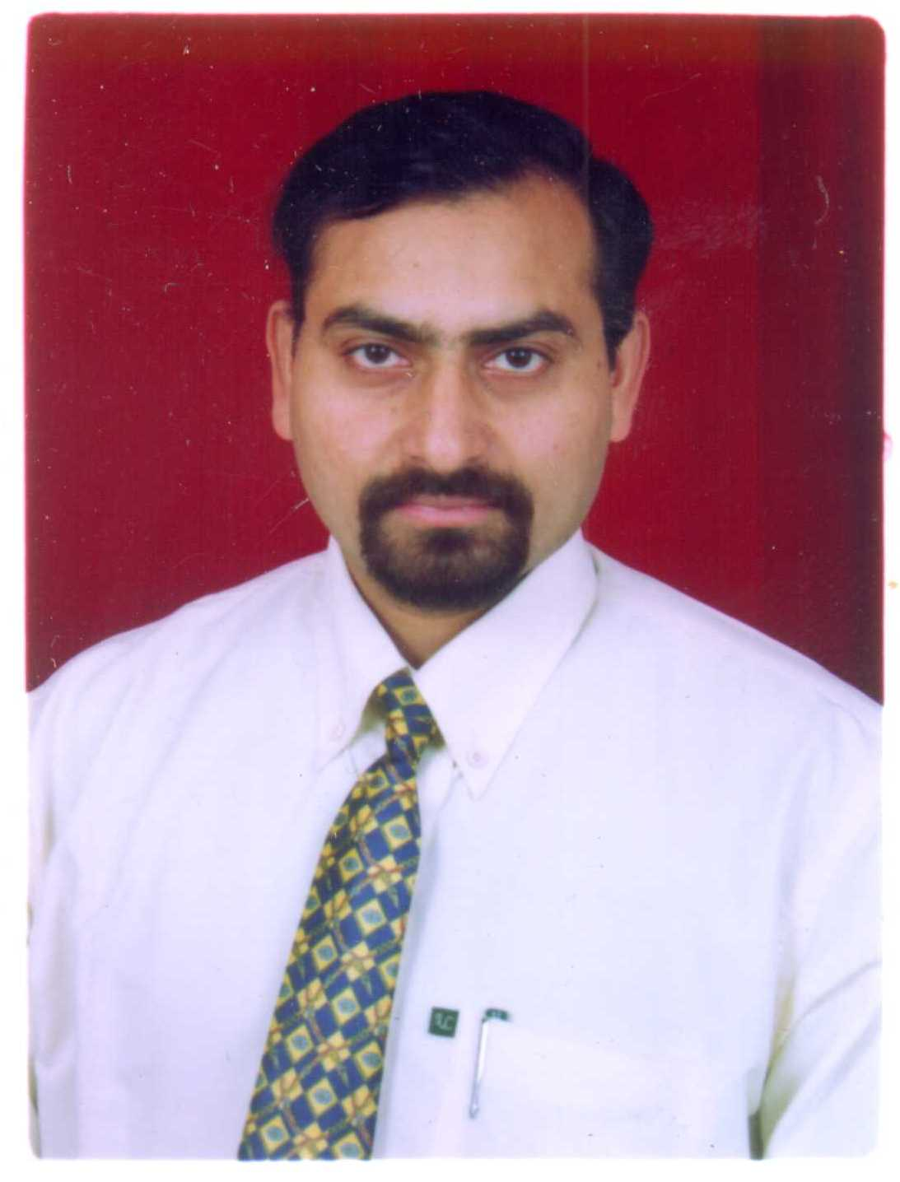
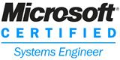
DEVI DUTT PANT
House No. 81, S. Extn.,
Mohan Garden, Uttam Nagar
New Delhi-1100 59

(M) 9911225848

9582763848

Career Objective
To serve my Experience & Knowledge to the best of my abilities in the interest of the organization
Professional Qualification
- MCSE (Microsoft Certified System Engineer)
(Microsoft Certification ID 6204236)

- Diploma in Software Technology from CMC Ltd. (A Govt. of India Enterprise), New Delhi.

Work Experience

Present Experience

Worked with National Institute for Smart Government (NISG), New Delhi as a Network Engineer from Feb 2019 to Feb 2020 for Insolvency and Bankruptcy Board of India (IBBI), New Delhi.

Job Profile

- Manage information technology and computer systems.
- Ensuring the smooth running of all IT systems, including Servers, Websites, Anti-virus software, print services and email system.
- Ensure security of data, network access and backup systems.
- Ensuring that software licensing laws are adhered to.
- Identify problematic areas and implement strategic solutions in time.
- Providing user training, support, advice and feedback.
- Managing crisis situations, which may involve complex technical hardware or software problems.
- Install, configure and manage Windows 2012 R2 Server.
- Preserve assets, information security and control structures.
- Manage Cisco Routers, Cisco Switches & Cisco Controller.
- DHCP Management.
- Software Installations & Troubleshooting.
- Dealing with Service Providers/Vendors.

Past Experience

Worked with M/s Society for Participatory Research in Asia, Tuglakaband Institutional Area, New Delhi as an Assistant Manager IT & Communication (IT In-charge) from Mar 2016 – Feb 2019.

Company Profile
Established in 1982, PRIA (Participatory Research in Asia) is a global centre for participatory research and training based in New Delhi. PRIA has field offices in 9 states and linkages with 3000 NGOs to deliver its programs on the ground.

Job Profile
- Manage information technology and computer systems.
- Plan, organize, control and evaluate IT and electronic data operations.
- Ensuring the smooth running of all IT systems, including Servers, Websites, Anti-virus software, print services and email system.
- Design, develop, implement and coordinate systems, policies and procedures.
- Scheduling upgrades and security backups of hardware and software systems.
- Ensure security of data, network access and backup systems.
- Ensuring that software licensing laws are adhered to.
- Researching and installing new systems.
- Act in alignment with user needs and system functionality to contribute to organizational policy.
- Identify problematic areas and implement strategic solutions in time.
- Audit systems and assess their outcomes.
- Preserve assets, information security and control structures.
- Handle annual budget and ensure cost effectiveness.
- Providing user training, support, advice and feedback.
- Managing crisis situations, which may involve complex technical hardware or software problems.
- Keeping up-to-date with new technology.
- Purchase New Hardware and Software, vendor survey, market research, maintaining registers of equipment issued, giving instructions to staff on how to use IT Equipment.
- Managing a team of 3 people in ensuring smooth running of IT.
Projects Implemented
- Implemented cost effective web based video conferencing solution.
- Implemented Greenstone (Digital Library Software).
- Done Analysis of IT Infrastructures of BRAC Institute of Governance and Development (BIGD), Bangladesh for Aga Khan Foundation, Bangladesh on behalf of PRIA.
- Implemented cloud based Project management and expense management system.
- Implemented cloud based HR management software and successfully integrated with attendance biometric system.
Worked with M/s Dhriti Infotech Pvt. Ltd., Mehrauli, New Delhi as a Manager IT from Nov 2010 to Jan 2016.

Company Profile
Dhriti Infotech Pvt. Ltd. is a KPO based at Mehrauli, New Delhi. Dhriti is doing international trading of Equity Bonds, commodities etc for a Singapore based MNC (Sinia Global). The company is employing around 100 employees.

Job Profile
Plan implement administer and manage complete IT setup of the organization. Major activities are as under:-

- Install, configure and manage Windows 2008 R2 (TT WAN Server).
- Manage Cisco Routers & Cisco Catalyst Switches.
- Monitor IPLC/VPN, Lease Line connectivity and ensure 100% uptime of the same and troubleshoot the problem if any.
- Managing a team of 2 IT personals.
- Install configure and manage ERP Server (Microsoft Dynamics Navision 2009) and giving remote support using RDP and as well as onsite support to end users (Windows Terminal Server 2008 R2).
- Liaison and coordinate with Singapore IT Team related to IPLC and TT WAN server installed at Singapore site.
- Patch Management
- Security Management using Watch guard Firewall, McAfee, Symantec/Norton Antivirus.
- Load Balancer, DHCP Management.
- Mail Server management and email user administration and configuration of Outlook for Email Clients.
- Software Installations & Troubleshooting MS Office 2010, Windows7, XP, X-Trader (for Trading), CQG, Now, Nest Trader and Norton Antivirus.
- Managing CCTV and DRV system.
- Dealing with Service Providers/Vendors.
- Purchase of IT Assets and Computer consumables.

Worked with M/s Advance Group of Companies, Rajokri, New Delhi as Assistant Manager IT from Nov 1995 to Oct. 2010.

Company Profile

Advance Group is a Manufacturer of Industrial Chemical named LABSA, a basic ingredient of Soaps and Detergents having Plants at Silvassa, Pondicherry, Indore, Mangalore & Kolkatta and enjoying the Status of Single Largest Sulphonation plant in Asia. The company is having turnover of around 700 Crores and employing 500 employees PAN India.

Job Profile

- Ensure the Security of Data Implement Security Policy and Permission of Servers.
- Install, Configure, Administer and Manage Microsoft Windows Environment, DHCP, DNS, Active Directory, Terminal Server, ERP Server, RIS & Software Deployment.
- Configuring/ Administering Domain Users and Groups (Password Settings/ Account Restrictions/Group Policy/IP Sec/ Profile Settings) Administrative security, Trust Relationship.
- Network Administration and Hardware Maintenance, Repairs in LAN having 1 NT 4.0 Server, Windows 2003 PDC, BDC, Windows 2003 Terminal Server & Windows 2003 ERP/SAP Server.
- Firewall/UTM Management (WatchGuard Firebox X750e)
- Patch Management.
- Maintenance support for around 150 Windows 7/ XP/Vista Desktops, Laptops & Linux based remote booting thin client PCs, & Peripherals like Dot Matrix, Ink Jet, Laser Jet Printers, Ups, and Wireless Routers etc.
- Configuration of server, Desktops and Thin clients for RDP and Giving Remote Support to clients through Net meeting, Remote Desktop & VNC.
- Maintaining & keep record of Backup's of Active Directory, Nodes and Laptop Users by Daily, Weekly and Monthly Backup in LTO using Symantec Backup Exec 11d.
- Software Installations & Troubleshooting MS Office 97/ 2000/2003/2007 Financial Accounting Package Tally, Autocad 2006/ 2008, Symantec Antivirus Installation & Update.
- Email Server administration and user configuration of Outlook & Outlook Express for Email Clients.
- Dealing with Service Providers/Vendors.
- Purchase of IT Assets and Computer consumables.
Computer Skills
- Networking : Network cabling and set up Switches, Routers for
new network segments.
(Windows 2012, 2008, 2003 Server/ 2000 Windows NT Server 4.0, LAN, WAN, TCP/IP, FTP and SMTP)
- Network Infrastructure : DNS, DHCP, Active Directory, Terminal
Services Services Server, IPLC/VPN, Video conferencing/
Web conferencing etc.
- Security Management : Configuration and management knowledge of
Watch Guard Firebox X750e and Dell Sonic wall TZ300 Firewall.
- Operating System : Windows 10/8/7/Vista/XP/2000/2003/2008,
MAC OS X
- Mail/Proxy Server : MS Office 365, Microsoft Exchange Server
(Installation and Configuration knowledge of
Microsoft Exchange Server 2003 for Internet and Intranet), Mdaemon Mail Server, Mercury mail server, Win Proxy.
- ERP : Microsoft Dynamics Navision 2009, Basic
knowledge of SAP Business One and installation knowledge of SAP ECC 6.0.
- Backup/Antivirus : Symantec Backup Exec 11d, AKG Backup,
Solution Windows Backup/Symantec Endpoint Server, Quick Heal, Norton, Mcafee, AVG, etc.

- Hardware : Very good knowledge of Computer Hardware
and its maintenance.

Packages : MS Office, Financial Accounting Package

Tally, Windows movie maker, AutoCAD, Open Office, TT, CQG, etc.

Cloud based software : Adobe Creative Cloud (InDesign, Dreamweaver,

Acrobat Writer etc.), Zoho Projects, Zoho Expense, GreytHR.

Academics
- Graduation from Delhi University in the year 1998.

Personal Detail
Father’s Name : Late M.C. Pant
Date of Birth : 5th June 1976
Marital Status : Married
Language Known : Hindi, English.
Email : pantddp@yahoo.com
Current CTC : 7.15/LPA
Notice Period : One Month

DEVI DUTT PANT

