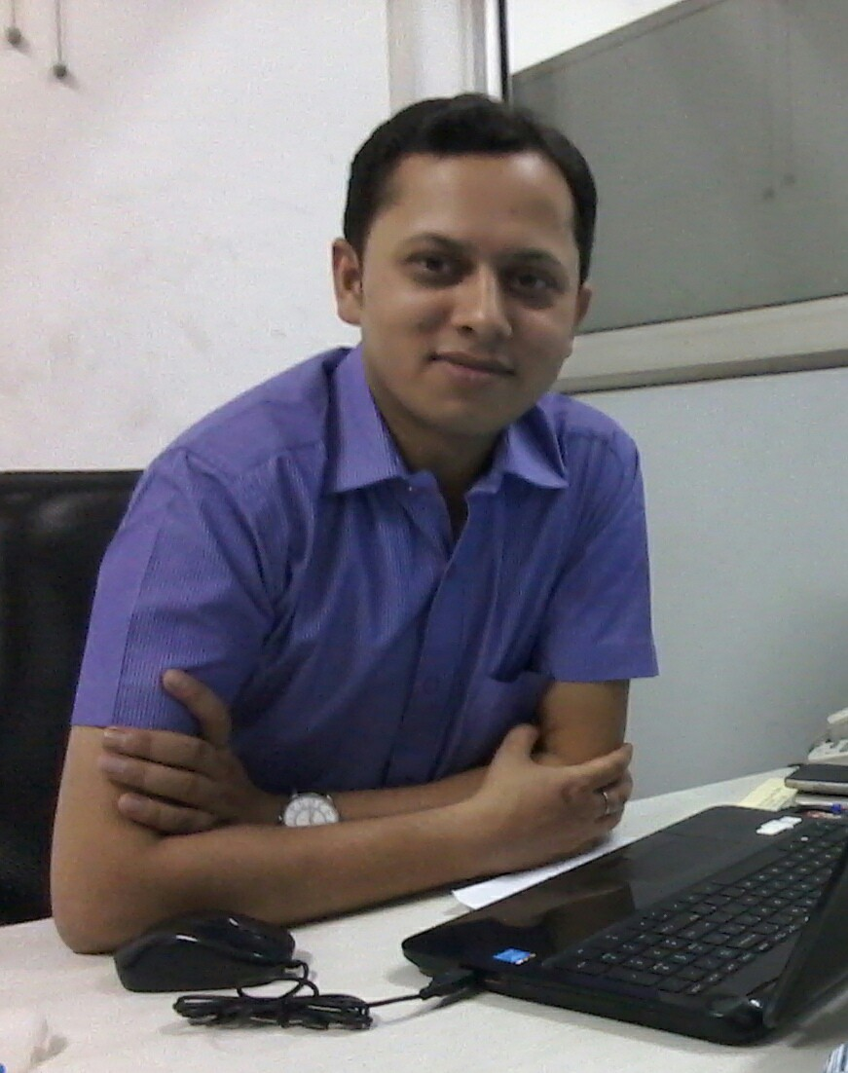

Respected Sir,
I am a Post Graduate “MBA” from Naraina College of Engg. & Tech., Kanpur (Affiliated by U.P.Technical University) in 2010. My career objective is to work in a dynamic and growth-stimulating environment which provides ample opportunities to utilize and enhance my skills. I look forward to be an asset to the organization and to move to higher Echelons of Professional career. Presently I am working as Personnel Manager with “Jagran Prakashan Limited” An Organization engaged in dealing with publication of Hindi daily News Paper in mostly states in India with the name of brand Dainik Jagran.
Through since June 2010 to till now of my career filled with strong urge to work in a challenging and growth oriented environment, I am looking for a better opportunity in a reputed Organization like yours and hereby enclosing my credentials “Curriculum Vitae” to support my application.
I hope my C. V. suffices your requirements for the same and at the same time, I am eager to hear from you soon. I shall be pleased to furnish the additional information, as and when required.
Thanking You in Anticipation.

Sincerely Yours.

(Abhishek Tiwari)
Enclosure *C. V.

ABHISHEK TIWARI
E-mail: - abhi29nov.hr@gmail.com , sonu6august@gmail.com

Contact no: 09580740545 & 09918760545

Senior Management Professional in:
HRD  Personnel Management  Administration  IR

HRD Functions | Strategic HR Management
Recruitment | Performance Management
Industrial Relations & Labour Law | Employee Relations
Compensation Management | Welfare Management
General Administration | Operational Management
Training & Development | Legal Compliances & Liaising
MIS | Leadership

Professional Snapshot:-
- An astute Professional with over 11 years chronicle Experience in the area of HR, IR and Administration Management.
- A creative communicator and presenter, able to establish report with individuals and group at all organizational levels.
- Having Good sense and rapidly evolving Experience in implementing HR Functions (like absenteeism, non-performance, Gratuity and F & F settlement, Leave policy & etc.), Disciplinary Functions, Time Management, Vendor & Cost Management, Record management & Labor Management.
- Proficient in implementing tools for Organization Development which includes Manpower Planning & Recruitment, Salary Creation, Training & Development, Employee Relations, Performance Appraisal, HR MIS, HR Audit, Administration, Labour (employees / contractual employees) related issues, Liaising and Statutory compliance work.
- Having Good sense of administration job Travel Policy (Hotel / Ticket Booking), Housekeeping work, Security, Medical policy for employees.

Employment History:-

Working in “Jagran Prakashan Limited” as a Personnel HR from December 2019 to Present an Organization engaged in dealing with publication of Hindi daily News Paper in mostly states in India with the name of brand Dainik Jagran.

Roles & Talent Acquisition
- Manage the Recruitment and selection function for all the departments (Mass Recruitment with job portals & placement consultant).
- Conducting HR Orientation and Induction of New Joiners.
- Responsible for transfer / suspension / termination / resignation and F & F formalities.
- Responsible for Joining formalities & Bank A/c Opening Formalities.
- Manage the sales incentives, skill management, and training & development concerns.

- Conducting Staff Welfare activity for all levels employees.
- Maintaining department wise Salary Sheet, Leave Record, Bonus, Training Schedule & performance appraisal sheets and co-ordinate with HODs for Annual increment.

- Replying to queries relating to salaries.
- Preparing HR MIS Reports on a monthly basis.
- Maintain secure system and confidential system of HR records as per corporate standards.
- Handel Labour contractor for labour supply and labour related issues.
- Communicate HR / Admin related modules time to time with all departments for update corporate environment.
- Also handle admin profile related to vendor and cost management, bills checking, & building and plant related works.
- Handel all legal matters of company (labour law as well as court cases).
- Having a good sense of IR & HR Audit.

Past Experience:-

- Worked in “Selzer Innovex Pvt. Ltd.” as a Manager HR from May 2017 to November 2019 an Organization engaged in dealing with Manufacturing of home care & plastic (kitchen ware) products. Selzer Innovex Pvt. Ltd. runs in pan India.

- Worked in “Smart Cars Limited” as a Manager HR from Jan 2015 to May. 2017 an Organization engaged in dealing with Automobile sector. Smart Cars Limited runs in Kanpur with the name of Pushp Honda. It’s a dealership of Honda Cars.

- Worked in “Singh Group of Companies” as a Manager HR & Admin from June 2010 to Dec. 2014 an Organization engaged in dealing with Automobile (Ford, Chevrolet, Renault Dealerships), Hotels (two 3 star Hotels), & Real estate sector. Singh Group runs in Kanpur, Lucknow, & New Delhi.

- Worked in “C.M. Gupta & Associates” as a Manager from 2004 to 2008 an organization engaged in dealing with financial work (Mutual Fund, PPF, and Post Office).

Qualification

Graduation in Arts (English, Political Science) in 2004 from Kanpur University.

Professional Qualification

Master’s in Business Administration from UPTU in 2010 in HR & Marketing.

- PGDCA from IGNOU in 2008.

- Having a good knowledge of MS Office & Navision.

Achievements

- Appreciated by HODs for implementing new ideas in the whole Branch.

- Won second position in Group discussions competition held by AIMA.
- Taken part in the event named Ad-Mad Show and gone First position.

Personal Vitae

Father’s Name : Mr. Chandra Kishor Tiwari (Retd. Govt. Officer)
Resident Address : 119/120, Bamba Road, Darshan Purwa, Gumti No.5, Kanpur
Languages Known : Hindi & English
Date of Birth : 6th August, 1982
Sex : Male
Nationality : Indian
Hobbies : Playing Badminton, & Listening Music.
Marital Status : Married
Passport No. : Z3062743
Current Salary : 45,000/- Per Month
Expected Salary : as per industry norms
Notice Period : 30 days (currently on notice period)
Eagerly waiting for an optimistic response from your side and a chance to grow professionally along with your Organization.

Thanking you,

(Abhishek Tiwari)

PLACE: …………… DATE: 19/05/2021

