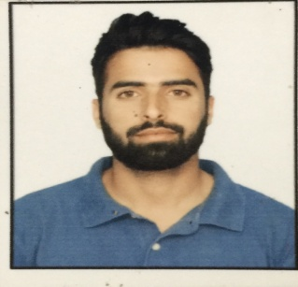**MUBASHIR BASHIR**

Rawalpora Srinagar, J&K, 190005

**Cell Phone:** 9906664263

**Email address:** [mubi1013@gmail.com](mailto:mubi1013@gmail.com)

**CAREER OBJECTIVE:**

Seeking a challenging and innovative position in a firm that will maximize the opportunities for me to implement my skill set and knowledge as well as use my capabilities in the best way possible so that I am able to enrich my skills and aid in the development of the firm I work in.

**PERSONAL INFORMATION**

**Date of Birth:** March 25, 1994 **Place of Birth:** Srinagar

**Civil Status:** Single **Position desired:** Manager

**Nickname:** Furqaan Sofi **Gender:** Male

**Mother:** Gulshan Akhter **Occupation:** Housewife

**Father:** Bashir Ahmed Sofi **Occupation:** Businessman

**Religion:** Islam **Nationality:** Indian

**PROFESSIONAL EDUCATION**

University of Kashmir

MBA in Finance and HR

Year: 2017-2019

NGF College of Engineering and Technology

B.Tech in Electronics and Communication

Year: 2012-2016

DOEACC

Diploma in Basic Computer Application

**SECONDARY EDUCATION**

School: Govt. Boys Higher Secondary School, Jawahar Nagar, Srinagar, J&K

School Year: 2009-2010

**WORK EXPERIENCE**

Supervisor in Zain Electricals, 2016-2017

**INTERESTS**

Supervising, Finance & HR, Telecommunications

**TECHNICAL SKILLS**

MS Excel, MS Word, Networking