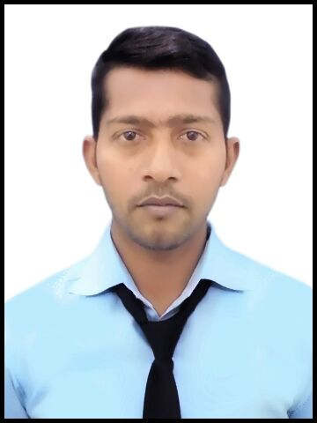
ZAHID USMANI
MECHANICAL ENGINEER
Mobile: +919717918522, 8934992582
E-Mail:usmanizahid296@gmail.com

JOB OBJECTIVE

To associate with an organization that has potential for future growth and ample scope of learning. I would be able to deliver the best of my knowledge and utilise the skill and implement to contribute towards new technologies.

PROFILE SUMMARY

- A keen interest in pursuing career in building Construction power projects.
- Having good knowledge in safety.

WORK EXPERIANCE

Work as SITE ENGINEER (2x660MW) power plant in LANSH ENGG. Pvt. Ltd. from 15th July 2017 to 15 February 2019.
Now working Quality Engineer in GLOBAL SCIENTIFIC SOLUTION from 1 March 2019 to till date.

JOB RESPONSIBILITY
- Supervision and quality control over the entire construction work.
- Discuss technical problems /drawings and execution difficulties with seniors.
- To informing the work every day to day my planning engineer and manager.
- Resolve all site problems.
- Drawing reading and work according to drawing.
- Ensuring that all construction activities carried out in compliance with all code and standards procedures of engineering design.
ACADEMIC DETAILS

- B.Tech (M.E) from college of engineering Science & Technology, Affiliated to Dr. A.P.J Abdul Kalam Tech.
University (UPTU) Lucknow, 2013-17 with Aggregate 76% HONS.
- XII from M A K Azad inter college Rampur Mau UP, 2013 with74. 5%
- X from ST. Xavier's High School Ballia UP, 2011 with 7.2 CGPA.
ACADEMIC PROJECTS

Project Title: Hybrid Rocker Bogie Suspension System.
Duration: 4 Months
Team Size: 4 peoples
Technology/Tool used: Mechanical & Electronic Devices.
Description: Rocker bogie suspension system was specifically designed for space exploration vehicles & first used for Mars Exploration Rover and its currently NASA’S favoured design for rover wheel suspension. The rocker-bogie design has no spring or stub axles for each wheel, allowing the rover climb over obstacles, such as rocks.
Key Learning: Utilising of Mechanical components as per their Specification.
INDUSTRIAL TRAINING

Organisation: Research Development & Standard Organisation (RDSO), Lucknow.
Duration: 4 Weeks
Details of training: Wheel Shelling Problem on LHB Coaches
Learning: To understand the wheels cleaning of defect materials with help of tread cleaning device. The defect characterized by expulsion of pieces of metal from tread surface due to which the wheel tread has developed cracks in the axial directional material flakes have come out in few locations leaving the pit mark on the wheel tread.

SOFT SKILLS

- Creativity.
- Hardworking.
- Good Communication.
- Leadership.
- Adaptability.

HARD SKILLS

- Auto-CAD.
- Power Point presentation.
- Microsoft Word.
- Microsoft Excel.

AREA OF INTEREST

- Playing Cricket.
- Travelling new places.
- Interacting with new people.
- Listening music.
- Playing Carom.
- Adventures.

SOCIAL ENGAGEMENTS

- Class Representative.
- Secured 1st ^{position} in Fashion show at Annual Day celebration.
- Winner of college level carom.
- Hospitality coordinator.
- Best Decorator.

PERSONAL DETAILS

Father name : GULAM HASSAN
Mother name : NOOR AAISHA
Date of Birth : 11th Agust 1996
Address : Vill+PO-DHELAI FIROZPUR MARYADPUR MAU, UP 221602
Language Known : English, Hindi (mother tongue), Urdu
Marital status : Unmarried
Nationality : Indian
Passport No : S6747607
Date of Issue : 14/09/2018
Date of Expiry : 13/09/2028
Place of issue : Lucknow
DECLARATION

I hereby inform that the information in this document is accurate and true to the best of my knowledge.

Place: Delhi ZAHID USMANI
Date Signature

