RESUME

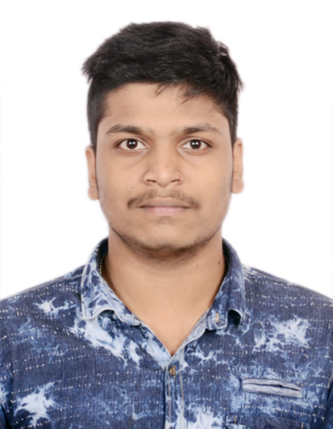

|  |  |
| --- | --- |
| Laxmi Kanta Sahu | *Phone No: 9937828951,9337429899*  *E-mail:sahulaxmikanta321@gmail.com* |

Career Objectives:

"To Explore New Areas Of Work In A Dynamically Stable Organisation"

Educational Qualification:

|  |  |  |  |  |
| --- | --- | --- | --- | --- |
| Name of the course | University / Board / Institution | Principal Subjects | % of marks obtained | Year of Passing |
| HSCE | BSE | FLO, SLE, TLS, MTH, GSC AND SSC | 78.67% | 2015 |
| Intermediate | C.H.S.E Odisha | Science | 58.5% | 2017 |
| BSC | Berhampur University | Chemistry | 8.01 CGPA | 2021 |
| Computer Education | Priyanka Institute Of Vocational Education | Ms office, Intetnet, Account billing payroll and Banking Taxation and Report | 68.25 | 2019 |
|  |  |  |  |  |

Packages :- Fair knowledge in MS-office ,

**Projec****t**

Food Adultertaion

INDUSTRIAL VISIT:

* IIT Bhubaneswar
* Nandankan Zoological park

PERSONAL SKILLS:

* Adaptable and self-motivator.
* Ready to take up challenges and task with enthusiasm.

:-Positive attitude and self-confidence

:- initiator and quick learner.

:- Learner

PERSONAL DETAILS:

Name : LAXMI KANTA SAHU

Mothers name : SANJULATA SAHU

Father's name. : KABIRAJ SAHU

Date of Birth : 16-09-1999

Gender : Male

Nationality : Indian

Material status : Single

Dist. - Koraput

Pin-764001 , Odisha

Permanent address : Dhanvi Township, 3rd lane, House No.87, Dongaguda,Hatapoda, Jeypur, Koraput

Languages : English, Hindi, odia.

Hobbies : Travelling, Movies, Cooking, Photography, Studying

DECLARATION

I hereby declare that the stated information in this resume is to and best of my knowledge.

Date:

Place: Laxmi Kanta Sahu