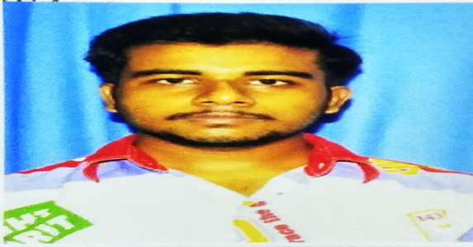 **RESUME**

**ANIKET BAKSHI**

🏠E4-167/B/NEW,HINDUSTAN GAS CO. RD.,BYE LANE-1,PARBANGLA,NUNGI,BATANAGAR,MAHESTALA,24 PGS(S.),

PIN-700140🖀8584080631/9088385017🖄 aniketbakshi99@gmail.com **Date of Birth:-** 27/04/1998

**Objective**

To pursue a challenging career and be the part of a progressive organization that gives scope to enhance my knowledge, skills and learning to contribute to the success of the organization.

**Education Qualification**

Pursuing Bachelor of Technology from Budge Budge Institute of Technology under Maulana Abul Kalam Azad University of Technolgy,West Bengal.

|  |  |  |  |
| --- | --- | --- | --- |
| **Course** | **Institution** | **Board** | **CGPA/Percentage** |
| **B. Tech.(ECE)** | Budge Budge Institute Of Technology | MAKAUT University | 6.8 / 69% ( 5th sem) |
| **Intermediate** | Nangi High School | West Bengal Board | 60% |
| **Schooling** | Nangi High School | West Bengal Board | 69% |

**Technical Skills**

* Programming Language Known: C, C++, Java ,Python,DBMS
* Packages Known: MS Word, MS Excel, MS PowerPoint, Microsoft SQL

**Co-Curricular Activities**

* Participated in Fabrication of Emerging Electronic Devices and System Workshop of BBIT.
* Participated in Technical workshop cum Technical quiz competition of Vani Institute.

**Extra Curricular Activities**

* Participated in Technical Debate Competetion in School and ranked Third on that competition

**Projects Undertaken**

* **Mobile Phone Signal Jammer:** This project is used to jam 4G, 3G and 2G mobile signals. In this project we have used 555 IC, BC547 transister, 7uf capacitor, LED and Resistors. This benefit of this project is that it can be used to jam the signals of mobile phone in the exam hall during exam. It can work for 4G, 3G and 2G signals.

**Hobbies**

* Working on any project in the Group.
* Reading Book.
* Playing Cricket.
* Checking daily technical news
* Checking different types of application

**Languages Known**

* Proficient in English, Hindi and Bengali.

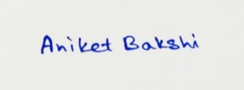

**DATE** : 15/10/2020

**PLACE** :Kolkata