**CURRICULUM VITAE**

* **OBJECTIVE** :
* Looking toward for on opportunity to prove myself as a Suitable candidate for your esteemed organization. Where I can expose my Qualities give my best.

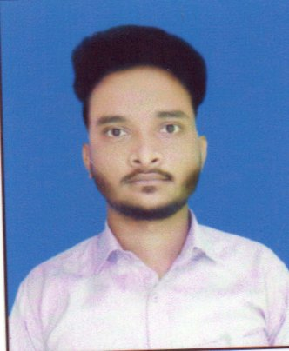**PERSONAL INFORMATION**

***PHOTO***

**NAME : RAMKRISHNA JANA**

**FATHER’S NAME : RAGHUNATH JANA**

**DATE OF BIRTH : 19/09/1993**

**SEX : MALE**

**NATIONALITY : INDIAN**

**RELIGION : HINDU**

**CAST : GENERAL**

**MARITAL STATUS : UN-MARRIED**

**EMAIL ID :** [**ramkrishna.ramu2@gmail.com**](mailto:ramkrishna.ramu2@gmail.com)

**CONTACT NO. : 8967661161**

**MOTHER TOUNGUE : BENGALI**

**LANGUAGE KNOWN : (BENGALI- READ, WRITE & SPEAK),**

**(ENGLISH- READ, WRITE & SPEAK), (HINDI-SPEAK)**

**PERMANENT ADDRESS**

**C/O : RAGHUNATH JANA**

**VILL. : KHASJANGAL,**

**P.O. : ABASH,**

**P.S. : KOTWALI,**

**DIST. : PASCHIM MEDINIPUR,**

**STATE : WEST BENGAL,**

**PIN : 721102.**

**ACADEMIC QUALIFICATION:-**

|  |  |  |  |
| --- | --- | --- | --- |
| **NAME OF THE EXAM** | **BOARD/COUNCIL/**  **UNIVERSITY** | **YEAR OF PASSING** | **% OF MARKS** |
| **MADHYAMIK** | **W.B.B.S.E** | **2010** | **50%** |
| **HIGHER SECONDARY** | **W.B.C.H.S.E** | **2012** | **38.4%** |
| **B.A. PASS** | **VIDYASAGAR UNIVERSITY** | **2015** | **40%** |

**EXTRA QUALIFICATION: CITA,DTP**

**DECLARATION**

I do hereby declare that all the statements in this application are true, complete & correct to the best of my knowledge and belief.

Date:-

Place :- ***(Signature)***