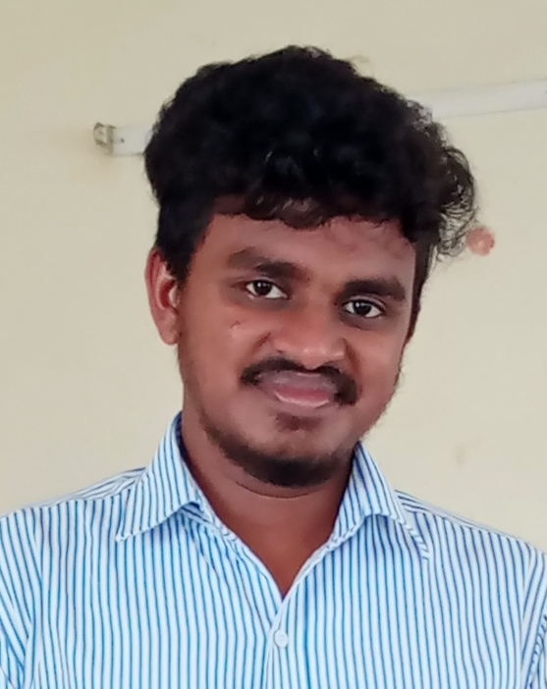
RESUME

SIDDULA LOKESH,
S/o S.VENKATRAO
D.No:5-144 URBAN COLONY,
DAMMAPETA (V),
DAMMAPETA (M), E-MAIL: siddulalokesh@gmail.com
BHADRADRI KOTHAGUDEM. CELL NO: 9700124578

Career Objective

Aim to be placed in challenging organization that gives me scope to update my knowledge & skills in accordance with the latest trends and be a part of team that dynamically works towards growth of organization.

Academic profile

Course | Institution/University | PERCENTAGE | During year/passing of year
B.Tech  (MECH) | Mother Teresa Institute Of  Science And Technology | 77.7% | 2018-22
INTERMEDIATE | VKDVSR JUNIOR COLLAGE | 95.5% | 2016-2018
S.S.C | Board of Secondary Education | 85% | 2015-16

Technical Skills

- BASIC C LANGUAGE
- Auto CAD (Computer Application)

SRENGTHS

- Positive thinking
- Proactive in nature
- Hard Worker

Personal Vitae

- Name In Full :S.LOKESH
- Date Of Birth : 14-08-2001
- Father’s Name : Venkatra
- Marital Status : Single,
- Languages known : Telugu, English,Hindi,Tamil little
- Hobbies : Traveling , Playing Chess, Reading Books
- Address : D.NO:1-166,Model colony, Dammapeta (V)
Dammapeta(m), Bhadradri Kothagudem (D).

Self Declaration

I hereby declare that the above information is true to the best of my knowledge and belief

PLACE: Bhadradri Kothagudem
DATE:
(S.LOKESH)

