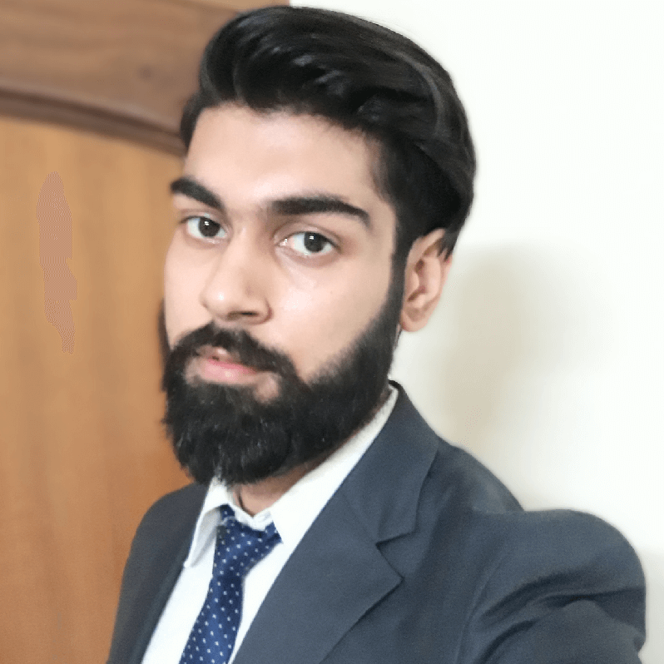 |  |  |  | Dhruv  Sehgal

Career Objective
To work towards sharpening my skills and to achieve organizational and my professional goals.

Abilities
Proven skills in increasing customer engagement and business visibility in online searches through successful SEO approaches. Experienced in developing marketing initiatives, increasing business success and boost sales. Excellent analytical, organizational and decision-making abilities.

Education

Bachelors of Business Administration | Symbiosis Centre for Management Studies, NOIDA (U.P)
- Senior Secondary | Maharishi Dayanand Vidyamandir Sr. Sec. School, Yamunanagar (2013-15)
- High School | Sacred Heart Convent Sr. Sec. School, Jagadhri, Yamunanagar (2013)

Skills
- Website Analysis | - SEO
- Client-focused | - SEM
- Strategic thinker | - SMO
- Competitor Analysis | - SMM
- Computer proficient | - Keyword Research

Experience

SEO Executive | Online Strikers, Delhi

(December 2018 – February 2020)

- Finding On-Page SEO errors.
- Performing Off-Page submissions for a website.
- Collaborated with designers and editorial team on marketing materials.
- Search Engine Marketing (SEM).
- Social Media Marketing (SMM), Social Media Optimization (SMO).

Software/Tools
- Keyword Planner
- Google Analytics
- Google Adwords
- Google Search Console (Webmaster)
- Ms Office(Excel, PowerPoint, Word)

 |  | #21, Chandan Colony, Phase-1, Lal Dwara Mandir Gali  Yamunanagar, Haryana,  135001
 |  | (+91) 7988889364  (+91) 6399000030
 |  | sehgaldhruv52@gmail.com
 |  | Dhruv Sehgal

