ABDUR RAHMAN.K.N. 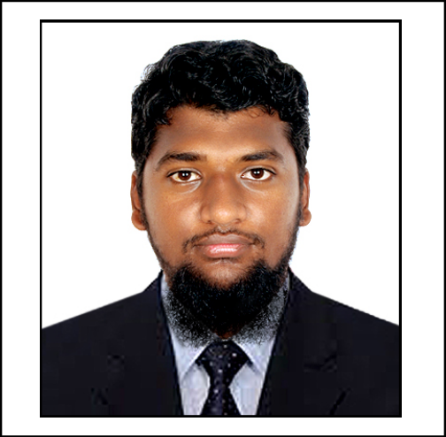

Email: abdur5826@gmail.com

Mobile: +91-8122678044



**CAREER OBJECTIVE:**

To be creative in working and effective in achieving the goals assigned, to help others achieve theirs, to improve my knowledge and skill and strive for perfection and growth of self and the world.

**EDUCATIONAL QUALIFICATIONS:**

|  |  |  |  |
| --- | --- | --- | --- |
| **COURSE** | **NAME OF INSTITUTE** | **YEAR OF PASSING** | **AGGREGATE/ CGPA** |
| B.E. MECHANICAL ENGINEERING | AALIM MUHAMMED SALEGH COLLEGE OF ENGINEERING. | **2018** | **6.7** |
| CLASS XII (STATE BOARD) | ST. ANNE’S MAT. HR. SEC. SCHOOL. | **2014** | **82.16** |
| CLASS X (STATE BOARD**)** | ST. ANNE’S MAT. HR. SEC. SCHOOL. | **2012** | **80.8** |

**ACADEMIC PROJECT:**

**Main Project:**

**Project Title: Performance analysis of coated single point cutting tool in turning operation.**

**Description:** The single point cutting tool is coating with (ZINC and NICKEL) by electroplating process and perform turning in lathe for their performance analysis and life is calculated by using scanning electron microscope (SEM).

**Mini Project:**

**Project Title: Design and fabrication of two axis movable vice**

**Description:** The vice is made to be movable in (X&Y) direction for holding of object to be machined in critical position.

**ACHIEVEMENTS / CO-CURRICULAR ACTIVITIES / EXTRA CURRICULAR ACTIVITIES:**

Completed “**AUTOMOTIVE IMPLANT TRAINING”** associated with “ **INDIAN MOTOR CORPORATION PVT LTD”** held at Nicola educational and research institute.

Completed “**PROTOTYPE MANAGER”** held at National Small Industries Corporation.

**INDUSTRIAL VISIT:**

* INTEGRAL COACH FACTORY (**ICF**).
* ASHOK LEYLAND.
* CENTRAL INSTITUTE OF PLASTICS ENGINEERING AND TECHNOLOGY(**CIPET)**

**COMPUTER SKILLS / KNOWLEDGE:**

AUTOCAD, SOLIDWORKS, CREO

**WORK EXPERIENCE:**

Sales Representative at “**OASIS INDIA A NETWORK PVT LTD”** in Chennai for **5** months.

**PERSONAL PROFILE:**

Father’s Name : NOOR MOHAMED.K.A.

Date of Birth : 18/12/1995

Gender : MALE

Language Known : TAMIL, ENGLISH.

Address : 15/2, IBRAHIM 1ST STREET,

CLIVE BATTERY, CHENNAI-600001.

**DECLARATION:**

I hereby declare that the above particulars furnished by me are true to the best of my knowledge and belief.

Date:

Place: K.N. ABDUR RAHMAN.