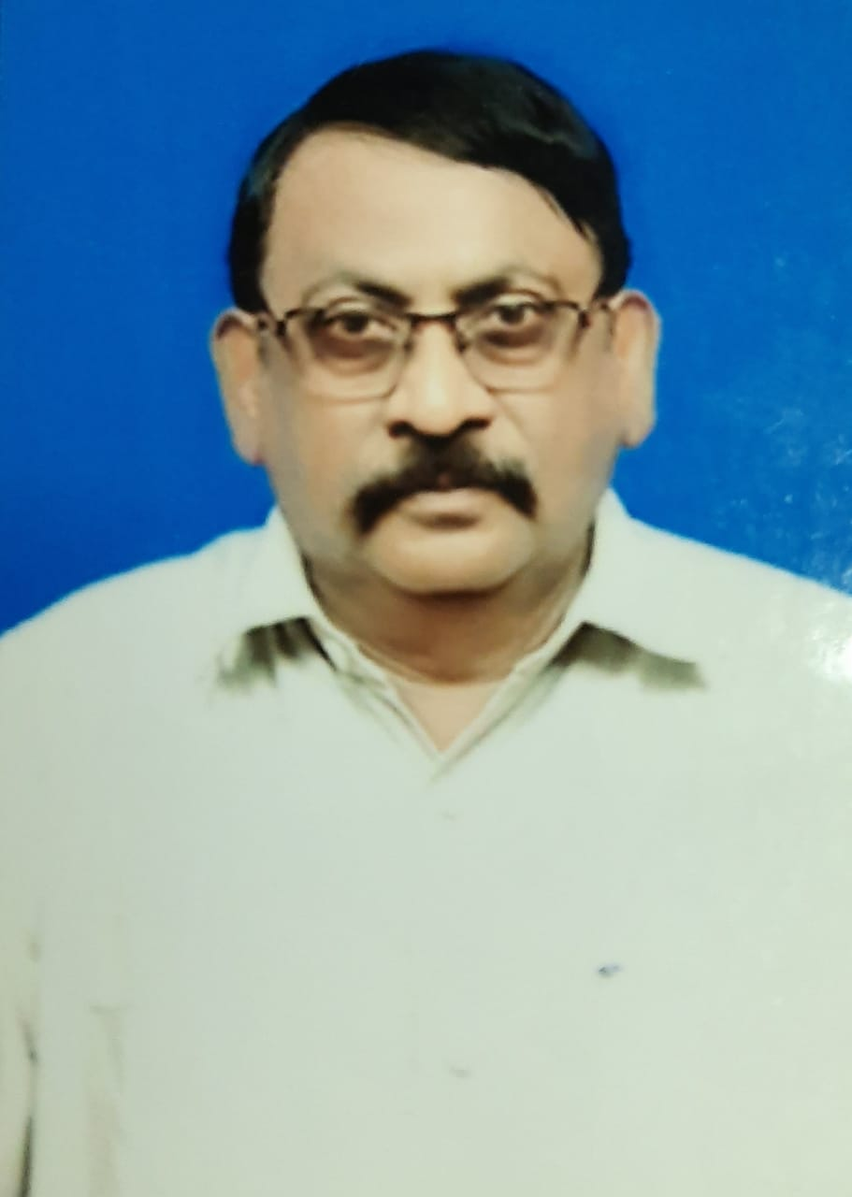 |  | B.L.N.Murthy  Managing Director  Suchalabha Tek LLP.
Profile  Contact  PHONE:  91 9440623604  EMAIL:  bandarumurthyln@gmail.com |  | Qualifications:  B.E (Mech)., F.I.E., C,E .,  WORK EXPERIENCE  Total 42 Years of experience in Cement industries in India and abroad  Panyam cements, Someswara Cements, Suadi Bahraini cement co, Texmaco cements ,Priya cements, Tabuk cements. Madras cements ( From 1974 to 2001 approx. 28 years ) and  Penna cement Industries Ltd. Vice President works  9.5 years (2002–2011)  Bharathi cement Corporation Pvt Ltd. Director -Works  5 Years (2011–2016)  Skills  1 )Green field cement Projects  2) Erection and Commissioning of Cement plant and Cpp.  3) Operation and Maintenance of Cement plant.  4) Modification and trouble shooting in cement plant.  5) Fuel Saving in cement plants  6) Stabilising the plant operations in cement Plant.  7)Design and modifications plant layout .  8) Introduction of Alternte fuels and Municpal solid waste) etc  9).Brouwn Field Cement plants.( Modernisation of Cement plants).  10) Fuel Saving and enhancing th  At Present;  Manging Director,  Suchalabha Tek LLP.

