**ANANYA RAI** 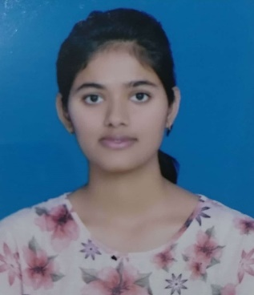

**A**

**R**

Ghazipur Tiraha Sahadatpura near Grihast Plaza Mau UP,275101

9309858602 ,9532878201 arai32524@gmail.com

I want to work in professional environment.

|  |
| --- |
| **Skills**  **Education** |

# Work Experience Intern

07/2020 to Present

TRPWS Virtual Internship

Our NGO is a club formed youngsters whose main motto is social servic. This Non Governmental Organisation (NGO) was formed by a group of young people who wanted to get a change in society.

## Student

08/2018 to 10/2018

HPE Education Services Pune

Programming Techniques using C & C++.There i work in a project.

Project -Student Database

Work as a Marketing & Editorial Head in College Mozilla Campus Club - 2 years

Intermidiate knowledge of Python and oops.

## KENDRIYA VIDAYALA

High school or equivalent

English, Hindi,Science,Maths,Social Science.

Uttar Pradesh

## BVDUCOEP

Bachelor’s

Information Technology

Pune

07/2017 to Present