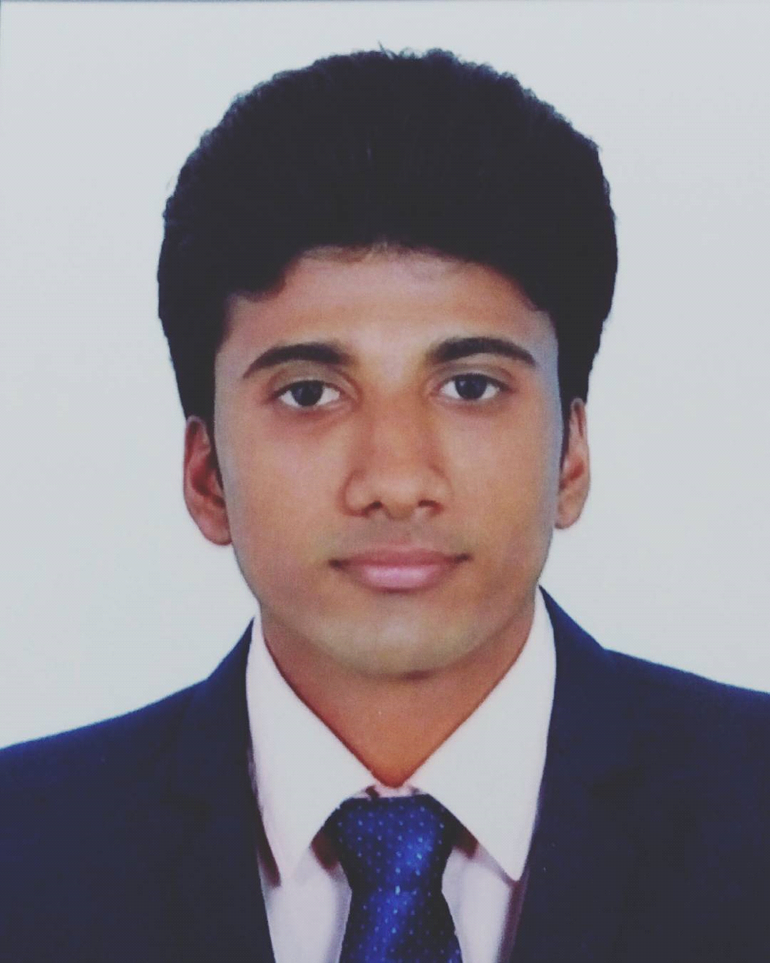

**SHAROOKHAN A S**

**ZAKKEER HUSSAIN NAGAR**

**KANNAMKODE, ADOOR P.O, PATHANAMTHITTA**

**KERALA**

**PIN- 691523**

**GMAIL- sharusharu393@gmail.com**

**+917561848612**

**CAREER OBJECTIVE**

**To work hard with full determination and dedication to achieve organizational as well as personal goal.**

**EDUCATIONAL QUALIFICATIONS**

**\*** Bachelor of commerce, Tourism And Travel Management.

University Of Kerala( 2017-2020)

K.V.V.S College Of Science And Technology, Adoor, Pathanamthitta.

**\*** Diploma in Aviation, Hospitality And Travel Management.

Frankfinn Institute Of Air Hostess Training, Trivandrum( 2017).

* Higher Secondary Education Certificate

Board Of Higher Secondary Examination,Government Of Kerala( 2016).

N.S.S.H.S.S Adoor, Pathanamthitta.

* Secondary School Leaving Certificate

Board Of Public Examination,Government Of Kerala( 2014).

P.G.M Boys High School, Adoor, Pathanamthitta.

**EXPERIENCE**

* Worked as a billing staff in Altemis multi cuisine restaurent for 6 months.

* worked as a Sales officer at Popular Maruti Suzuki sales and service

**SKILLS**

* Communication

* Listening

* Leadership

* Swimming

* Driving

* Travelport Galileo Reservation System Software

* Computer Knowledge

* Fidelio( Property Management Software)

**HOBBIES**

* Gardening

* Listening To Music

* Reading

**EXTRA CARICULAR ACTIVITIES**

* Participated in Cricket,Sub District School Athletics championship

2013-2014

* Cadet of Bharat Scounts And Guides

* Cadet of Junior Red Cross Society

* Member of Social Science Club

* Certificate of participation in Personality Development Camp

Directrote of Minority Welfare,Govt. of Kerala.

* Certificate of Merit for winning the first place in mappilapattu

competition in college

**LANGUAGES KNOWN**

* Malayalam( reading, writing, speaking)

* English( reading, writing, speaking)

* Hindi( reading, writing, speaking)

* Tamil( speaking)

**PERSONAL DETAILS**

Father's name : Abdul Salim

Mother's name : Mrs. Aysha Salim

Religion : Muslim

Nationality : Indian

Date of Birth : 02/01/1998

Gender : Male

Mobile : +917561848612

Gmail : sharusharu393@gmail.com

Driving License No : B9563109

Passport No : P5147810

**REFERENCE**

Place of issue : Pathanamthitta

* The Pricipal

K.V.V.S. College of Science And Technology

Adoor, Pathanamthitta, Kerala. Pin: 691523

* The Head Of Tourism And Travel Management Dept.

K.V.V.S College of Science And Technology

Adoor, Pathanamthitta, Kerala.

**DECLERATION**

I hereby declare that the above particulars are true to the best of my knowledge & believe. If I am offered an opportunity to work, I will discharge the duties entrusted to me to the best of my capacity& to the entire satisfaction of my superiors.

Place : Adoor

Date :

SHAROOKHAN A S