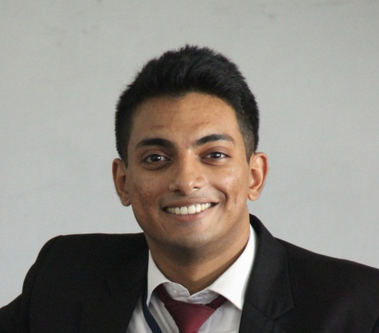

|  |  |
| --- | --- |
| **Abhijit Ghosh**  Contact Number :- **+91 9874449132** | **Address –46a, R.N.Das road, Dhakuria, Kolkata 700031**  Email Id –ajghosh3003@gmail.com |

**Objective:**

To obtain a position that will enable me to use my strong organizational skills and ability to work well with people also to work with a prestigious organization and challenging projects, this enables me to enrich my experience, thus paving a way for my long-term growth and also contribute to the growth of the organization.

**Experience Summary:**

* Worked at **ITC Sonar Bangla as a industrial trainee for 4 month.**
* Working with **Jubilant Food works ltd** under brand name “**Domino’s pizza” as a shift manager** from 14th June 2017.
* Currently Working with **Jubilant Food works ltd** under brand name “**Domino’s pizza” as a Restaurant Manager** from 1st December 2018 till now.

**EXPERIENCE**:

|  |  |  |  |  |  |
| --- | --- | --- | --- | --- | --- |
| **Organization & Designation** | **Tenure** | **CTC(INR)** |  |  |  |
| ITC Sonar Bangla | 4 Months | Industrial trainee |  |  |  |
| “Domino’s Pizza” as a Shift manager | 1year 6months |  |  |  |  |
| “Domino’s Pizza” as Store Manager | currently | 322560 |  |  |  |
|  |  |  |  |  |  |

**Dominos Pizza Experience**

* As Shift manager in Prince Anwarshah road (4 months)
* Transfer to Ajay nagar(4 months)
* Transfer to Metropolis Mall(1 month)
* Transfer to Park Circus(8 months)
* Promoted to store Manager and transferred to City Centre 2 Kolkata(2 month)
* Transfer to Lake Mall(8 months)
* Transfer Chandan nagar(2years 2 months and counting)

**RESPONSIBILITIES:**

* Responsible for daily sales achievement.
* Daily inventory keeping as well as periodical inventory checks.
* Giving all proper staff targets to all the staff.
* Giving Staff Targets & Ensuring Achievement of the same.
* Indenting & Replenishment of Stock from Commissary.
* Generating Reports & Reporting the Same to Supervisor.
* Handling all Administrative Works Relevant to the Store.
* Holding Employee, Customer & Community Connect Activities
* Restaurant Handling
* Monitoring Sales growth.
* Cost line and profit & loss management.
* Taken care of customer service & resolving any kind of issues.
* Taken care of HR related job & responsibilities like interviewing potential candidates and uploading documents for further verification from HR.
* Store management including managing P&L / Budget including sales, shrinkage & expenses.
* Motivation, Training and leadership of team.
* To improve and achieve overall efficiency of the store.  
  Ensuring compliance with company policies, procedures through delegation and supervision.
* To ensure that the Guest receive the best service possible at all times.
* Inventory Control, Cost Control, Shrinkage Control, Operation,   
  Acquiring, Renewing and Servicing Members in the Store.  
  Process and Management Analysis.
* Store Maintenance and Upkeep.
* To ensure that before month end all bills need to update in the   
  Conduct bench marking surveys
* To ensure that before month end all bills need to be updated in the system
* Ensure proper storage and issuance of all food and beverage items.
* Maintain Records of goods ordered and received.

**Professional Qualification:**

|  |  |  |  |
| --- | --- | --- | --- |
| **Year** | **Examination** | **Board/** | **Institution** |
|  |  | **University** |  |
| 2013 | CBSE(XII) | Delhi | B.D.Memorial |
| 2017 | BSc in Food & Hospitality Management(IGNOU) | Govt Owned | IHM(Taratala) |

**Project:**

**ITC Hotels (Sonar Bangla)**  – Visibility Impact in Hotel sector for 4 months .

**Stations worked in** –

1. Housekeeping
2. Room services
3. Kitchen operations
4. FO(Front Office)
5. Laundry

**Generic Skill Set:**

Good communication skills, Proficient in PC skills, Ability to work in teams, Ability to lead a team, Listening skills, Managerial Skills, Analytical Skills.

**Computer Knowledge:**

* Windows package - XP,2003
* MS Office package - Word, Excel, PowerPoint 2007.

**Extra-Curricular Activities:**

* Professionally trained to play cricket.
* Learned to play guitar.
* Riding bikes has always been my stress buster
* Well trained on swimming skills also won 2 medals in such events

**Personal Profile:**

Father’s Name : Anup Ghosh

Date of birth : 30/03/1995

Gender : Male

Languages Known : Hindi, English & Bengali

Nationality : Indian

Hobbies : Playing cricket, guitar and swimming.

PAN No : BTUPG8858G

Adhar No : 764332812523

**References:**

**Declaration:**

All of the above mentioned information has been correctly specified by myself under my conscience .

**Date:**

**Place: Kolkata, INDIA (Abhijit Ghosh)**