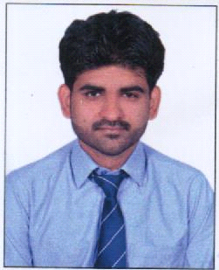

AVLOK SINGH KUSHWAH

Email ID: ab284310@gmail.com

Contact No. +91 8770615553

**Career Objective:**

Seeking for an organization which provides me the opportunity to improve my skills and knowledge to growth along with the organization objective.

**Educational Qualification:**

|  |  |  |  |  |
| --- | --- | --- | --- | --- |
| **Course** | **Institute** | **University / Board** | **Year of Passing** | **Result** |
| MBA  BBA(Honours) | Prestige Institute of Management, Gwalior  ITM University gwalior | Jiwaji University, Gwalior  ITM University gwalior | 2017-19  2013-16 | 75%  74% |
| 12th | DPS Public school Gwalior | CBSE | 2012/13 | 64% |
| 10th | HBEC Kanpur | ICSE | 2010/11 | 61% |

**Computer Proficiency:**

* **OS:** Window 2000, XP, Window7, Window8, Window10

➢ **Packages:** Microsoft Office Word, Microsoft Office Power Point, Microsoft Office Excel.

➢ Internet Browsing

**EXPERIENCE:**

6th Month Experience in Just Dial As A Sales Executive Post.

One &Half year experience in ICICI BANK as a Debt manager…

**Participation:**

* Participated in International conference organised by PIMG.
* Participated in Spandan events organised by PIMG.

**Personal Skills:**

* Self-motivated.
* Goal oriented.

**Hobbies:**

* Listening Songs.
* Cricket
* Football

**Personal Details:**

* DOB : Nov.05.1996
* Father’s Name : Arvind Singh Kushwah
* Languages Known : Hindi & English
* Address : House no 16, Fort enclave near koteshwar temple gwalior..

**Declaration:**

I hereby declare that all the information furnished above is correct to the best of my knowledge.

.

Date:

Place: Gwalior **AVLOK SINGH KUSHWAH**