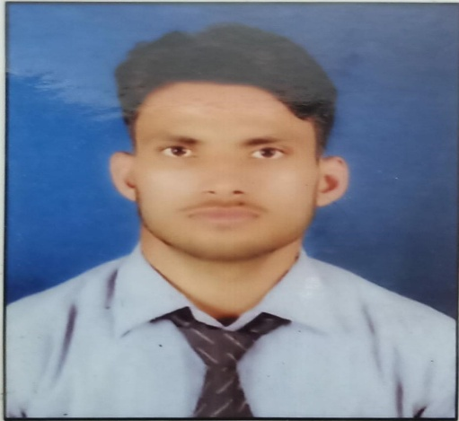**Career Objective**

**KUNDAN KUMAR**

Address :- Vill+Post Baidynathpur

PS – Rosera, Dist – Samastipur

Bihar Pin – 848210

Mobile – 9399487313

Email ID – Kundan.4595@gmail.com

To work in an organization where innovation and excellence is the way of life and I can use my knowledge & skill to produce value added results as well as enhance my skill and career.

|  |  |  |  |  |  |
| --- | --- | --- | --- | --- | --- |
| Sr. No. | Course | College/School | University/Board | Year of passing | Marks Obtained |
| 1. | B.E. ( Electronics and Communication Engineering) | Corporate Institute of Science and Technology, Bhopal | RGPV | 2020 | 7.87  CGPA |
| 2. | 12th | DAV Public School Sector 6 Bokaro, Jharkhand | CBSE | 2016 | 54. % |
| 3. | 10th | St. Xavier’s High School Deoghar, Jharkhand | CBSE | 2014 | 7.4 CGPA |

##### Educational Qualification

**Skills**

* Management Skills
* Basic Computer Skills
* Communication Skills
* Leadership Skills

**Internship & Training**

**1.Bharat Sanchar Nigam Limited, Bhopal**

Training on Tele Communication at BSNL Bhopal

Training Duration: 15 days

* **Summary :** The training topic are more related to telecommunications their lab equipment and related technologies to this domain. The course content may vary depending upon the BSNL training center.
* Electronic worldwide switch Digital.
* National Internet Backbone.
* Main distribution frame.
* Electronic worldwide switch Digital Advanced Technology extended.
* System Advanced Technology extended.
* IP TAX CTX.
* Centre for development of Telematics

**Professional Qualifications**

* Being an Individual, I am a good motivator and an optimistic person.
* High level of team spirit and ability to take up responsibilities and work efficiently.
* Can adapt to any environment with ease.
* Possess good interpersonal, communication and organisational skills with proven abilities and can handle responsibility independently.

**Achievements & Extra curricular activities**

* Visited Central Power Research Institute, Bhopal
* Attended a workshop on PCB Designing at CIST Bhopal
* Attended a STTP on 5G Communication at LNCT Bhopal

**Hobbies**

* Playing Games
* Reading books

**Personal Details**

Date of Birth – 14th Dec 1998

Father’s Name – Mr. Rabindra Narayan Choudhary

Mother’s Name – Mrs. Meena Devi

Martial Status – Unmarried

Nationality - Indian

Sex - Male

**Declaration**

I hereby declare that the above-mentioned information is correct up to my knowledge and I bear the responsibility for the correctness of the above-mentioned particulars.

DATE:

PLACE: **Kundan Kumar**