**RESUME**

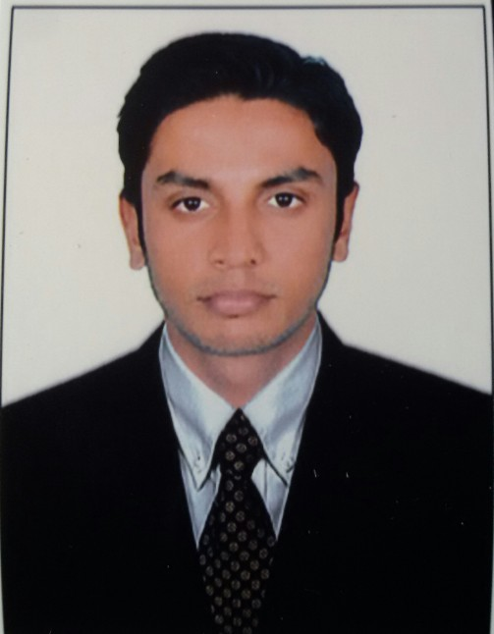

**IMRAN**

Mobile :+919743578979

[imran.his.khan@gmail.com](mailto:imran.his.khan@gmail.com)

Place : Bangalore

**Career Objective:**

A dynamic M.Com professional with more than 4 years of Accounting experience, On MNC Company,To work in a globally competitive environment on challenging Assignments that shall yield the twin benefits of the job satisfaction and a steady paced professional growth.

**PROFESSIONAL EXPERIENCE:**

**ASIA TYRE CENTER in DUBAI: Position held – Accountant - period from 15/12/2016 to 20/03/2019.**

* Controlling Payable and verifying monthly supplier ageing reports.
* Recording invoices in system and Reconciliation of customers & vendors statement of a/c.
* Reconciliation of sales and receipts and reporting discrepancies.
* Issuing Sales Invoice & credit notes.

**Thomson Reuters India Pvt Ltd: Position held –Associate Content Analyst** **Period from 22/09/2014 to 30/09/2016**.

**The job profile includes:-**

* A self-motivated and organized professional with 2 years of experience with Thomson Reuters since September 2014.
* Started off my career as a trainee content analyst
* Promoted to Associate content analyst
* Thomson Reuters is the world leading source of intelligent information for business and professionals.

**Job Responsibility:**

* Analysis of Financial reports of the companies (Press Releases, 10Ks and 10Qs, etc) and updating I/S, B/S, C/F and other relevant data into the product.
* Segmental and Geographical analysis of the revenue, expenses and net income of the company.
* Capture share related data, like types of shares, public or private, par value, voting rights & insider share holdings etc.
* Analyzing the effects of any right issue, share consolidation and splits on the current share and dividend per share.
* Converting from local currency to Companies functional currency by using exchange rate for all statements financials.
* Identifying US, IFRS and GAAP, updating Financials according to the GAAP.
* Building new Private and Public Company with summarized financials (profiles) and giving information on pre & post IPO.
* Analysis of OM (Operating Matrix) reports of the companies for the Global Markets and capturing the OM data by research.

**P.Chandra Mohan Hande Charted Accountant Office:Position held – Accountant / Audit Assistant - period from 1/4/2011 to 30/06/2012.**

**Roles & Responsibilities:**

* Preparation of clients -Trial Balance, Profit and Loss a/c and Balance Sheet.
* Recording invoices in system and Reconciliation of customers & vendors statement of a/c.
* Controlling Pre-payment Schedule.
* Reconciliation of various General Ledger account.
* Generating customer statement of account and forwarding to the related party.
* Posting and generating Collection & Sales Reports.
* Reconciliation of sales and receipts and reporting discrepancies.

**Education Summary**

|  |  |  |  |
| --- | --- | --- | --- |
| **Curriculum** | **Institution** | **Yearof Passing** | **Class** |
| **MCOM( Finance)** | Canara College, Mangalore | 2014 | First |
| **BCOM(Finance)** | Govt. First Grade CollegeThenkanidiyoor, Udupi. | 2012 | Second |

**Computer Skills**

* Accounting Software : Tally ERP9,
* Operating System : Microsoft Windows,
* Database : MS Access, Outlook, Word, PowerPoint
* Office Suite : MS Office, Excel.
* Other Software : TRF, DO+. Excellence.

# PERSONAL INFORMATION

Name : Imran

Date of Birth : 19-9-1990

Gender : Male

Father’s name : Mohammad Hanif

Marital Status : Single

Languages : English, Hindi, Kannada, Malayalam, Tulu

Nationality : Indian

Permanent Address : Ibrahim Manzil, Santhosh nagar,

Karamballi, kunjibettu Post, UDUPI

PIN - 576102

**Declaration** –

I hereby declare that all the above information mentioned is true to the best of my knowledge.

**Date:**  **IMRAN**

# 