**RESUME**

**Mohit Verma**

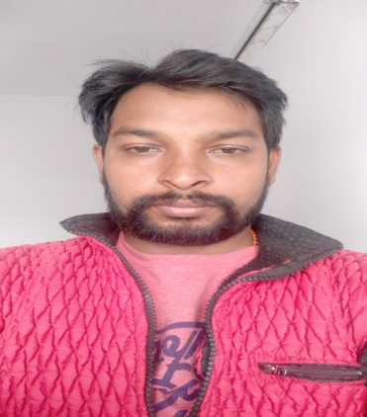

**Add-** Rahamat Nagar Po. Amethi Dist Lucknow

**Ph.** 8299297184,8308400082

**Email : mohit7785mode@gmail.com**

**Qualification**

* I have done High School And Intermediat Completed From U.P board
* B.C.A two years Auncompleted.

**Computer Knowledge**

* Two years B.C.A Corce Completed From Sikkim manipal
* ADCA

**Life Skills**

* Good Communication
* Computer Knowledge

Experience

* G.F.K Mode Pvt. Lmt. Five Years.
* IMRB Pvt.Lmt.2 years
* Modulus research 1 year

Personal Detail

* Name Mohit Verma
* Fathers Name Mr. Ramsumiran Verma
* Mothrer’Name Mrs. Meena Devi
* Sex Male
* D.O.B 06/02/1993