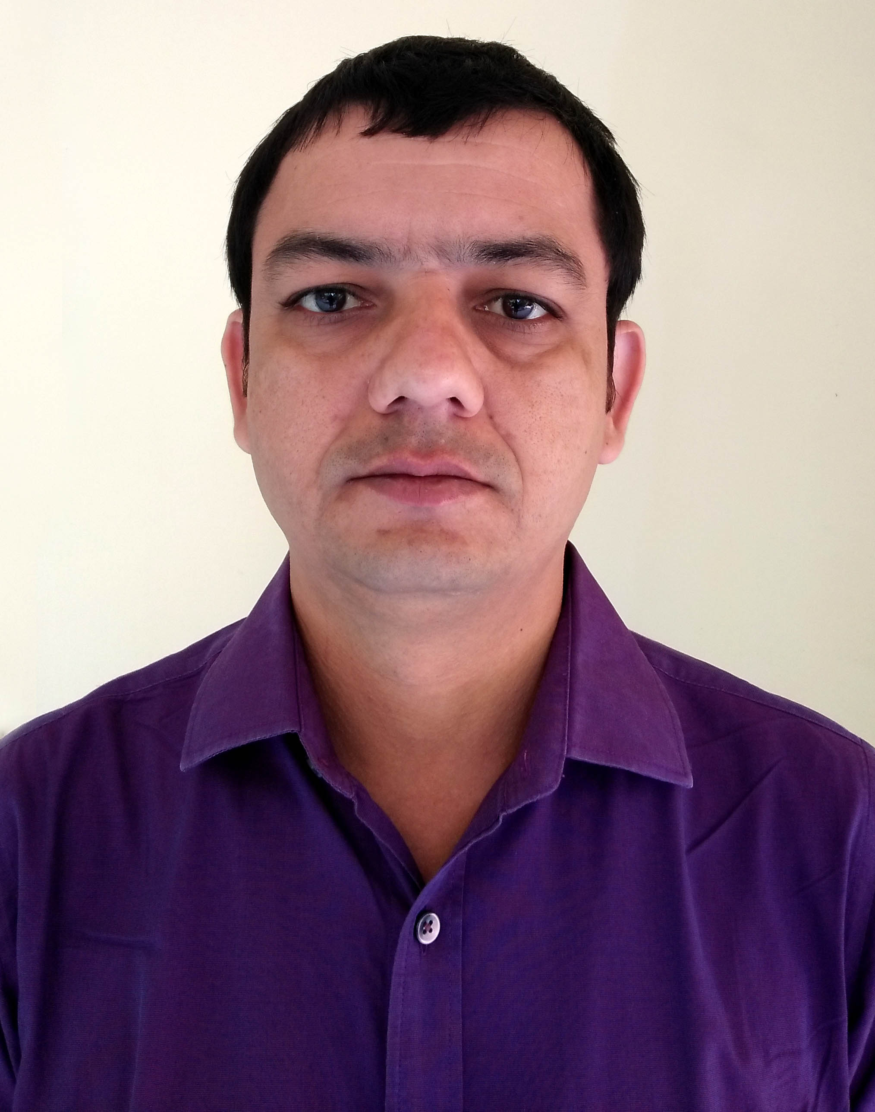
Lokesh Mishra

Mailing Address:
House No. 62, R K Puram, Phase - 1
Tajganj, Agra, U.P. (INDIA) PIN: 282001
Contact: +91 9899697037
E-mail:lokeshjee@gmail.com
Objective:
Being in the field of Marketing since last 10+ years I have always tried to benefit the company by utilizing my skills and strengths. I have subsequently learnt many essential skills at every level of my professional career. Here at your organization, I want to use my skill further to enhance the profitability of the company as well as my professional career and economic growth.

Key Skills:
- OOH Media planning and retail branding at rural, urban, town, cities and metro cities.
- Motivate the co workers and demonstration of leadership quality.
- Strong presentation and negotiation skills.
- Strong Public Relation (PR) with Distributors, Dealers, Advertising Agency, Vendors, Researchers and other Professionals.
- Quality oriented within the given time line.
- Ability to analyze company needs and develop appropriate courses of action.
- Ability to plan, initiate, executes and concludes the company need within the budget.
- Positive interpersonal skill with captivating qualities.

Major Client Handled:

- Dixcy Textile Ltd. : UP, UK, OD, MP, CG Bihar & Jharkhand
- Lancer : UP & UK
- Medimix : UP, UK, Delhi Bihar & Jharkhand
- Samsung (Cheil) : UP (W) & UK
- RSPL – Namaste India : Delhi
- Telenor : UP (W) & UK
- Whirlpool : UP (W) & UK
- V Mart : UP, UK, OD, Delhi & Bihar
- Mankind : UP (E)
- Vectus Industries Ltd. : UP, UK & Delhi
- @home Store (Neelkamal Ltd.) : Delhi NCR
- Prime Mart : Delhi, UP & UK
- Binani Cement Limited : UP, UK & Bihar & Jharkhand
- UTL Solor Power : UP, UK, Haryana, Rajasthan & Punjab
- Idea : UP (W) & UK, Bihar & Jharkhand
- Sakarni Wallputti : UP (E & W)
- Emami : New Delhi, UP (E & W), Haryana, Punjab & Rajasthan
- And many more clients ………

Work Experience:

APN Solar Energy Pvt. Ltd. – Agra, Manager – Planning & Marketing (01 Dec 2020 – Till Date)

- Communicated with client and account executives in order to understand client’s needs and expectations.
- Successfully built new business through effective planning and implementation.
- Presented best plans that meet the budget of clients.
- Researched target audience with their habits and lifestyles in all the sectors.
- Worked with Agencies and Distributors to discuss on cost in urban as well as rural area.
- Research and analyze markets, trends, and other national and local demographic, geographic, and psychographic specifications.
- Managed existing partners and developed strategic business partnerships.

Retail Effects – Delhi NCR, Manager – Planning & Marketing (01 Feb 2015 – 30 Nov 2020)

- Communicated with client (Mankind, Dixcy Textiles, Telenor, Idea, Medimix, RSPL etc.) and account executives in order to understand client’s needs and expectations.
- Successfully built new business through effective design and implementation of strategic marketing and branding plans (Rural Activities).
- Presented best plans that meet the budget of clients.
- Researched target audience with their habits and lifestyles in all the sectors.
- Worked with media buyer to discuss on cost and book advertising space in urban as well as rural area.
- Trained and mentored performance of new advertising media (Wall-wrap etc).
- Developed an advertising media training manual for the company.
- Worked with the creative teams Completed project within deadlines and budget set by client.
- Research and analyze markets, trends, and other national and local demographic, geographic, and psychographic specifications.
- Managed existing partners and developed strategic business partnerships.

Innovative Creations - New Delhi, Marketing Manager (Oct 2007 – 31 Jan 2015)

- Category & consumer analysis.
- Agency handling & yearly ATL planning.
- Developing creative BTL activity plans to support secondary targets.
- Managing BTL (Events, canopies, on ground activities) executions.
- Involvement in formulating marketing plan to achieve strategic goal.
- Handling launches campaigns & penetration campaigns.
- Extensive market visits to do market researches & identify gaps.
- Managing marketing collaterals.
- Regularly Interact with competitors.
- Responsible for region specific marketing activities and consumer centric brand building through Innovation, Trade Marketing (like in shop , POP ), rural and urban activities.
- Work with client personnel to identify and deliver new/innovative BTL support material/activation.
- Creating vendor base who are ready to work & grow under company policies.

Academic Profile:

- Bachelor of Journalism and Mass Communication, Advertising (BJMC) from Institute of Professional Studies, Ghaziabad, U.P. (C.C. Singh University, Meerut).
- Senior School Examination from Sarvodaya Boys SSS No. 1, Jheel, Khuranja New Delhi in year 2003 with CBSE Board.
- Secondary School Examination from SLS DAV Public School, Mausam Vihar, New Delhi in year 2001 with CBSE Board.

Professional Qualification:

- Diploma in Multimedia, AMS, Graphic Designer (Specialization in Advertising) from Arena Multimedia, Preet Vihar, New Delhi.

Hobbies And Interests:

- Sports such as Hockey – Athletes - etc..
- Travelling – Driving – Photography – Mobile – Laptop

Extra Curricular Activities:

- Participate in “North Zone Hockey Tournament”, Hissar, Haryana (INDIA) 2001.
- Participate in “50th JAMBOOREE” Chennai 2000 organized by Bharat Scout and Guide.
- Won “RAJYA PURASKAR” from Delhi State for Best Scout of the Year 1998-99.
- Participate in “Inter Zone Hockey Tournament” in year 1999 and 2000.
- Participate in “Hans Raj Hockey Tournament” in year 1999 and 2000.
- Participate in “Zonal Athletes meet” in year 2001-02 with IInd Position.
- Participate in “SAARC JAMBOOREE” Khurda, Orissa (INDIA) 1998 organized by Bharat
Scout and Guide at International Level.

Personal Information’s:

Father Name : Mr. Lalan Kumar Mishra
Date of Birth : 08th Oct 1985

Nationality : Indian
Sex / Marital Status : Male / Married
Language Proficiency : English – Hindi

Declaration:
I hereby declare that the particulars furnished information‘s above are complete and correct to best of my knowledge & belief.

Place : AGRA
Date : (Lokesh Mishra)

