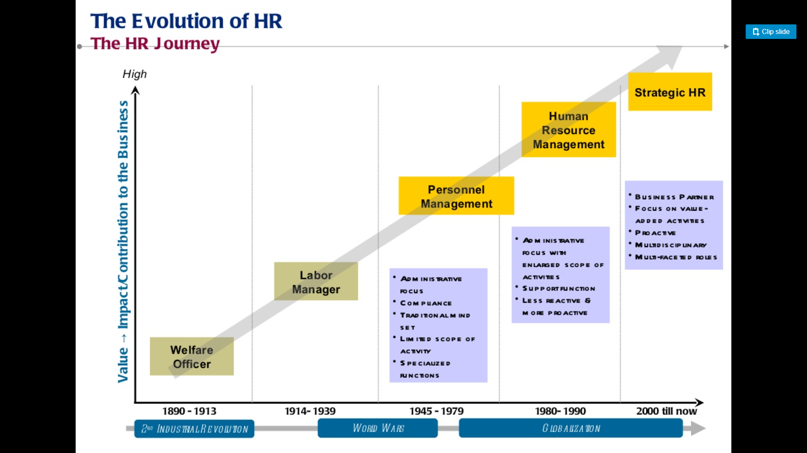

<https://husys.com/blogs/what-are-the-hr-solutions-at-current-scenario/>

<https://www.selecthub.com/hris/hr-trends/#:~:text=The%20presence%20of%20AI%20doesn,on%20offering%20guidance%20in%202020>.

<https://www.game-learn.com/10-trends-that-will-shape-the-future-of-human-resources/>

<https://www.gartner.com/smarterwithgartner/future-of-work-tops-hr-priorities-for-2020-21/>

<https://www.inc.com/jacob-morgan/what-does-future-of-human-resources-look-like.html>

<https://home.kpmg/xx/en/home/insights/2019/11/the-future-of-human-resources-2020.html>

Technology