**Akshitha Anirudh**

**Mobile No.:** +91 98094 19832 ~ **E-Mail: aanirudh21@gmail.com**

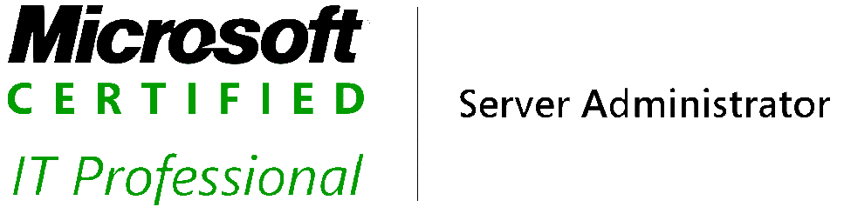



***Seeking assignments in IT domain of Exchange, O365, Windows Server and Active Directory with a growth oriented & reputed organisation as a Technical Administrator***



**PROFESSIONAL ABRIDGMENT**

* ***An astute professional with a rich experience of 6+ years in IT industry.***
* Currently associated with ***Hexaware Technologies, Chennai as a Service Desk Team Lead.***
* Expertise in handling ***Multiple issues predominantly in Microsoft applications such as Active Directory, Exchange server and Office 365 along with other issues with Printers, VPN Login, etc.***
* Conversant with Tier 2 and Tier 3 team to coordinate and resolve technical issues.
* A proactive planner with dexterity in identifying and adopting emerging technologies to achieve organisational objectives and KPI norms.
* Proficient in building and maintaining relations with Team members, Management and Client.
* Demonstrated abilities in handling challenging issues related to multiple technical platforms.
* Excellent communication skills and an ability to communicate technical directions in simple, clear language.
* Customer service focus and an understanding of delivering to agreed customer requirements.
* Ability to quickly build rapport and to treat people with empathy and patience.
* Ability to work as part of a team and to share knowledge to support and improve service delivery.
* Ability to be positive and actively encourage and mentor others within the team.

**CAREER CONTOUR**

***June’17 – Jan’20 Hexaware Technologies, Chennai Associate Software Engineer***

***Jan’20 – Till Date Hexaware Technologies, Chennai Service Desk Team Lead***

***Key Role as an Agent:***

* Resolving and fulfilling incidents and requests routed to Service Desk from internal staffs.
* Providing IT support for multiple technologies mostly Microsoft to a wide user base.
* Handling incoming telephone calls, emails and self-service Incident/ Request tickets.
* Ensuring all actions, conversations and work are recorded/ documented in the IT Service Management Tool-Service Now
* Use various knowledge bases for known errors and work around to aid diagnosis and resolution.
* Create Knowledge base in case an issue is reported which is reported for the first time and does not have any KB support.
* Escalate the incidents/ Requests to the appropriate Tier 2 and Tier 3 support teams if the same is not under Tier 1 authority and requires investigation on Server end.
* Providing On-Job (or) Classroom Training to new team members depending upon their previous experience and exposure.
* Handling critical issues such as P1, P2 and Spam email issues.
* Providing Delegate permissions, Calendar permissions, Email forwarding, O365 license assignment on O365 portal.
* Creating New users, disabling existing users or any modification on both AD and Exchange On-Premise console according to type of requests from HR/ Management.

***Key Role as Lead:***

* Responsible for managing the operation of the Service Desk.
* Leading incidents and requests to resolution.
* Developing Service Desk process and workflows
* Providing and developing communication plans to customers
* Providing on call support
* Contributing to the Change Management Process
* Interaction with clients through everyday meetings to discuss any open items, SLA targets and SD performance.

***Key Areas:***

* Manage and co-ordinate the processing of incoming calls / tickets to ensure courteous, timely and effective resolution of incidents and requests
* Develop and implement ticket handling and escalation policies and procedures.
* Develop and implement team and inter-team workflow processes
* Lead, co-ordinate and allocate incidents and requests
* Be an escalation point and provide co-ordination and support for the Service Desk during high severity incidents
* Provide communication to customers in preparation for planned work and unplanned outages
* Raise and work with other team leaders on resolving reoccurring incidents / requests
* Ensure processes are carried out in accordance with agreed standards or procedures
* Provide reporting on call volumes and incident trending within the Service Desk and wider IT Team.
* Contribute to Service Level reporting to Management
* Lead team planning, decision making and service improvement activities
* Implement service improvement ideas.
* Lead local Change Management meetings when required as a backup to the Change Manager.
* Contribute to the Change Management Process.
* Evaluate employee job performance, through goal setting and performance appraisals.
* Be a focal point for the team for communication and issue identification, resolution and escalation
* Provide technical mentoring and coaching of team members where appropriate.
* Lead Service Desk Team Meetings.

***Feb’15 – Nov’15 CSS Corp Private Limited, Chennai Application Engineer***

***Key Role:***

* Handling customer queries / issues through Voice (International) transactions to the best of customers’ satisfaction.
* Ensuring adherence to standard operating procedures as designed by the process and the organization.
* Awareness of relevant service levels and meets goals set by the project.
* Providing code assistance to the support engineers for complicated and high priority issues which have not been escalated.
* In-depth analysis of issues raised by end users and the support engineers working towards the resolution until closure.

***Oct’11 – March’13 Educomp Solutions Limited Smart Class Coordinator***

***Key Role:***

* Smart Class Coordinator deals with coordinating teachers to use the Smart Class effectively
* Provide technical and academic support.
* Monitoring and administration of local network and server
* Reporting and solving of hardware and network issues ASAP
* Coordinate on tracking status, providing updates & resolution confirmation
* Maintain and Monitor Reports.
* Escalating issues to specialized support groups for complex technical issues.
* Report to the Academic Support Group Manager.
* Understanding problems & providing end user solution.

***Feb’10 – March’11 Data Computer Education Teaching/ Lab Instructor***

***Key Role:***

* Providing practical and theory training to students in Microsoft platform
* Administration and Monitoring of local network.

**SCHOLASTICS**

2014 **BCA, Modern Group of Institutions (Affiliated to Dr C.V. Raman University)**

2012 **RHCE V6, CMS Computer Institute, Trivandrum**

2005 **XII A.S.H.S.S Parippally, Kerala – 78%**

2003 **X St. Jude H.S.S Kollam, Kerala – 81%**

**COMPUTER SKILLS**

* Proficiency in MS Word, Excel and fast enough to adapt to implemented application in the Company.
* **MCITP**: Server Administrator, Active Directory and Infrastructure

**PERSONAL DOSSIER**

**Date of Birth:** 21st January’88

**Permanent Address:** Kodimoottil house, Paripally (P.O), Kollam- 691574.

**Languages Known:** English, Malayalam, Hindi and Tamil.

**Current CTC:** 3.74 l p.a

**Expected CTC:** 7.0 l p.a (Negotiable)