Shikha Chaudhary  Address: Village- Girdhar patti, Post- Bariyawan,  Akbarpur Ambedkar Nagar,224210  Mobile: 9651891526  E-Mail: shikhachaudhary526@gmail.com | 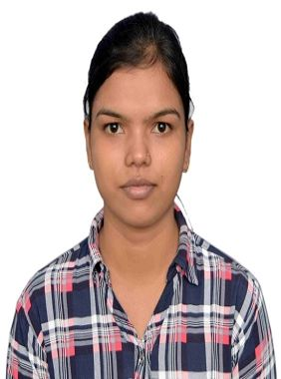

Career objectives:-
- To seek dynamic and challenges career an organization strives for excellence with my knowledge and team effort while making positive contribution to promote the individual opportunity and professional growth.
Qualifications:-
S. No. | Standard | Passing year | Board/University Name | percentage
1. | High School | 2014 | U.P. Board | 90.5%
2. | intermediate | 2016 | U.P. Board | 84%
3. | B.Tech | 2020 | A.P.J. Abdul Kalam Technical University | 69.14%

Technical Skills:-
- C language
- HTML
- CSS
- Javascript
- Python
- Microsoft office
- Microsoft word
- Microsoft excel
Project:-
- Project on “Automatic path sensing machine” (Approved by – IIT BHU, Varanasi).
Summary:- Fully automatic machine for obstacle avoiding and following a specified path.
Internship:-
- Cloud computing and Internet of Things using Raspberry Pi
June 19 – July 19 2019
From: IIT BHU Varanasi
Training:-
- C Programming
June 4 – July 4 2017
From: UPTECH COMPUTER CONSULTANCY LTD. (LUCKNOW)
- Image processing computer Vision and Application
March 5 – March 9 2019
From: Rajkiya Engineering College, Ambedkar Nagar
- Android Application Development
Sept 30 – Sept 30 2019
From: IIT BHU Varanasi

