**Harsh Maheta**

***Sr. Graphic Designer***

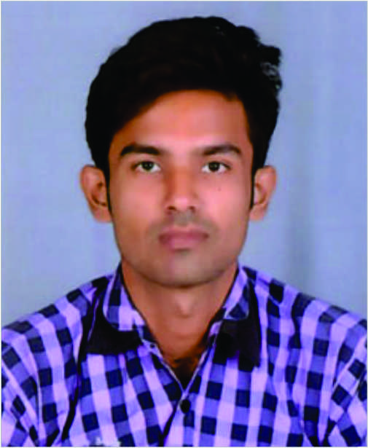

**OBJECTIVE**

To have a growth oriented and challenging career, where I can contribute my knowledge and designing skills to the organization and enhance my experience through continuous learning and teamwork.

**TECHNICAL SKILLS**

Adobe Photoshop, Adobe Illustrator,

Corel Draw, MS Office, Marketing

Social Media marketing

**PROFESSIONAL SKILLS**

Problem solving ability, Marketing knowledge, Print knowledge, Digital design knowledge, Social media & networking, Flexibility &

Time management.

**PERSONAL TRAITS**

Leadership Ability, Team handling, Management & Mobilization skills

**EXPERIENCE**

**Senior Graphic Designer, DTP Operator & Marketing Executive**

**MOSAIC WORKSKILLS PVT.LTD. INDORE (M.P.)**

**2015 to Present**

This is the leading organisation with lots of Govt. & Academic Projects. I started my career in Mosaic as a DTP operator and also support the marketing team for collaterals and branding and now working as Graphic Designer and also support Social media team.

**PROJECTS**

**PMKVY 1.0 & 2.0**

As from my joining I started working on the designing work

which is related to designing layouts, producing images, and developing styles for websites & social media advertisements.

**Project Links**

<https://www.facebook.com/mosaicworkskills/?ref=br_tf>

<http://www.mosaicnetwork.in/featuredcourses.html#pmkvy>

**Project Details**

**PMKVY - Pradhan Mantri Kaushal Vikas Yojana**

2015 – Present

* Responsible for all marketing works (Branding, Advertising, Mobilization, Admission, Data Collecting)
* Handle the admission process with mobilization team
* Responsible for all the marketing collaterals
* Develop the advertisement section
* Collaborate with digital marketing team for online promotion

**DDUGKY - Din Dayal Gramin Kaushal Yojana**

2016 – Present

* Responsible for all the Marketing Work (Branding, Advertising, Mobilization)
* Collaborate with the Marketing team for Branding purpose
* Handle the process of Online marketing

**PERSONAL PROFILE**

Father’s Name

Mr. Rajendra Maheta

Mother’s Name

Mrs. Sandhya Maheta

Date of Birth

28-04-1993

Gender

Male

Marital Status

Unmarried

Language Known

English & Hindi

**HOBBIES**

Photography & Playing Sports

(Cricket, Lawn tennis,

Badminton, Etc.)

**EDUCATION**

**MASTER OF BUSINESS ADMINISTRATION**

DAVV University – 2016 – 2018

**BACHELOR OF BUSINESS ADMINISTRATION**

DAVV University – 2012 – 2015

**HIGHER S. SCHOOL**

MP Board University – 2012

**HIGH SCHOOL**

MP Board University – 2010

**CERTIFICATION**

**DIPLOMA**

**ARENA ANIMATION INTERNATIONAL PROGRAM**

2013 – 2016

**CONTACT**



Hmharshmaheta1993@gmail.com



+918602675477

+918319389933

**Resident -**

180, Moti Bunglow,

behind Darji Dharmashala,

Dewas (M.P.) – 455001 – India

**HARSH MAHETA**