Kiran Jat  Vadodara, Gujarat  +91 7698242797  jatkiran2034@gmail.com | 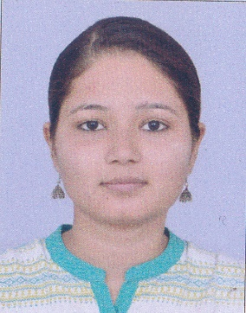
Career Objective:
I have involved in all phases of software engineering, seeking for an opportunity to work in a challenging environment to prove my skills and utilize my knowledge & intelligence in the growth of the organization.
Technical Skills:
- Programming Languages : Core PHP, Java Script, AJAX, Jquery, HTML, CSS
- Query Languages : SQL
- Database : MySQL, Oracle
- Operating System : Linux, Windows, Android
- Framework : Laravel
- LMS : Moodle
- Payment Gateways, Adobe Connect Api Integration
Work Experience:
- Internship
At Aimaces, Akota.
Duration – 4 months
From January 2018 to April 2018
- Currently Working
  - At Webmyne Systems Pvt Ltd., Alkapuri
  - From July 2018 to Present Date
Academic Qualification:
Course/Degree | Board/University | Percentage | Year
M.C.A. | The Maharaja Sayajirao University, Baroda | 60.8 % | October 2015 –  April 2018
B.C.A. | Shreemati Nathibai Damodar Thackersey Women’s University(S.N.D.T.) – Mumbai | 61.72% | July 2011 - April 2014
H.S.C. | Gujarat Secondary & Higher Secondary Education Board, Gandhinagar | 68.8% | March 2011
S.S.C. | Gujarat Secondary & Higher Secondary Education Board, Gandhinagar | 56.15% | March 2009

Projects:
- EDUSITY
Duration: Mar 2019 to Present (Full Time)
Technology: Laravel
e- Education system OR LMS (Learning management system) online webinar sessions for courses and offline courses, paid course, free course, Teachers, Students and Parents
Check out: https://www.edusity.com/

- Developing APIs (Moodle LMS)
For: Helix Oppotunity institute (Onsite)
Dec 2018 to Mar 2019 (Full Time)
Technology: Moodle LMS
Developing Moodle based APIs for Angular Based Front End (LMS)
http://www.helixopp.com/
https://www.youtube.com/watch?v=UdixOaA5vIs

- Book Commentary System
Duration: Sep 2018 to Dec 2018 (Full Time)
Technology: PHP (In MVC Structure)
Reviewer and Author interaction through reviewing books. Reviews author books, Feedback, Rating
https://www.thebookcommentary.com/

- Copy HotSpot
Aimaces (vadodara : Offsite)
Duration: Jan 2018 to Apr 2018 (Full Time)
Technology: Core PHP
The main idea was to put all the printing shops at one place(named copy hotspot), so that they can serve better, fast and targeting major number of customers, by printing stuffs like Thesis, Journals, Notes, Books, etc. and delivered at their customers place.

