D E E PA K V E N U G O PA L
G r a p h i c A R T I S T

Kadannampatta Sanjeevani (HO)
Nr. Veterinary Hospital Cherakkaparamba (PO) Malappuram Dist Kerala, India
679321

E D U C AT I O N S
2007 - SSLC
2007-2009 - HISHER SECONDARY
2009-2011 - TTC
2011-2014 - Bachelors Degree (BMMC) 2018 - Diploma in 3D Animation & VFX

SKILLS AND PERSONAL QUALITIES

Learning & Problem Solving Time management
Team work
Project management & Coordination

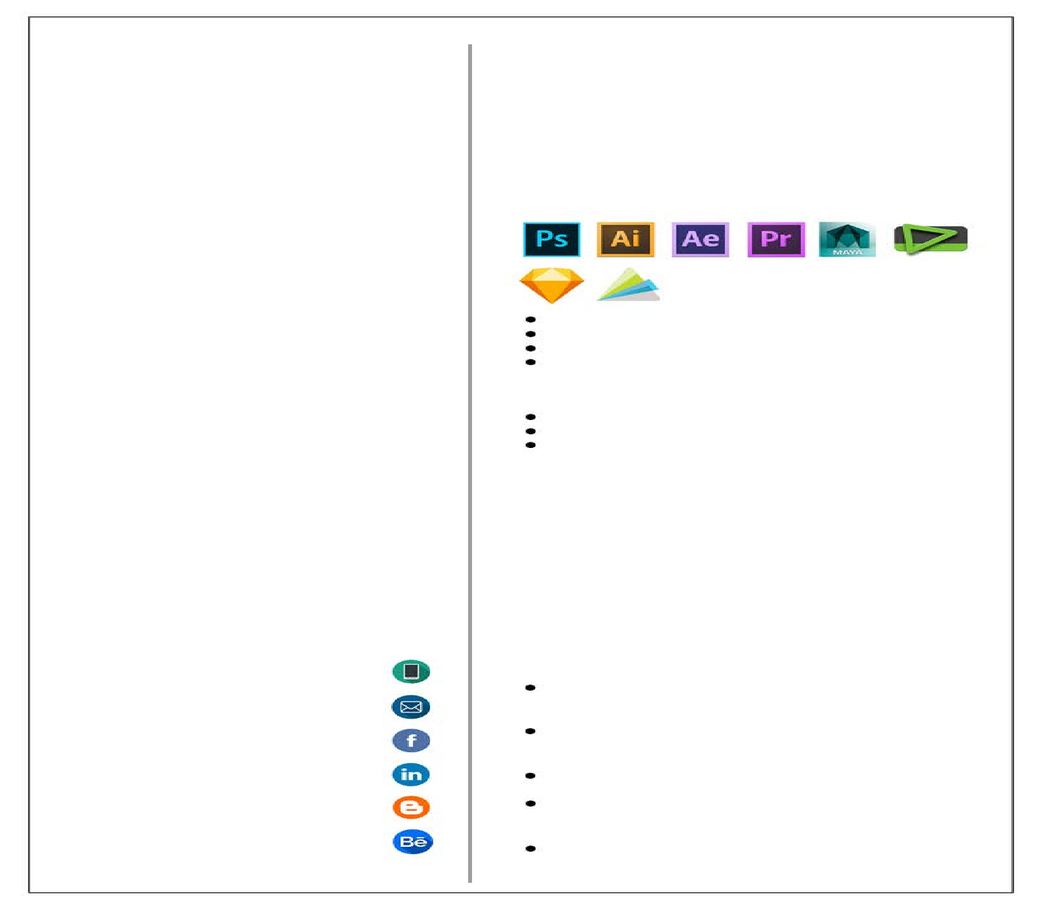
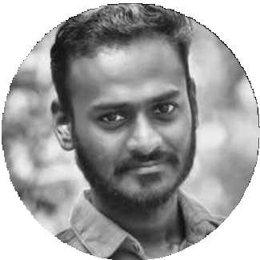
D.O.B: 16.February.1992 Nationality: Indian Gender: Male
Marital Status: Single Blood Group: O+ve Passport Number: L9931371

O B J E C T I V E
To find a job as a Graphic Artist to improve skill in creative technology and to maximize my skills by giving my contribution to the company as much as I able to give.

Phone
(+91) 9633996728

Email
deepusanjeevani@gmail.com

Facebook
facebook.com/deepusanjeevani

Linkedin
linkedin.com/in/deepak-venugopal-12280a33/

Blog
8mpclicks-deepakvenugopal.blogspot.in

Behance
behance.net/deepusanje1992
Graphic Designing
M.S Office Web Designing

Designing, Reading E-Books, Playing Games, Surfing Internet, Travelling, Exploring

English, Malayalam, Hindi

Still Photography, Videography, Data Entry

E X P E R I E N C E
As an Audio/Video Editor in
U cube channel Perinthalmanna

As a Transaction Processor at Conduent Inc. at Infopark, Kochin.
Doing freelance designing works. Worked as a 2D Compositor in
Next Education Ind. Pvt. Ltd, Hyderabad

Working as a Graphic Designer in Al-Farhan Printers, Barka, Oman

