**SMITA TRIPATHI**

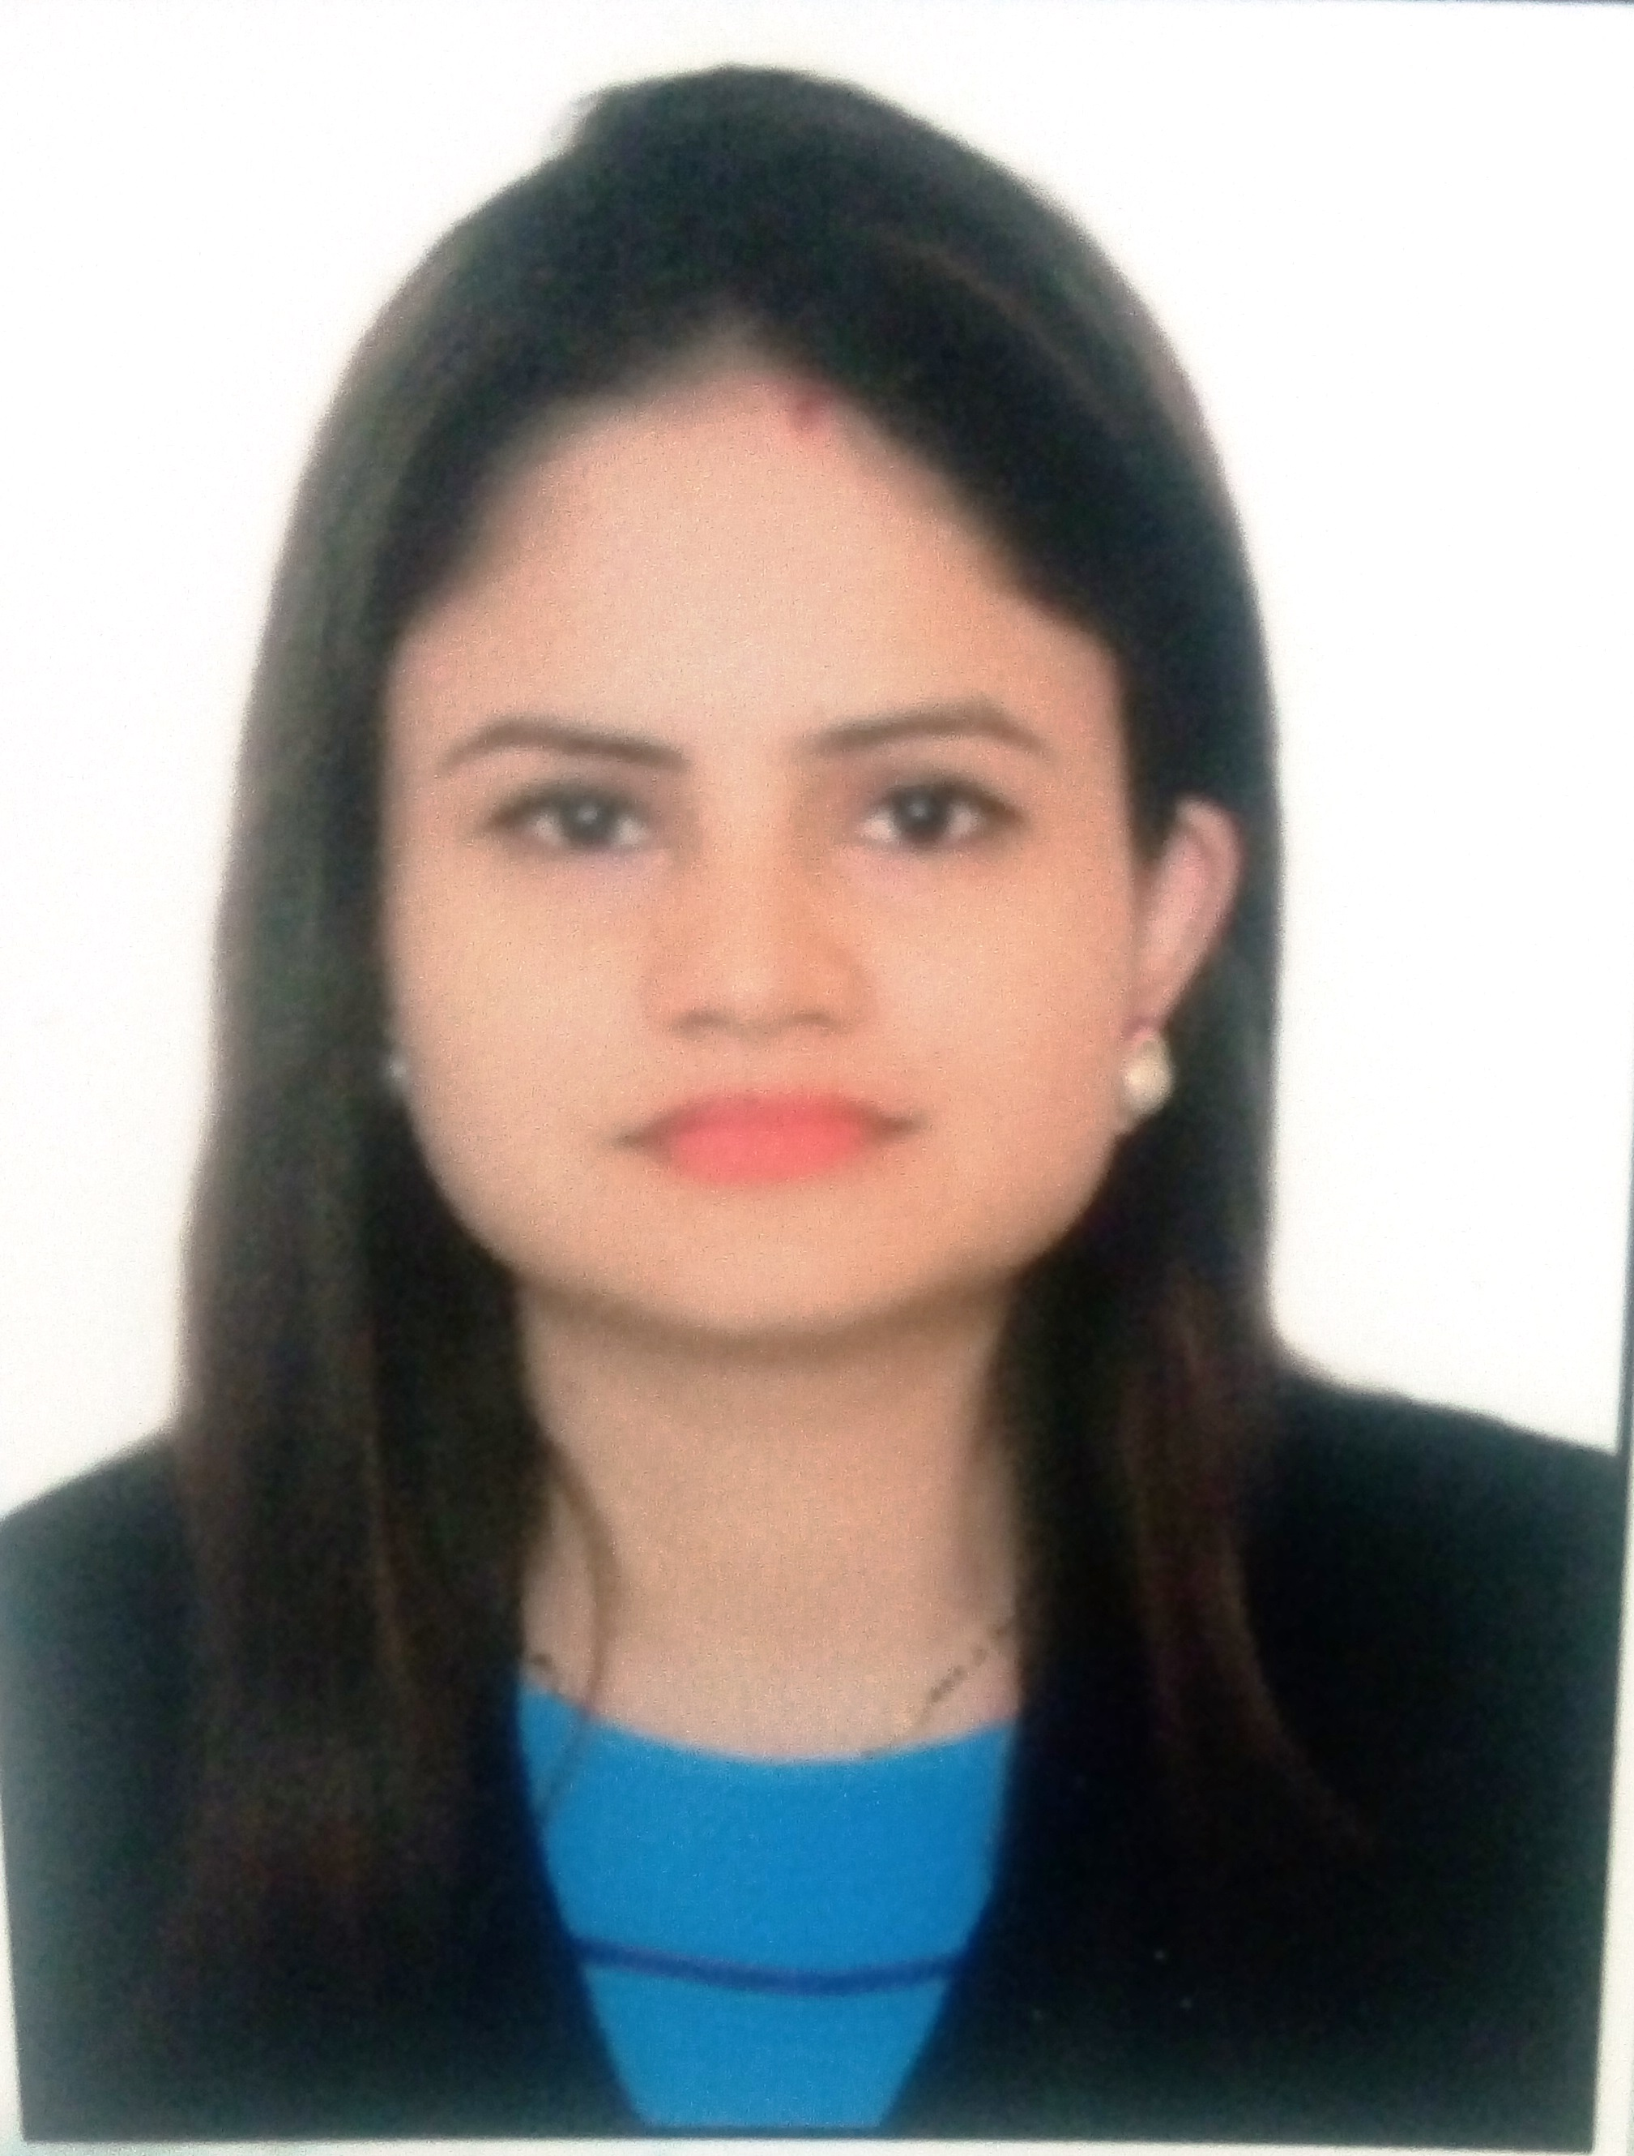

✆: +91-9810503181

🖂: smitatripathi.2009@gmail.com

**CORE COMPETENCIES**

Electrical Estimation & Control

Sales Engineering

Project Management

Business Development

Client Relationship Management

Market Intelligence

**Business Development/ Product Manager**

**Industry Preference: Manufacturing /Engineering**

**Location Preference: Delhi/NCR**

Goal-oriented professional offering **nearly 10 years** **& 7 months** of experience; targeting assignments in **Business Development/ Sales Engineering**

**PROFILE SUMMARY**

* Working as a Business Development Manager in BITS (Building Industrial Technical Solutions for bridging the gap between industries & academia.
* Handling the center for career planning & development dept. on one hand
* Dynamic Professional associated with **Control & Switchgear Electric Ltd., Delhi as National Product Sr. Engineer (North)**
* Hands-on experience in exploring and developing new markets, identifying customers, managing brand promotion & new product launch, accelerating growth and achieving desired sales goals
* Understanding & Analysis of Sales / Market channels in relative Industry
* In-depth knowledge of the concepts of Comparison Sheets, the Market Scenario, making Presentations to make the product promotion successful, preparing reports for sales & marketing activities, market survey,

An effective communicator with excellent interpersonal, negotiation, analytical and decision-making skills with experience of working in a deadline-driven environment

Please insert a passport size photograph

**ORGANISATIONAL EXPERIENCE**

**Since August, 2018 with ABES Engineering College, as a Business Development Manager & Corporate Relation Manager**

**Key Result Areas:**

* Pitching industries and generating leads for the students.
* Good exposure in Data Compilation & Data Analysis. Excel etc.
* Skilled in preparing customized presentations according to the requirement of the market.
* Meeting with new clients and building faith with the existing ones.
* Convincing skills and aggressive towards achieving the goal
* Providing training to students on soft skills as well as developing confidence in them.
* Generating leads from the industries & helping the students to work on live projects.

**Since Feb’12 with Control & Switchgear Electric Ltd., Delhi as National Product Sr. Engineer (North)in Sales and Marketing**

**Key Result Areas:**

* Creating reports for tracking lead conversion at every step of the sales funnel and working with the sales team for plugging leaky funnels
* Preparing documents according to the research conducted in market about the competitors’ product.
* Evaluating projects feasibility, preparing project feasibility report and determining the viability based on the technical, financial & economic parameters
* Coordinating with the sales team for achieving targets.
* Making a roadmap and strategic decisions for the growth of the business.
* Defining all group information requirements, marketing information system and sales support framework
* Implementing competitive and market intelligence capabilities through systematic and objective analysis of relevant information, relating to target markets, competitor and economic environments
* Administering different products like Bus Trunking (Sandwich + Air) & Lighting Trunking including the Technical Data sheet, its design, technical standards & its costing which involves the taxes & duties involved
* Generating sales reports, activity reports & revenue forecasts and completing all documentation & administrative records, fully and accurately
* Maintaining market segments like industrial, institutional, data centers & building sectors and writing up concise, value-based sales proposals
* Developing quotations for different enquiries whether of domestic or export region
* Recognizing skills to quickly establish rapport with customers, up-sell products and build a clientele
* Assisting with calculations regarding the bus bar size & voltage drop used in different projects and technical parameters like reading the drawings, preparing the BOQ, and making quotations as per the technical specifications of the product

**Highlights:**

* Streamlined regulatory process for product registration resulting in additional business opportunity
* Successfully studied technical matters like effect of Harmonics & IP Protection on product and delivered presentation to the management which was very much appreciated

**Jul’10 - Feb’12 with Jakson Engineers Ltd., Noida as Project Engineer (Switchgear Division)**

**Key Result Areas:**

* Identified prospective clients and maintained relationships with the existing by understanding the product requirements
* Furnished and delivered the presentations utilizing the overall functional knowledge on and off the clients’ site
* Engaged in pre-sales activities like documentation & MIS reporting
* Supported marketing team by attending trade shows, conferences and other marketing events
* Provided pre-sales technical assistance and product education while liaising with other members of the sales team and other technical experts
* Provided quotes to the client for customized requirements and negotiated tender and contract terms; designed technical presentations and displayed products to clients
* Performed ongoing R&D on geographical and demographic profiling to identify and capitalize on unmet market needs ahead of the curve

**Highlights:**

* Delivered presentations with cross sales concept; arranged workshops and seminars; managed total business and garnered sales revenue
* **Renault Nissan:** Engaged in costing, tendering & technical as well as commercial discussion with the client & order worth US ($) 40353.80
* **Hotel Aakriti**: Personally visited the clients site, explained them the functions & advantages of the product and changed the query into order which was a successful one worth Rs. 1 Crore
* **IICA Manesar**: Managed costing, tendering, visiting the site and getting the order along with the dispatch of materials worth Rs. 14 Lacs
* **AIIMS Projects**: Administered costing, tendering and all the relevant details along with the execution of order of AIIMS Bhopal worth Rs. 86 Lacs

**ACADEMIC DETAILS**

**2010 B.Tech.-Mechanical** from U.C.E.R., Greater Noida with 73%

**2005 12th** from Mahanagar Girls’ Inter College, Lucknow(U.P. Board) with 70%

**2003 10th** from Mahanagr Girls’ Inter College, Lucknow(U.P. Board) with 78%

**ACADEMIC PROJECT**

**Title:** Magnetic Braking System

**Duration:** Six months

**Technology:** The project was well equipped with electromagnets and was also advanced with special features to result into a well-designed application to safeguard the vast and widely used braking system.

**Project Details: “**Magnetic Braking System” project was a plan for vital implementation in vast 4 wheelers to avoid accidents and time delays, thus resulting in an efficient safeguard system with the use of Eddy Currents which were usually considered as a loss.

**EXTRACURRICULAR ACTIVITIES**

* Acknowledged with **Best Team Member Award** in an open debate competition held at **Central Drug Research & Institute, Lucknow**
* Won many debate, creative writing, singing & extempore competitions at college and state level
* Achieved third prize in Debate Competition at U.P. level on topic “ **Scientific Research is a Blessing or Curse”**

**PAPER PRESENTATIONS**

* Presented papers on “Weapons” & “Human Rights and Environment” at school and college level and won third prize

**IT SKILLS**

* MS Office (Word, PowerPoint & Excel)
* Internet Applications

**PERSONAL DETAILS**

Date of Birth: 19th February 1987

Languages Known: English & Hindi

Total Exp : 10 yrs 7 months