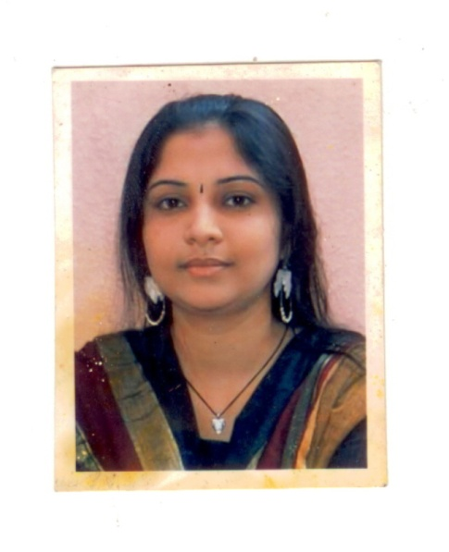
Deepa V
Contact : +91 86808 36654
+91 7550160303
Email: noddyworld@gmail.com

OBJECTIVE

Quest to work and learn in a real professional and vying ambience that enables me to cope with emerging as well as latest technology and make best use of it for the growth of organization.

WORK EXPERIENCE

- Working for D.A.V Public School, Velachery, Chennai.
Responsibilities: (Computer Operator)
- Coordinating with Teacher’s Resource Department.
- Typing question papers, from VI to XII.
- Maintaining student’s personal information.
- Conducting Olympiad exams for the students
- Maintaining Computer Lab

- Worked for Sree Narayana Mission Senior Secondary West Mambalam, Chennai.
Duration: 3rd June 2013 – March 29th 2019

Responsibilities: Teacher (Coordinating with Admin & Exam Department)
- Handled classes from I to VIII (Computer Science)
- Handled classes for VI to VIII (Social Science)
- Maintaining teachers and students' databases.
- Sending SMS to the parents.
- Typing question paper for the examinations.
- Handled front office.

- Worked in Fatima Matriculation Higher Secondary School, Saidapet, Chennai
Duration: August 2010 to June 2012

Responsibilities: Teacher
- Handled computer science for the primary classes
- Handled English in the class 3
- Handled Library.
- Taking care of smart board for all the classes
- Handled Administration work

- Worked for Jurulss Technology Solution (Never Skip), Implementer, Anna Nagar, Chennai.
Client: Akshayah Matriculation Higher Secondary School
Duration: October 2009 – July 2010

Responsibilities: (Implementer in the schools)
- Sending SMS to Parents
- Maintaining Master Excel Sheets of all Classes Students and Staffs
- Co-ordination with Backend Team
- In charge of all correspondence of various classes.

- White House Business solution (P) Ltd
Duration – September 2007 to July 2009
Responsibilities: (Help Desk)
- Attending incoming calls and outgoing calls
- Receiving documents for the clients and sending faxes
- Maintaining Employee database and keep track of the updates timely
- General Administration works
- HR coordinator, sourcing and screening, update the CV in the portal for the future reference.

- Virtusa India Pvt Ltd
Duration – 21st Jan 2006 - Aug 2007
Responsibilities: (HR Coordinator)
- HR coordinator
- Sourcing and screening,
- Update the CV in the portal for the future reference.

EDUCATION
- PGDCA (Post Graduate Diploma in Computer Applications) from Annamalai university 2015
- M.H.R.M (Master of Human Resource Management) from Annamalai University 2007- First Class
- M.A.,(Sociology) from Queen Mary’s College, Chennai 2003- First Class
- B.A.,(Sociology) from Queen Mary’s College, Chennai 2001 - Second Class

TECHNICAL PROFICIENCIES
- Diploma in Computer Application
- Proficient in MS-Office – MS Word, MS PowerPoint, MS Excel
- Well versed in Tally 6.3
- English Typewriting - First Class

LANGUAGES KNOWN

S.No | Languages | Read | Write | Speak | Understand
1. | Tamil | Yes | Yes | Yes | Yes
2. | English | Yes | Yes | Yes | Yes
3. | Hindi | Yes | - | - | Yes
4. | Marathi | - | - | Yes | Yes

PERSONAL DOSSIER
Name : V. Deepa
Father's Name : Mr. Vijendra Rao (Retired Bank Employee)
Address : 62, Lake View Road,
G3 Kamakoti Flats,
West Mambalam, Chennai (India) – 600 033.
Pass Port No : K 3857516
Phone : 8680836654 (INDIA)
Email : noddyworld@gmail.com

Date:

Place: Signature

