RAVILLA PAVAN BRAHMAKUMAR 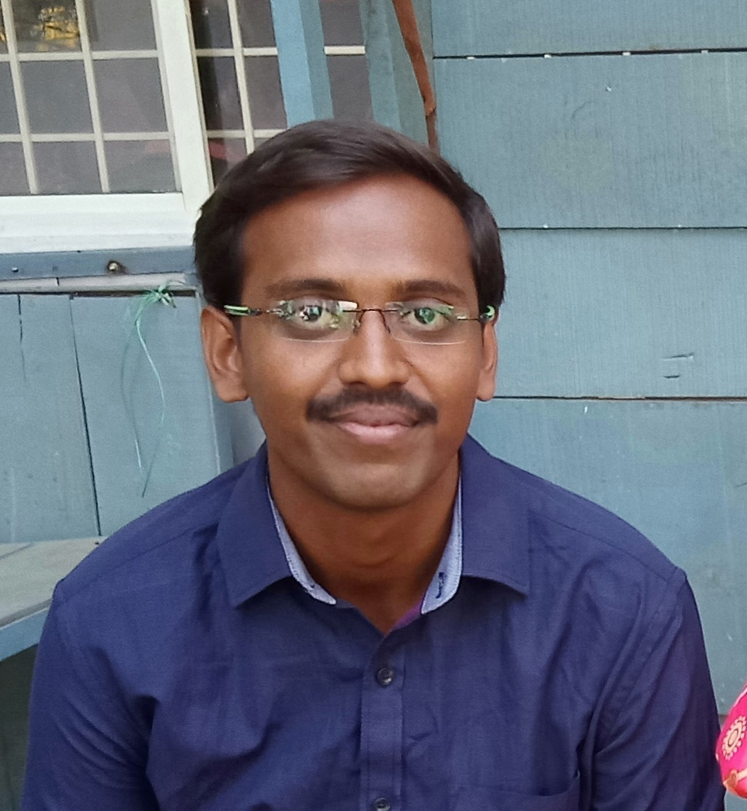
Email: ravilla.brahmakumar@gmail.com
Contact: +91 9010073297
Objective:
To obtain a responsible challenging and rewarding position in a software development organization with an established track record where my skills,abilities and technical abilities can be utilized.
Educational Qualifications:
Course | Institute | University/Board | Year of Completion | Percentage (%)
B.Tech (C.S.E) | Malineni Perumallu Educational Society’s | JNTU-Kakinada | 2019 | 78.63
Intermediate | Sri Chatinaya IIT-JEE Academy | Board of intermediate | 2015 | 90.8
SSC | Dr.KKR’S Gowtham International School | Board of secondary Education | 2013 | 8.7 (GPA)
Certifications:
- “Microsoft” Certification in java development.
Technical Skills:
- Programming language :UI Dev usingHTML5,CSS3,Javascript&AngularJS,C P, Core Java.
- Packages : MS Office (MS-Word, Power point, Excel).
- Database Management : SQL sever.

Case Study:

WEB SERVICE PLUGIN FOR US STATE REAL ESTATE PORTALS

Description: An online business portal can replicate the look and feel of your business and provide you with greater control over your day-to-day processes. Regardless of time or user location, a web portal can be accessed quickly and easily on any device. In this project, Full MEAN-STACK is developed for searching the real estate details of New Jersy city. This approach uses terms of a Angular and NoSQL and evaluates results due to the user's preferences. At the end of the project, the web application is developed.
Internship:
- “Java applications and development” organized by Aspire Vision Tech Pvt. Ltd.

Academic Project:
- Title : A Layered Defense System against Cryptographic Ransomware Attacks
Using Machine Learning
- Description :cybersecurity attacks caused by Cryptographic Ransomware massively crippled organizations across the globe. Based on the analysis of an extensive Ransomware dataset, this paper presents a layered defense mechanism with monitoring of a novel compact feature set that characterizes Ransomware behavior. Strong Trap layer (early detection), Machine Learning layer (zero-day intrusions) and File Backup layer (preserving user data) helps RansomWall to attain a detection rate of 98.25% with near-zero false positives using Gradient Tree Boosting Algorithm.

Co- curricular Activities:
- Presentation paper on “BLOCKCHIAN”, “MICROSOFT HOLOLENS” in various college fests.
- Particapated in a workshop on “ BLOCKCHAIN and HACKATHON” which was conducted by idea labs.
- Particapated on “COMMUNICATION AND SOFTSKILLS” organized by mpes.

Extra- curricular Activities:
- Organized various events like college fests,enginners day etc.
- Participated in sports like cricket,volleyball.
- Participated in 10K Walk Festival last two years.
Awards & Achivements:
- Got a 2nd prize in IMO in school(International Mathematics Olympiod).
- Got a 2nd prize in Academic Year.

Soft Skills:
- Communication skills.
- Presentation skills.
- Leadership skills.
- Quick learning on new technologies
Traits:
- Self-motivation.
- Positiveness.
- Self-Confidence.
Personal Details:
Father’s Name : R.Lakshmi Narayana
Mother’s name : R.Venkata Narayanamma
Date of Birth : 6 MARCH 1996
Address : Flat No. 403, Vyshanavi Apartments, Postal Colony, Narasaraopet, Guntur (522601)
Declaration:
I hereby declare that all the information given above is true to the best of my knowledge.
(R.BRAHMAKUMAR)

