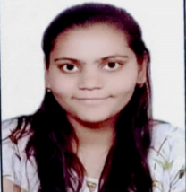**RESUME**

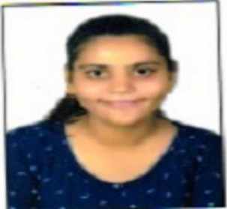 **Name :** VARTIKA GUPTA

**College :** Government Women Engineering

College, Ajmer

**Branch :** Electrical and Electronics Engineering (EEE)

**Date of Birth :** 02/10/1998

**E-Mail :** vartikagupta1267@gmail.com

**Batch :** 2016-2020

**Program :** B. Tech.

**Gender :** Female

**Nationality :** Indian

**Contact No. :** 7976600897, 7597721891

**Permanent Address :** H.NO.6, New Govind Nagar Ramganj, Ajmer, Rajasthan (305001)

**OBJECTIVE:-**

To work with a professionally managed organization, where I can serve my best and giving sincere input to the esteemed company. I am a highly organized and hardworking individual looking for a responsible position to gain practical experience.

**EDUCATION:-**

|  |  |  |  |  |
| --- | --- | --- | --- | --- |
| **YEAR** | **QUALIFIC--ATION** | **STREAM** | **UNIVERSITY/BOARD** | **%/CGPA** |
| 2019-20 | B. Tech. | Electrical and Electronics Engineering | Govt. Women Engineering College Ajmer | 68.2% |
| 2015-16 | XII | Science- maths | CBSE | 61.2% |
| 2013-14 | X | ALL | CBSE | 6.4 CGPA |

**WORK EXPERENICE:-**

* Trainee Site engineer in project of DFCCIL.

**SKILLS:-**

* **Computer Application :** MATLAB , MS- OFFICE, C, C++, Python
* Good communication, management and Leadership skills.

**ACHIEVEMENTS:-**

● Prepared a Research Paper on “ OTA BASED SECOND ORDER ACTIVE FILTER REALIZES LOW PASS, HIGH PASS , BAND PASS AND BAND REJECT FILTER “

* Gold Medallist in College Level badminton Competition.
* Silver Medallist in College Level basketball.
* 3rd position Holder in Quiz in Jaipuria Institute of management.

**EXTRA CURRICULAR ACTIVITIES:-**

● I have coordinated many events in college.

* Attend Workshop on “Dynamics of Entrepreneurship and Innovation”.
* I have participated in “Indian Engineering Olympiad”.
* Attend Workshop on “frontier of applied chemistry”.
* Attend Workshop on “Smart Girl”.
* I was the secretary of ISTE (INDIAN SOCIETY OF TECHINCAL EDUCTION).

**TRAININGS AND PROJECTS:-**

**TRAININGS:-**

1. TATA POWER AJMER DISTRIBUTION LIMITED(T.P.A.D.L.)

**2.** Practical training in KOTA THERMAL POWER STATION (KTPS)

**PROJECTS:-**

1. Smart energy meter.
2. Air quality pollution monitoring drone.

**DECLARATION:-**

I hereby declare that the above particulars are true to the best of my knowledge.

**PLACE:** Ajmer

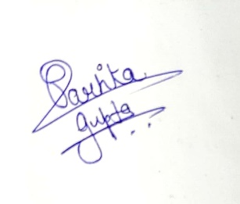

**VARTIKA GUPTA**