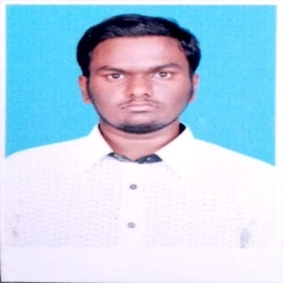

**Name**: MOHAMED AJMAL ABDUL HAMEED K.A

**Email id**: [ajmalabdul1998@gmail.com](mailto:ajmalabdul1998@gmail.com).

**Phone no**: 91-7358992480.

|  |
| --- |
| **Objective** |

To grab an opportunity and set myself a goal where I can be innovative and attain challenging position by exercising my interpersonal and Personal skills to fullest for the growth of the organization and mine as well

|  |
| --- |
| **Academic Qualification** |

|  |  |  |  |  |
| --- | --- | --- | --- | --- |
| **Degree** | **Institute** | **University/Board** | **Year of Passing** | **Percentage** |
| B.Sc.Computer Science | Sadakathullah Appa College | Manonmaniam Sundarnath University | (2016-2019) | 80% |
| 12th | TIME Matric Hr Sec School | State board Education | 2016 | 63% |
| 10th | The Golden Jublie Matric Hr Sec School, | State board Education | 2014 | 74% |

|  |
| --- |
| **Software Proficiency** |

Operating System : Windows 7.

Database System : Oracle.

Web Technologies : HTML, PHP,JSP,C.

|  |
| --- |
| **Certificate** |

NowPurchasing **“Cisco Certified Network Authorized CCNA”** is at itech Academy Tirunelveli .

Certificate of Language Proficiency course “**The Current** **Communication Skill**” in Al Amanath English Academy. Tirunelveli.

|  |
| --- |
| **Personal Particular** |

Gender : Male

Date of Birth : 04.09.1998

Father’s Name : ABDUL RAZAK .A

Languages known : English, Tamil.

Native Place : Tirunelveli-India

Address : 8 Sappani Alim West Street, Melapalayam Tvl**.**

|  |
| --- |
| **Assurance** |

I assure you that the above given information are true to the best of my knowledge and skills.

**Yours Faithfully**

