

***CURRICULUM VITAE***

Shweta Vispute 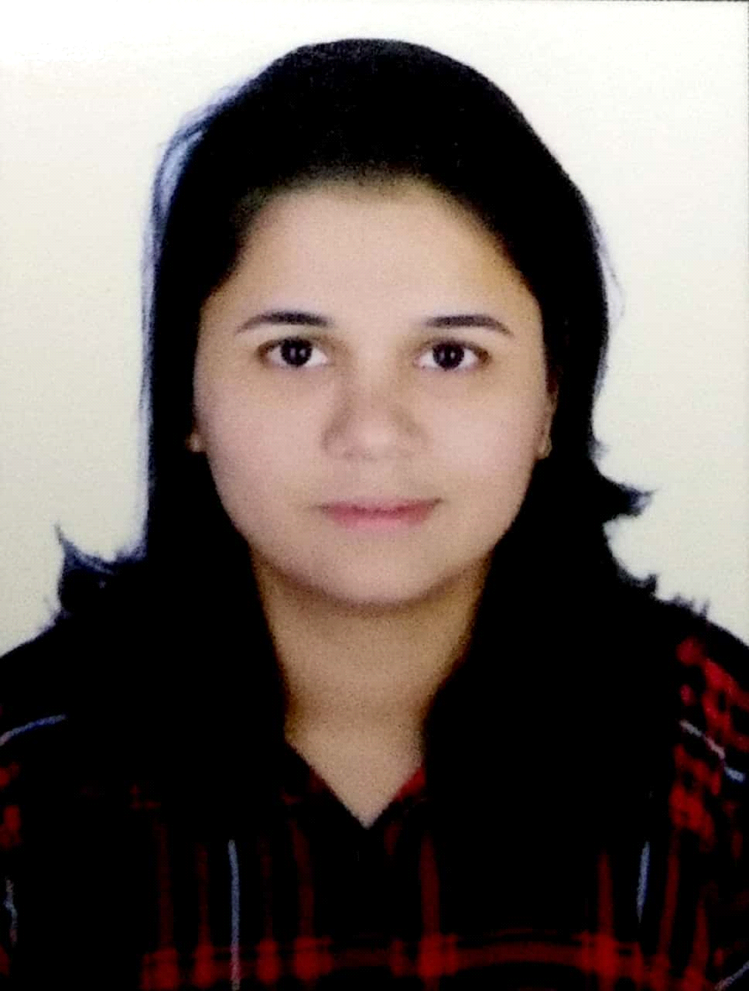

 [Shwetavispute44@gmail.com](mailto:Shwetavispute44@gmail.com)

 7738171298

Add: Airoli, Navi Mumbai 400 708

***============================================================***

**Objective:**

Secure a responsible career opportunity to fully utilize my training and skills, while making a significant contribution to the success of the company.

**Accolades:**

* Digital Marketing Certification Course from Proideators Digital Marketing Institute, Thane.
* Bachelor of Business Administration in Finance from Mahatma Gandhi University with 65% in 2015.
* H.S.C. from N.K.T. College with 63% in 2012.
* S.S.S. from New Kalwa High School with 75% in 2010.

**Digital Marketing Certification:**

* Digital Marketing Certificate from Proideators
* Digital Unlock Certification
* Google Analytics Certification
* Google Adwords Certification
* Hubspot Inbound Certification

**TECHNICAL SKILLS-**

**Website Development (CMS - WordPress):** Category Ecommerce, website, Blogging, Corporate website

**Social Media Marketing** - Experience in managing social media platforms such as Facebook, Twitter, LinkedIn, Google Plus, Pinterest, Quora and Instagram.

**Google AdWords:** Search Ads, YouTube Ads, Display Ads, App Promotion

**SEO:** Keywords Search, Search Console, Competitive Analysis,

**Digital Marketing Strategy** - Analyzing web traffic devising strategies to drive online traffic to the company website Strong Brand visibility in the online space.

**Channels**: Paid, Organic & Affiliate.

**On-Page** activities like Meta tag creation, Keyword Analysis, Google Analysis, Google Webmaster etc.

**Off-Page** activities like social bookmarking, Directory Submission, Forum posting, Blog commenting, Article Submission, Link Building, Quora, Business Listing etc.

**Managing Google Analytics** and Google Tag Manager Tools

**Mobile Marketing** - ASO (App Store Optimization)

**Email, SMS & Whats app marketing** - Managing Tools like Email Marketing (mail chimp), SMS & whats App Marketing, ORM

**Analysis Tools** - SEMrush, AWR Cloud, Similar Web, MOZ, Majestic, Ahrefs, Social Mention

Evaluating the effectiveness of marketing programs, analysis and insights.

Reporting of campaigns with in-depth analysis on the performance of keywords, ad copies, bounce rates.

**Personal Skills:**

* Stable in every situation.
* Flexible with the work responsibility and time.
* Tendency to think and plan carefully before acting.
* Ability to accept and complete the given task on time.
* Quick learner

**Internship:**

**Seven Group as a Digital marketing intern from 27th December 2019 to 27th April 2020.**

**Responsibilities**:

1. On Page SEO

2. Off Page SEO

3. Social media marketing

4. Email, SMS and whats app marketing

5. Competitor analysis

6. Keyword research

7. Graphic designing

**Work Experience:**

* R.F. Interior decorator as a back office executive from 10th December 2015 to 5th May 2017.
* In Convergys from 29th May 2017 to 21 November 2017 as a chat process agent in billing team.
* Worked with WNS Airoli as a Senior Back office Associate for Amazon process from 27th August 2018 to 24th September 2019.

**Personal Details:**

**Name:**  Shweta Vispute

**Date of Birth**: 7th December 1993

**Gender**: Female

**Nationality:** Indian

**Languages Known**: English, Marathi and Hindi.

**Hobbies**: Watching movies and listening to music, Surfing new things online

**Declaration:**

I hereby declare that the above mentioned particulars are true to the best of my knowledge and belief.

Date :

Place: Mumbai (Shweta Vispute)