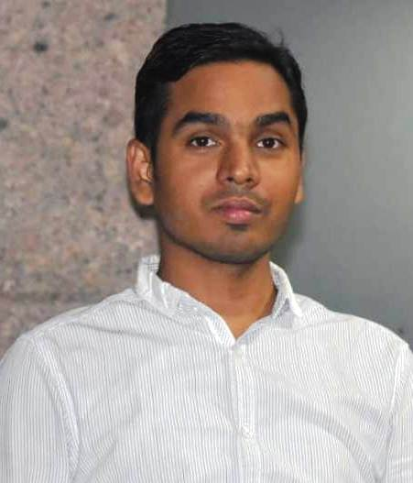
CURRICULUM VITAE

Balkrishna Kumar
Email id-balkrishna.248@gmail.com

Mobile No-8447714721, 9870350229 E-Mail- balkrishna.248@gmail.com
House No-442/20, Near Ram Mandir
Shakti Nagar, Gurgaon -122001

OBJECTIVE
To establish myself as one of the top notch personnel in the Garment industry, experiencing my career in Merchandising, Quality Assurance and Retail with the hard work, technical abilities and skill.

PROFESSIONAL EXPERINCE

Total Work Exprienence: 8 YEARS (KNITS, WOVEN, SAREE & KURTI)

From FEB 2014, to till date:-

Organization: - Boutique International, Gurgaon

Designation: - Merchandiser

Buyers Handling: - Nordstrom

Product: - Kids Wear (Boys & Girls), Sweaters (Boys & Girls)

Responsibilities
- Responsible for merchandising & production management, including sampling, fit & preproduction approvals, fabric & trim approvals, testing, Sealer, Top sample works with production team for delivery & the production status update the same to buying agency
- Sourcing &Negotiating for some of fabric and trims from the supplier ensure that send material in house as planned and chase them in case of delays.

Doing costing with senior merchant across all styles & negotiating the same with buyer
- Prepare TNA/WIP based on the order confirmation date to the shipping date
- Preparing Production file which contains fabric and trim swatches -Specification sheets, all comments, wash standards, embroidery / print swatches and any other relevant swatches should be handed over to Production department after reviewing
- Attending PPM meeting with buying house QA, Production team & discuss technical comments with production team. In order to ensure all the comments are well downloaded and incorporated in bulk and production planning and inspection closures.
- Manage sealing process, fit meeting schedule and on time delivery of pr‐production samples.
JAN 2013 TO JAN 2014- Worked as “Sales Executive “at Jalan Wholesale Bazar, Varanasi (UP)
Product Category –Saree & Kurti
JOB RESPONSIBLITIES:-
- Organized racks & shelves to maintain visual appeal, engage customers & Promote specific merchandise.
- Directs customers by escorting them to racks and counters.
- Ensure smooth functioning of the outlet as per the standards and processes defined
- Drives sales through engagement of customers, suggestive selling, and sharing product knowledge
- Track, analyze, and take steps to increase footfalls to ensure monthly sale targets for the store are met
- Ensure support to the marketing team in execution of in-store promotion or loyalty programs
- Work alongside retail representatives to boost sales by enhancing product presentation & advertising collateral
- Analyzed & properly proceed product returns & help to customers in find alternative merchandise to meet needs

FROM JULY 2012 TO DEC 2012-Worked as Management Trainee at Color Cocktail, Gurgaon

Products: -.Women wear (Top, Skirt, Pants, Dress, Shrugs, Jumps suit)

Job Responsibilities:-
- Sourcing the fabric, raw material for incoming style or ongoing style, coordinating with existing vendors and finding the new one.
- Preparing products of listing product details, including catalog details such as the products names and descriptions.
- Monitor daily activities and communication with vendors regarding the fit and other changes if any changes are requires in the product.
- Keep continues quality check on going production, with regular vendors visits to checking the quality of the product.
- Checking and assuring samples quality, specifications, designs and colors as prior to in house

PROJECTS/RESEARCH
Completed 4 Months Graduation Research Project at Seventymm.com, Gurgaon (Jan 2012 to April 2012)
Project Title : An Analysis of sales performances i.e. –Apparel, Electronic, Accessories and Footwear of online retail organization- seventymm.com
Description: Comparative Analysis of Sales performances among various categories, Impact of product review performances on sale under various category, Analyze of website profile and performance, Comparative Analysis of registers users vs. visitor’s users.

internship
Two Months Summer Internship at Radnik Export, Gurgaon
Description: The internship aimed at analyzed the performance of all the departments ,obtained data, created ideal flow chart and identified improvements areas and gave suggestions for future reference Additionally focused on particular style to study the reason that leads to its late shipment and the loss incurred by the same.

PROFESSIONAL CREDENTIALS:
- 2010-2012-Post Graduation in Master of Fashion Management (MFM) From NIFT (NATIONAL INSTITUTE OF FASHION TECHNOLOGY), Kolkata.

COMPUTER PROFICIENCY
- Graphic Design -Coral Draw, Photoshop , Tally .ERP

ACDEMIC QUALIFICATION
- 2007-Graduation (Arts) - R.K.D. COLLEGE , Patna (2003-2007)
- 2003-10+2 (Science ) – S.P. College , Dumka(2001-2003)

PERSONAL INFORMATION
Father’s Name : Mr. Dwarika Pd Mahto
Date of Birth : 20thJuly1986
Mobile : 91-844771472, 9870350229
E-mail : balkrishna.248@gmail.com
Mailing Address : C/O-Kapil Munjal, House No-442/20,Near Ram Mandir, Shakti Nagar, Gurgaon

DECLARATION
I hereby declare that all the above mentioned facts are true to the best of my knowledge. An opportunity to associate with your prestigious firm would find my sincerest efforts in providing my potential.
Date : Yours Truly,
Place : Gurgaon Balkrishna Kumar

