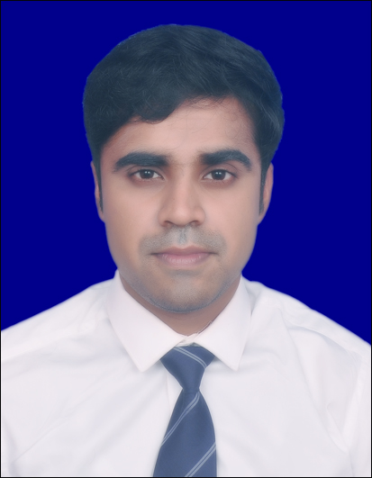ABHISHEK GHOSH 

**Objectives**

To work in an organization that offers challenging opportunities, which provides innovative work and exposure to the latest technologies where I can continuously enhance my skills by working sincerely and contribute to the company’s growth to the best of my potential.

**Skill Highlights**

|  |  |
| --- | --- |
| * Project management * Valuation analysis * Project Feasibility analysis | * Project cost management * Contarcts & claim management |

C:\Program Files (x86)\Microsoft Office\MEDIA\CAGCAT10\j0205462.wmf**Work Experience** (3 Years 1 month)

* **Management Trainee**– Oct 2020 - Present

**MYK Arment**

* Specification Consultant
* Deal with key client like PWD , CPWD , NRL , NFR, MES , AIR FORCE , DRDO , IOCL ,NHIDCL etc. to get associated with their schedule as per their specification.

* **Junior Engineer**- Dec 2015 - April 2017

**NCC Limited**

* **SICPAC project under Govt. of Meghalaya at Shillong, Meghalaya**
* Project quality management during construction of the project.
* Cube Strength Inspection, Building materials (Sand, aggregates, cement, water, brick etc.), Concrete quality check as per specification.
* Quality of work inspection during the time of execution.
* Quality control of Concrete Batching Plant
* Maintain the all the required records of Quality Assurances
* Coordinate with Client.
* Sample Approval of Building Materials.
* Preparation of Secure Advance Bill, Royalty challan.
* **ISMU project under CPWD at Dhanbad, Jharkhand**
* Site execution:
* Execution of Construction activities.
* Preparation of BBS, updating daily Progress report
* Making chart of progress as per actual Vs planned.
* Reconciliation of Construction Materials.
* Quality Control:
* Tests of sample materials for defects and find out the deviations from specifications.
* **Quality Assurance Engineer**-Jun 2015 - October 2015

**Lokenath Buildcon Pvt Ltd.**

* **TICT Project, New Town ,Rajarhat , North 24 -Pgs. ,WB**
  + Execution of Piling foundation construction
  + Conduct Pile Tests , Quality Management during Pilling.
* **Site engineer-** July 2014 -May 2015

**Trimurti Construction Developers and Builders**

* **Beur Vatika Site, Patna**

**•** Site management:

* Assign the work Force as per Planning.
* Execution the Site
* Composing the PRW bill.
* Forming of BBS

**C:\Users\SUKANTA SIL\AppData\Local\Microsoft\Windows\INetCache\IE\M99KH6W2\Cap2[1].jpgEducation**

|  |  |  |  |
| --- | --- | --- | --- |
| **Course** | **Institute** | **CGPA/%** | **Passing Year** |
| **PGPM**  Infrastructure Finance  Development & Management | National Institute of Construction Management and Research , Pune.  **(2018-2020)** | 7.09 | 2020 |
|
| **B. TECH**  Civil Engineering | Budge Budge Institute of Technology  (**2010-2014)** | 7.05 | 2014 |
|
| **12TH**  **Science** | Kalyani Pannalal Institution  **(2008-2010)** | 61.20 | 2010 |
|
| **10TH** | Bedibhawan Rabitirtha Vidyalaya  **(2008)** | 66.50 | 2008 |
|

* **Certifications**
  + **Software Application (certified):** *AutoCad & BIM ;*February –April ,2019
* **Workshop** : *Entrepreneurship & Management in construction*;27th October , 2018
* Successfully passed the ESCAP E-Learning series on *PPP awareness* certification ; 14th April , 2020