**ANUPAM SINGH**

E-Mail: [anupam.singh4747@gmail.com](mailto:anupam.singh4747@gmail.com%20) ~ **Contact:** 08081474747, 09935170747

***~ Top Management Professional~***

***~Marketing Research / Sales & Marketing ~***

***Offering over 10 years of rich and extensive experience providing fiscal, strategic and operations leadership in uniquely challenging situations***

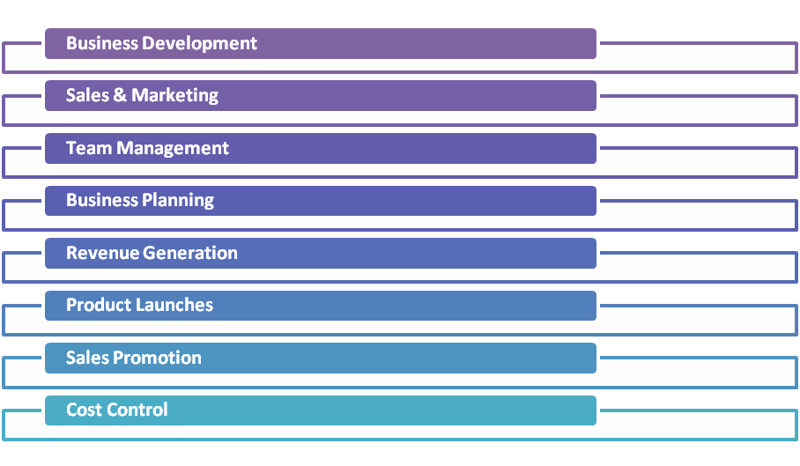**SYNOPSIS**

**Currently associated as AGM in R.A Motors Pvt. Ltd. (TATA Motors Authorized Dealer).** Adroit in handling operations for driving business by effective relationship management & delivery of value added service.

Experienced in strategising direct marketing plans, accomplishing sales targets for all crops and seeds, providing necessary assistance & ensuring achievement of the organizational revenue targets in budgeted parameters. Deft in turning around underperforming business & enhancing value of operating business units through process improvements focused on sales & best practice identification and implementation. Effective communicator with excellent relationship building, presentation & interpersonal skills; strong analytical, team leadership, problem solving & organizational abilities.

**WORK EXPERIENCE**

**Since Jan’ 17: R.A Motors Pvt. Ltd. (TATA Motors Authorized Dealer), Farrukhabad as AGM**

**Nov’ 13- Jan’ 17: Kamlesh Auto Wheels Pvt. Ltd. (Mahindra & Mahindra Authorized Dealer), Firozabad as AGM**

**Aug’ 11 – Nov’ 13: Rajendra Auto Wheels Pvt. Ltd. (Mahindra & Mahindra Authorized Dealer) Farrukhabad as Sales Manager**

**Jul’ 10 – Aug’ 11: Nippo Batteries Co. Ltd., Kanpur as Sales Officer**

**Sep’ 09 – May’ 10: Genie Corporation Ltd., Ahmedabad as Sr. Sales Executive**

**Jan’ 03 – Mar’ 05: NIIT Ltd. as Marketing Executive**

**Areas of Expertise:**

* Strategizing business directions to ensure profitability in line with organizational objectives
* Conceptualizing and implementing promotional strategies as a part of market development effort
* Reviewing and interpreting the competition after in-depth analysis of market information to fine-tune the marketing strategies and escalating business volumes
* Mentoring, motivating and guiding team members ensuring sales - business generation and achieving budgeted figures & activity ratio on monthly basis
* Identifying and networking with financially strong and reliable distributors / dealers, resulting in deeper market penetration
* Devising & implementing strategies for product positioning, pricing and product promotion activities
* Developing and appointing new channel partners to expand product reach in the market and coordinating with the dealers & distributors to assist them to promote the product
* Developing competencies of sales people through appropriate training programs and setting incentive scheme for boosting team spirit and moral of the sale force

**PROJECTS UNDERGONE**

* Summer Training & Preparation Project in Wipro Ltd. Ahmedabad (FMCG) From 10th May 2009 – 30th June 2009
* Grand Project Preparation a Study of Marketing Strategies and Consumption Pattern of Ice Cream in Ahmedabad

**QUALIFICATION**

* HWC (Honors Diploma in Web Centric Curriculum) from NIIT in 2002
* MBA (Marketing) From IBMR Ahmedabad (Gujarat) in 2010
* PGPM from IBMR Ahmedabad (Gujarat) in 2010
* B.A. From C.S.J.M University Kanpur in 2005

**PERSONAL DETAILS**

Date of Birth 8th January, 1985

Marital Status Unmarried

Nationality Indian

Permanent Address Shiv Nagar Colony, Farrukhabad, District- Farrukhabad 209625, Uttar Pradesh

Languages: English and Hindi