RESUME

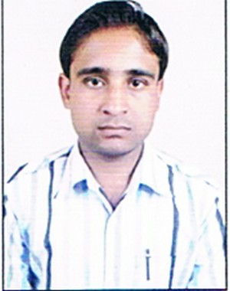**RAHUL KUMAR MISHRA**

VILLAGE NIPANIYA POST CHHATWAI

TEHSIL SOHAGPUR DIST. SHAHDOL (.M.P.)

Pin Code:- 484001

Mob.No.8959578640 , 797114380424

**: QUALIFICATION**

|  |  |  |  |
| --- | --- | --- | --- |
| **Name of Exams** | **University/Institute Name** | **Year** | **Percentage** |
| 10TH | MP BOARD BHOPAL | 2008 | 61.00% |
| 12TH | MP BOARD BHOPAL | 2010 | 63.00% |
| B.Com (CA) | A.P.S.U REWA | 2013 | 60.00% |
| PGDCA | Maharishi Mahesh Yogi | 2014 | 68.00% |
| I.T.I.(surveyor) | GOVT. ITI SHAHDOL | 2018 | 74.00% |
| D.led | MP BOARD BHOPAL | 2019 | 89.80% |

**COMPUTER KNOWLEDGE :**

Ms Office, Data Entry

, Windows, Internet Surfing, **Tally.ERP 9.3**

**EXPERIENCE :**

* 5 YEAR (2012-2017) experience **Kishok BANK** SATPURA NARMADA CHITRIYA GRAMIN BANK..
* 1 Year (2017-2018) experience for **amrita hospital** shahdol for recpition with billing dipartment.
* (2018-2020) running experience for **gust teacher** in govt.school shahdol.

#### PERSONAL PROFILE:

Name : RAHUL KUMAR MISHRA

Fathers Name : SHRI RAM NIVAS MISHRA

Date of birth : 09/07/1992

Marital Status : marriage

Nationality : Indian

Sex ; Male

Language : Hindi , English

#### DECLARATION:

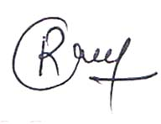 I hereby declare that the above mentioned information is correct up to my knowledge and I bear the responsibilities for the correctness of the above mentioned particulars.

**Date:- / / 2020**

**Place: SHAHDOL**  **RAHUL KUMAR MISHRA**