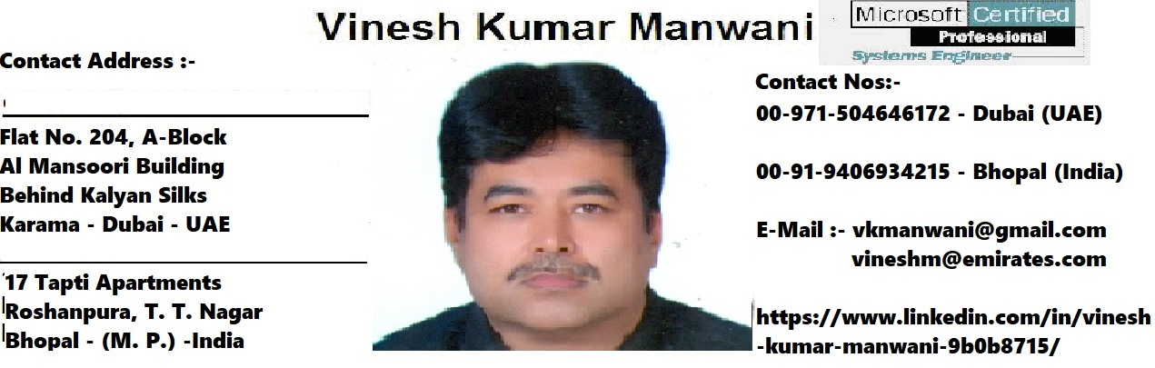

Profile:-

I am an IT professional with 25 years of rich experience in IT Support and Infrastructure Deployment at Dubai (UAE) and India. From last 20 years I am working as IT Sr. Support Engineer with Emirates Group - IT an IT divison of DNATA/Emirates Airlines, Dubai - UAE.

Career Objective :-

A leadership role in a progressive organization requiring demonstrated performance and leadership role in a challenging new environment within the IT industry. My long-term career goal is to become an IT infrastructure Deployment Manager / IT Project Manager or IT head.

Summary:-

In addition to the MCSE and CCNA certification, I have around twenty five years of professional experience at Gulf and India in IT industry such as Infrastructure Deployment i.e. Deployment of Routers, Switches, Hubs, Access points, Server Racks, PABX, Patch panels, Network cabling, Servers, workstations, Laptops, Tablets, PDAs, iPads, Blackberry, printers and scanners etc. Managing the corporate network, leased circuits, ADSL, Alcatel IP phones, including Administration, Remote Access, Troubleshooting of LAN, WAN, Wireless network in mixed Operating Systems environment (Window, Linux and Novell). Providing Support to 400+ Emirates group applications.

Professional Certifications: -

MCSE, MCP (Exchange Server), CCNA. Worked on VMWare, ITIL, Azure (No Certification)

Accomplishments (Projects completed in Emirates Group – IT):-

Have completed different projects for Emirates Group like Windows NT roll out project, Y2K update, Cluster Server Build, Microsoft Exchange migration, Windows XP Migration Project, Win2K3, Windows 7 Migration project and Windows 10 Migration project.

Servers Ranges Worked on -

HP Compaq Proliant 380, Blade servers, Cluster Technology, Virtual servers, Enterprises Servers

Network Operating Systems :-

Novell, Windows NT4.0, Windows 2000, Win2K3, Windows XP and Windows 7, Windows 10

Professional Experience:

IT Sr. Support Engineer (Sep’ 1999 to till date – Emirates Airlines, Dubai - UAE)

- Technical lead for the Dubai airport Terminal 3/Concourse 2 project to deploy around 4000+ network devices including check-in counter PCs, BTPs, BPPs, Self Check-in Kiosks, FIDS Kiosks, SITAB workstations, telex printers, internet Kiosks, Flight Information Plasma display units, Boarding Gate PCs, Servers, PDAs, Blackberry, scanners, network printers etc.
- Lead role during the Emirates Group Windows NT, Windows XP, Windows 7 and Windows 10 Migration projects. Migrated around 10000+ desktops and 1200+ laptop users all over the Emirates Group.
- Remote Access (Mobile computing) configuration and support to 1200+ laptops and home PC users.
- Have Build and Deployed around 15+ Servers for the Emirates Group (File & Print, Exchange, Resource Server etc. Cluster & Non Cluster technologies)
- Troubleshooting of network and communication problems, installation and configuration of Windows XP, Windows 7, Windows 10 and Exchange & Mail clients.
- Supporting around 400 + Emirates Group In-house applications

Sr. IT Support Engineer (Jun’98-Jun’99)-OHI Telecommunication Co. LLC. Muscat - Oman

- Maintaining 1000+ desktop and 30+ LAN servers using Microsoft Windows NT and TCP/IP with DHCP, WINS, and DNS in multi -sites environment connected through Routers and Microwave.
- Senior technical lead in a WinNT Roll out project to standardize Windows NT workstation and Windows 95 clients.
- Providing technical expertise for Windows NT users.
- Coordinating a project to update and standardize desktop technology. The project involved planning for and deploying a large number of new desktop systems and upgrading software and hardware configurations of older systems.

Sr. Customer Support Engineer (Sept’ 1995 to May’ 1998 - IT&T Ltd. New Delhi - India)

- Install, configure and Support the PCs (stand alone as well as network mode), also peripherals such as Dot matrix, Laser jet, Desk Jet printers, Scanners, Modems, add on cards (ISA, PCI, PCMCIA) such as multi media kits, fax modem, network cards as well as Internet, Computer Projection systems, Mega Monitors etc.
- Maintain the Novell 4.1 (60 nodes) and Windows NT (100 nodes) based LANs.(AT&T structural cabling, Ethernet backbone, Win95 clients, Proxy Server for internet, Mail Server, Switches, Hubs, Routers and VSAT for WAN).

Field Support Engineer(May’ 1994 to Sep’ 1995 – Informatics Computer Systems-New Delhi)

- Installation, Maintenance and servicing of Intel Based PCs & associated peripherals, provide the software support for various DOS & Windows based application.

Certificates Courses / Trainings completed

1) Supporting Flight Information Display at Dubai Intl. Airport Emirates Airlines Internal
2) Alcatel VOIP Solution Alcatel Lucent
3) Oki Laser Printer (Service & Support) OKI Printing Solutions
4) Supporting Self Check-in KIOSK Machines at Dubai Intl. Airport Hoeft & Wessel AG Germany
5) IER 57 ATB2 Printer (Service & Maintenance) IER, Air Transportation
6) Alcatel PABX System 4400 Alcatel Lucent
7) Internal Win2k3 – Server Migration Microsoft Corp. Inc
8) VMWare VMWare Inc.
9) Supporting Aviva (TN3270) Emirates Airlines Internal
10) Fujitsu Siemens Notebooks & PDA Fujitsu Siemens Computers
11) Intermac Airline & Transportation, Field Support Intermac Printers AB
Awards:-

- Best idea Award for Emirates.com Website design project Emirates Airlines, Dubai

- Millennium Team Award for Y2K Compliance project Emirates Airlines, Dubai

- Mabrook Silver Award for Most Efficient IT Support in crisis Emirates Airlines, Dubai

Educational Qualification:-

1.: - Bachelor of Engineering (Electronics & Power Engineering branch)
Year of Passing: - 1993
University/Board: - Nagpur University, Nagpur - India
%age / Grade: - 57% (2nd Class)
Project: - Design and Development of Automatic street
Lighting System for the Secondary type of Road.
2. – Diploma in Electrical Engineering
Year of Passing - 1988
University/Board: - MP Board of Technical Education, Bhopal - India
%age / Grade: - 70% (1st Class)
Project: - Design and Development of Automatic Regulated
Power Supply unit.

3. - Advanced Diploma in Computer Applications (One Year)
Year of Passing: - 1994
Board / University: - Maharashtra Technical Board, Bombay - India
%age/ Grade: - 77% (Honors)
Project: - Computerized Inventory Control System
using dBase III plus
4.: - Diploma in Management
Year of Passing: - 1999
University / Board: - IGNOU, New Delhi – India
%age/Grade: - 1st Class

