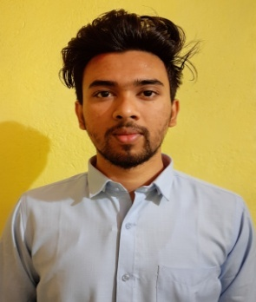 **RESUME**

**Name :** Padoum Roy

**Contact Number :** 9366260750

**Email** **:** royaa2345@gmail.com

padoum.roy.fiem.cse17@teamfuture.in

**CURRENT STATUS :**

Pursing B. tech in Computer Science and Engineering (CSE) (7th Semester) at Future Institute of Engineering and Management (FIEM), Kolkata and will complete by June-2021.

**Career Objective :**

To work in a professional environment where I can effectively utilize my knowledge and skills, thereby enabling me to grow and fulfil organizational goals.

**Academic Qualification :**

**B. Tech in Computer Science & Engineering :** 4th Year

**Name of College :** Future Institute of Engineering and Management

**University :** Maulana Abul Kalam University of Technology

|  |  |  |  |  |  |  |  |  |
| --- | --- | --- | --- | --- | --- | --- | --- | --- |
| **SEM** | **1** | **2** | **3** | **4** | **5** | **6** | **7** | **8** |
| **SGPA** | D | D | 6.24 | 7.02 | 6.88 | 8.65 | - | - |
| **Average** | 7.19(up to 6th Semester) | | | | | | | |

**Secondary (10th) Examination :**

|  |  |  |  |  |  |
| --- | --- | --- | --- | --- | --- |
| **Examination** | Board | **Year of Passing** | **Marks** | | |
| **Obtained** | **Out of (Total)** | **%** |
| **10th Std** | TBSE | 2015 | 403 | 700 | 57.57 |

**Diploma Examination :**

|  |  |  |  |  |  |
| --- | --- | --- | --- | --- | --- |
| **Examination** | Board | **Year of Passing** | **Marks** | | |
| **Obtained** | **Out of (Total)** | **%** |
| **Diploma** | Tripura University | 2018 | 6.54 | 10.00 | 65.40 |

**Trainings :**

|  |  |  |  |
| --- | --- | --- | --- |
| **SL. NO.** | **Company** | **Training Project Title** | **Duration** |
|
| **1** | National Informatics Center | HTML,ORACAL,ANDROID And Visual Studio | 3/7/17 to 29/7/17 |
| **2** | Ardent Computer Pvt. Ltd. | Machine Learning Using Python | 23/12/19 to 23/01/20 |

**Achievements (Academic & Social) :**

* Robotic Workshops
* Swachh Bharat Activities

**Subject of Interest :**

* C
* Java

**Interests & Extra Curricular :**

* Travelling and Photography
* Love to spent time in the gym
* Event Management

**Languages Known :**

* English
* Hindi
* Bengali

**Personal Details :**

|  |  |
| --- | --- |
| Permanent Address : | Shantipara, Agartala, Tripura(w) |
| Date of Birth : | 01/10/1998 |
| Passport No : | T8605445 |
| ADHAR Card : | 3660 6907 0018 |
| PAN Number : | DBTPR1157J |

**Declaration :**

I hereby declare that all the above information given by me is true to the best of my knowledge and belief.