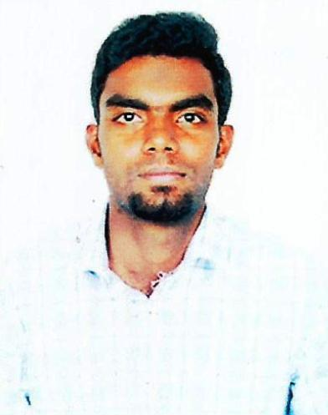 ***RESUME***

**SIDDHARTH.K**

**Mobile: 9600183852**

**Email:** siddiqkarthi1996@gmail.com

**CAREER OBJECTIVE:**

Seeking to build an innovative career and to contribute by being an effective team player putting forth my technical and administrative skills for the benefit ̟of the organization.

**EDUCATIONal qualification**

|  |  |  |  |  |
| --- | --- | --- | --- | --- |
| **Examination** | **School/ college** | **Board/ University** | **Year of Passing** | **Percentage** |
| DIPLOMA IN  MECHANICAL ENGINEERING  (S.W) | CENTRAL POLYTECHNIC COLLEGE THARAMANI | DIRECTORATE  OF TECHNICAL  EDUCATION  (DOTE) | 2018 | - |
| SSLC | ST.BEED’S ANG IND.HR.SEC,SCL,  CHENNAI-04 | STATE BOARD | 2013 | 68 |

**Work Experience :**

**Reselant Innovation Pvt Ltd : Bharatpe**

**May–2020 to May 3, 2021 (1 Year)**

**Work as a MIS & Backend support – Chennai and Tamil Nadu. Handling the fleet managements of fos and TMs, on time Reports, Performance comparisons and reviews the performances and Merchants support handling.**

**TECHNICAL SKILLS:**

* Excel – reports / Presentation
* Able to draw diagrams using AUTO- CAD.
* SQL Queries and Data Analyst
* Has sound knowledge in Ms-Office
* Operating CNC machines

**STRENGTHS:**

* Leadership quality ,Team worker,
* Pressure handling,
* Ability to do the repetitive task in an optimized,WQ
* Quick learner of advance technologies,
* Excellent grip over written communication.

**PERSONAL PROFILE**

Father’s Name : Karthikeyan. D

Mother’s Name : Girija.K

Date of Birth : 21/11/1996

Nationality : Indian

Address : No:3, Jaganathan street, Eldmas road,teynampet,

Chennai- 18

Marital Status : Single

Gender : Male

Nationality : Indian

Languages known : Tamil, English

**DECLARATION**

I hereby declare that the above furnished details are all true to the best of my knowledge and belief.

Place: Chennai

Date: **(SIDDHARTH.K)**