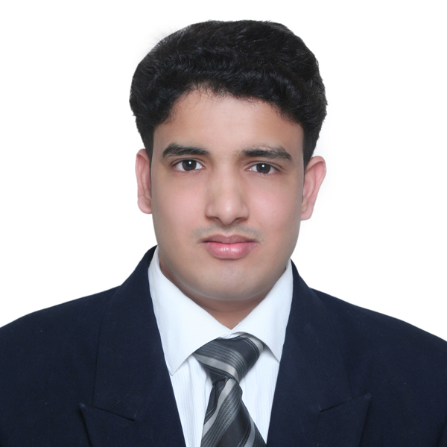
SANDESH DALVI
Contact: +91 (0) 7387960471, Email Id: dalvi.sandesh12@gmail.com

HOSPITALITY MANAGEMENT PROFESSIONAL
Seeking a challenging and rewarding opportunity with an organization of repute which recognizes & utilizes my true potential while nurturing my analytical and technical skills
PROFILE

- Competent and result oriented professional offering over 10 years of experience in Travel, Catering and Hospitality Industry across Operations, Catering, Guest Relationship Management, Menu Planning, Quality Management and Purchase/Procurement Operations; currently pursued PGD in Hospitality Management from ISBM, Business & Hotel Management School, Luzern, Switzerland,
- Industrious & resourceful professional consistently streamlining operations by utilizing & implementing processes that meet company standards and clients’ needs, thereby ensuring profitability, quality and excellent customer service.
- Adept at identifying business opportunities and building marketing thrust to exploit available market potential. Proven expertise in creating and developing innovative business strategies to ensure deeper market penetration.
- Focused and hardworking, self motivated and team oriented; willing to go the extra mile, effective team player with excellent communication and inter-personal skills. Thrive on challenges and quickly adapt to new environments and responsibilities.
CAREER GLIMPSE
SOTC Travel Ltd., MUMBAI, INDIA.
Since Jan’14
Currently working as Tour Manager.
- In dept knowledge of destinations like Europe, Australia, Far East and South Africa.
- Welcoming groups of corporate/ holidaymakers at their starting point and announcing details of travel arrangements and stop-over points.
- Checking tickets and other relevant documents, seat allocations and any special requirements;
- Helping with passport and immigration issues.
- Helping holidaymakers check-in and settle into their accommodation.
- Communicating a range of information on itineraries, destinations and culture.
- Informing passengers of arrival and departure times at each destination on the itinerary and ensuring that all members of the group are back on the coach before departing from each stop;
- Making sure all travel arrangements run according to plan and that accommodation, meals and service are satisfactory.
- Organizing entry to attractions and transport.
- Ensuring that the tour is running smoothly.
- Responding to questions and offering help with any problems that arise, ranging from simple matters, such as directing a member of the group to the nearest chemist, to more serious issues, such as tracing lost baggage.
- Dealing with emergencies, such as helping a holidaymaker who is ill or those needing to contact family members urgently.
- Making contact in advance with places to stay or visit to check details and arrangements.
- Liaising with hotels, coach companies, restaurants and other clients.
- Advising about facilities, such as sights, restaurants and shops, at each destination.
- Writing reports and maintaining records.

HOTEL NEELAM’S THE GRAND, GOA, INDIA.
Oct’ 12- Dec’13
Duty Manager/ Sr. Sales & Marketing Exe.

WAY TO INDIA GROUP OF RESTAURANT, BERN, SWITZERLAND, Jan’11- Jun‘11
Industrial Trainee

COMMON WEALTH GAMES 2010, DELHI, INDIA, Jul’08 – Nov’09
Asst. Project Officer, Catering Department

RAMANASHREE GROUP HOTELS AND RESORT, BANGLORE, INDIA Aug’07 – Jan’08
Management Trainee

ITC GRAND MARATHA SHERATON, MUMBAI, INDIA, Oct’05 –Feb’06
Industrial Trainee
ACADEMIA
PGD, Hospitality Management,2011
ISBM, Business & Hotel Management School, Luzern, Switzerland,
Diploma in Hospitality Management, 2006
Institute of Advance Management, Goa, India
Class XII, 2004
Gogate Joglekar College, Ratnagiri, India
Date of Birth: 1st Aug 1986
Languages Known: English, Hindi, Marathi & basic German
References:
- Ms. Stuti Das  Sales Head  SOTC Travel Ltd.  Urmi Estate  Lower Parel (w), Mumbai  Tel:- +919820627091 | - Mr. Shyam Kalangutker  FOM- Neelam’s The Glitz  Post office road, Calangute,  Bardez, Goa.  Tel:- +91 832-2281781  M:- +919822125765

0)412504441

SANDESH DALVI
Contact: +91 (0) 7387960471, Email Id: sandy_dalvi12@rediffmail.com
Dear Sir/ Madam,

I am writing to express my interest in joining your team.

My resume is enclosed for your review and consideration. To describe myself in a nutshell, I am hardworking; ready to take up any challenge of life abreast with the latest trends and a team player with excellent communication skills.

Possess over 10 years of work experience working across Travel and Hotel Industry; completed PGD in Hospitality Management from ISBM, Business & Hotel Management School, Luzern, Switzerland,

My basic objective is to hone in my skills for comprehensive personality development and be an epitome of trust and reliability in the corporate world. My prime goal is to understand professional environment and capitalize on opportunities.

Professionally I am looking for an opportunity that will help me utilizing my skills in the above areas. My detailed resume is enclosed herewith for your kind perusal and consideration.

I am confident that you would find my strong initiatives and commitments to excellence coupled with demonstrated experience and exposure ideal for the position.

I would welcome a personal meeting to further discuss your requirements and my ability to meet the same.

Thanking you for your consideration and forthcoming response.

Yours Sincerely

Sandesh Dalvi

