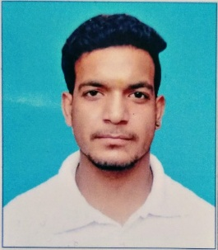**AKASH PANDEY**

**Mobile-8840343096**

[**Email-akashpandey5456@gmail.com**](mailto:Email-akashpandey5456@gmail.com)

**Career objectives**

To obtain a position that will allow me to utilize my knowledge, technical skills, experience and willingness to learn in making an organization successful.

**Experience**

* **MARUTI SUZUKI INDIA POWERTRAIN PLANT, GURGAON**
* **Duration: From-04/04/2018 to 03/04/2019**
* **Designation: worked as Maintenance Electrician (Utility)**

**Academic Qualifications**

|  |  |  |  |  |
| --- | --- | --- | --- | --- |
| Course | Board | Institute | Passing year | Percentage |
| ITI | NCVT | DAS ITC, BALASORE | 2015 | 73.28% |
| MATRICULATION | WBBSE | SER MIXED HIGH SECONDARY SCHOOL, KHARAGPUR | 2011 | 54.12% |

**Skills and Attributes**

|  |  |
| --- | --- |
| Key skills | Key competencies |
| * Quick Learner * Good at Time management * Effective Team Player * Good at relationship building * Good Behavior with colleagues | * Good knowledge of electrical work * Bus trunking,DB preventive Maintenance and connections * Knowledge of single and three phase wiring |

**Personal details**

* Date of birth. :20-02-1995
* Gender. :Male
* Father’s Name. :Late.M S Pandey
* Present Address :N11/98C 6B Ranipur,near om public school

Manduadih,Varanasi,U.P-221010

* Permanent Address :House no-103 jalalpur mutfarka post-Nedula

Dist-Allahabad,U.P-212401

* Nationality :Indian
* Marital Status. :Unmarried
* Language. : Hindi, English

**Declaration**

* I hereby declare that all the information given above is true to the best of my

Knowledge and credence.