**RESUME**

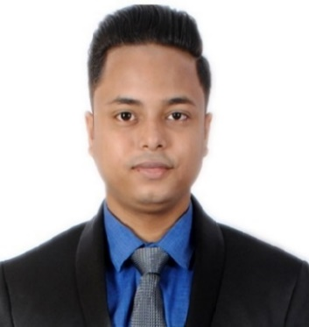**Aniket Das**

**Address**- Spandan Apartment(B4), Kurmi Bunglow Road,

Ambicapatty, Silchar-788004

District- Cachar

State- Assam

**Contact Number**: 9609027286 / 8638264546

**E-mail**: [das.aniket242@gmail.com](mailto:das.aniket242@gmail.com)

***Career Objective:***

I aspire to establish myself as a top-quality service-oriented personal in the industry and boost my career by serving the needs of the customers with my skill and knowledge.

***Summary of Skills:***

* Active listening.
* Adaptability.
* Communication.
* Creativity.
* Skilled in addressing and solving customer’s queries in a professional manner.
* Critical Thinking.
* Decision Maing.
* Interpersonal Communication.

***Professional Qualification:***

* + Professional training from renowned institute of Guwahati, Jettwings Group of Institutes in:
* Aviation
* Hospitality
* Tourism

***Academic Qualification:***

* Completed Class 10th from Board of Secondary Education, Assam in 2012.
* Completed Class 12th from Assam Higher Secondary Education Council in 2015.
* Completed 3 years of B-Tech in Computer Science Engineering from Sikkim Manipal Institute of Technology (SMIT).

[Graduation not completed due to medical reasons]

***Work Exerience:***

Working in Sheraton Grand Hotel and Convention Centre, Whitefield, Bengaluru

Date of Joining: 25/11/2019

Department: Front Office

Designation: Front Office Associate

***Extra Activities:***

* Participated in District level body building competition in 2014.
* Participated in swimming competition during school days.
* Skilled in playing guitar and also performed in many functions since 2012.

***Personal Details:***

* Father’s Name: Amit Das
* Moher’s Name: Mitali Das
* Date of birth: 17/02/1996
* Languages known: Fluent in English, Hindi and Bengali.
* Hobbies:
* Drawing.
* Playing guitar.
* Travelling.
* Marital Status : Single
* Nationality : Indian
* Gender : Male
* Religion : Hinduism
* Caste : GENERAL
* Languages Known : English, Hindi, Bengali
* Passport : R2174617
* Aadhar Card : 8582 4364 9412

**Declaration**

**I do hereby declare that the information given above is true to best of my**

**Knowledge and believe**

**Place: Whitefield, Bengaluru (ANIKET DAS)**